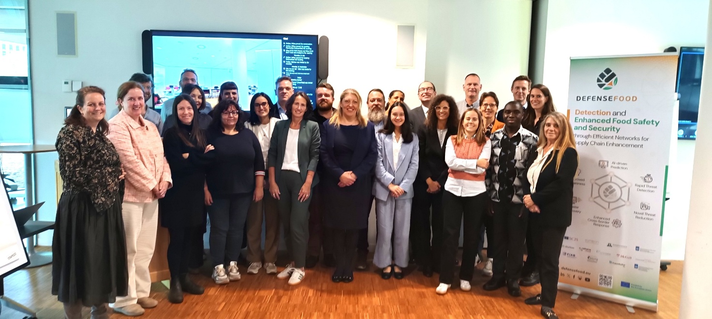Detection and Enhanced Food Safety and Security through Efficient Networks for Supply Chain Enhancement - DEFENSEFOOD
Lead by the SUSTAINABLE CRIMINAL JUSTICE SOLUTIONS EUROPE (Belgium), researchers from 13 European countries have come together under the "DEFENSEFOOD" project, a research initiative aimed at enhancing the resilience of the EU food supply chain against chemical, biological, and radiological (CBR) threats, ensuring robust preparedness, rapid response, and effective recovery.
Focusing on vulnerabilities
The project examines the entire food chain to understand where risks could appear and how they can be managed effectively. In addition, it focuses on three critical case studies (cereals, shellfish, and water supply), which are essential to public health and particularly vulnera-ble to contamination. To address these risks, the project aims to sup-port the production, processing, and distribution of food by:
▪ developing AI-enabled risk identification and decision-making tools
▪ raising awareness among authorities, the food industry, producers, and consumers about potential food-related risks,
▪ providing training and guidance to help stakeholders respond confidently and effectively during crises (through an AI-powered knowledge platform and learning tools)
▪ sharing best practices across countries to improve European food systems’ collective resilience
To achieve these goals, DEFENSEFOOD combines practical strategies with predictive analytics, laboratory techniques, and simulation models. This combination enables faster detection, more accurate assessment, and informed decision-making, ensuring that threats are contained and that supply chains recover swiftly.
Making a real impact by safeguarding food security
DEFENSEFOOD will address the challenge of intentional and accidental contamination of the food chain through a comprehensive risk mitigation approach, leveraging state-of-the-art tools such as Artificial Intelligence (AI), Earth observation data (e.g., Copernicus), and advanced detection technologies for CBR agents as well as social science assessments and capacity building.
By integrating scientific innovation, cross-border collaboration, and advanced technologies, the project sets a new standard for safeguarding Europe’s food systems, empowering stakeholders to anticipate, detect, and respond to threats effectively. Its work ensures that communities, economies, and public health are better protected, creating a resilient food supply chain for today and the future.
The comprehensive approach of DEFENSEFOOD addresses critical areas of threat management, fostering cross-border collaboration, technological innovation, and capacity building to protect public health, bolster economic stability, and secure food systems. The project’s structured strategy, encompassing seven interconnected work packages (WPs), ensures a full spectrum response from anticipation to post-crisis learning and communication. WP1 focuses on proactive anticipation and prevention by leveraging horizon scanning, predictive tools, AI, and real-time data to monitor potential disruptions and strengthen preparedness. WP2. The team headed by Vincenzina Fusco (Institute of Sciences of Food Production – CNR-ISPA) will enhances rapid detection using advanced laboratory techniques and both targeted and untargeted analyses to swiftly identify contaminants, reducing response times will contribute in developing an evidence-based analytical decision tool that guides through the consecutive steps required for the timely laboratory detection of potential food safety hazards: broad screening for the presence of CBR contaminants in the food and feed chain, subsequent confirmation, identification and quantification by targeted detection methods, and the analysis of indicators for an intentional release, aiming for an early detection of food safety risks independent of their origin. Moreover, Vincenzina Fusco will lead the task 2.2 on the Development of confirmed identification, quantification and monitoring methods of incident causative agents. WP3 implements impact mitigation and recovery measures by establishing effective containment protocols and outlining strategies for rapid operational restoration, minimising public health and supply chain disruptions. WP4 promotes continuous learning and adaptation, integrating lessons from past incidents to bolster future resilience. WP5 advances knowledge management and communication through user-friendly decision-support tools that disseminate best practices and strategic recommendations across the supply chain. WP6 focuses on training and capacity building, equipping public and private stakeholders with essential skills via workshops, training sessions, and simulation exercises, fostering coordination and preparedness. WP7 ensures cohesive project management, aligning WPs, optimising resources, and achieving milestones. It oversees governance and scientific coordination through consistent monitoring, ethics considerations, and advisory board facilitation. This integrated approach ensures that the tools, insights, and strategies developed throughout the project are applied effectively to build a more resilient and secure food system.
Per informazioni:
Vincenzina Fusco
CNR-ISPA
vincenzina.fusco@cnr.it

