Study of phase transitions in crystallizable polymers and their relation with relaxation processes in confinement regimes

Report on the scientific activity performed during the visit of
Prof. G. Strobl at the “Istituto per i Processi Chimico-Fisici del C.N.R.”
in the framework of the Short Term Mobility program of C.N.R.
8 – 22 April 2010

Abstract

After a short reminder of the aim of the activity, the aspects of crystal morphology and constrained segmental dynamics in polymer crystallization are briefly introduced. The main body of the report collects the discussion of selected aspects of the problem, which are considered of central importance for a development of a comprehensive view of the multiplicity of phase transitions assisting and/or accompanying polymer crystallization. Planned forthcoming collaborations are listed then.

Aim of the activity

Create the bases to arrive at a formulation of a statistical thermodynamical model describing the crystallization and re-crystallization processes occurring in polymers. The theory should be based on experimental data concerning
- morphology of organized semicrystalline structures (from X-ray diffraction at small and wide angle)
- calorimetry
- dynamical mechanical relaxation (DMTA)
- broad band dielectric spectroscopy (BDS)
The scheme worked out by Prof. Strobl [1,2], relating morphology to thermodynamic conditions of crystal formation is actually the best, and is mainly focused on the crystalline and mesophase components of the polymeric system. On the other hand, recent activity performed at the Istituto per i Processi Chimico-Fisici del C.N.R. (hereafter CNR-IPCF) has focused on the effects of confinement on the segmental relaxation dynamics in semi-crystalline polymers [3]. The purpose of the project is to merge the two aspects together in order to give consistency to the actual modelizations. In particular, the following aspects have to be considered:
- confinements effects on the segmental relaxation dynamics and on the thermodynamic stability of the crystalline domains
- existence conditions of mesomorphic domains and their role in the first stages of crystallization and re-crystallization processes.

Outline of the backgrounds

Melt crystallization (Strobl’s scheme)

When the crystallite morphology is put in relation with the thermodynamic conditions controlling its stability, a complex scenario emerges as schematized in the phase diagram of Fig.1.

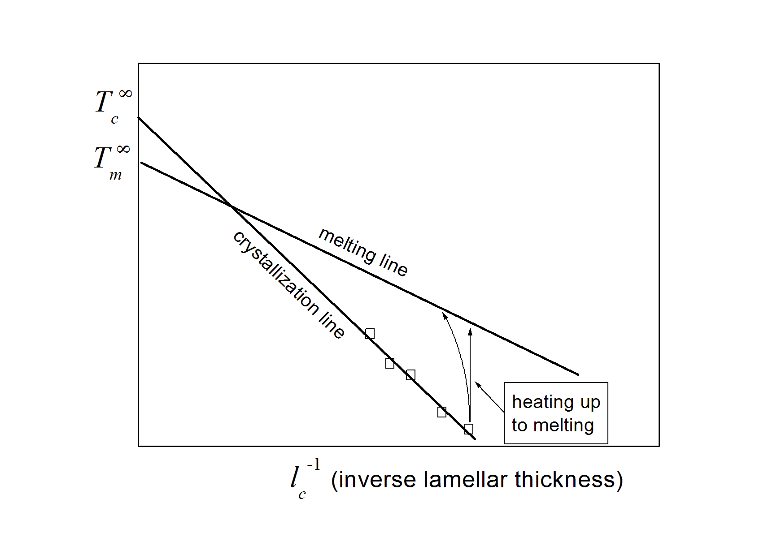
Fig. 1

The relation between (lamellar) crystal thickness l_{c} and crystallization temperature T_{c} is represented by a straight (crystallization) line intercepting the ordinates at T_{c}∞. On the other hand, when lamellae of different initial thickness (i.e. different T_{c}) are heated up and melt, the values of final thickness at the corresponding melting point lie also on a straight (melting) line, intercepting the ordinates this time at T_{m}∞ < T_{c}∞. The slope of the crystallization line is larger. The temperature T_{m}∞ characterizes the equilibrium between an infinite crystal and an infinite melt. The lateral crystal growth is mediated by a mesophase and its kinetics is determined by the undercooling with respect to the temperature T_{zg} ( < T_{m}∞) where the infinite melt and the infinite mesophase would be in equilibrium. In Fig. 2 the stability domains of the different phases intervening in the crystallization process are represented by a plot the chemical potential μ as a function of T. The advantage of the representation of Fig.1 is the explicit information on the crystal thickness; on the other hand, Fig. 2 has the advantage that the state of the amorphous component is also shown (see e.g. [4]).
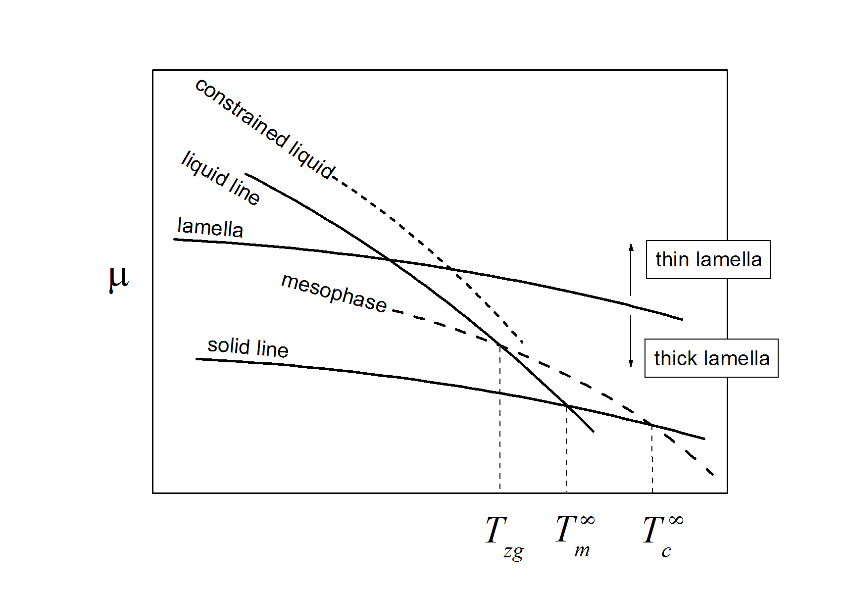
Fig. 2
The temperature at which a crystalline lamella looses stability is determined by the crossover of the lamellar line with either a mesophase line (possibly upward shifted in case of a finite thickness of the mesomorphic layer) or a liquid line (also possibly shifted upwards by the presence of constraints); details can be found in refs. 1 and 2.

Segmental relaxation (recent advances)

The conformational relaxation properties of amorphous regions are influenced by the presence of embedding crystals as causes of constraints. From the statistical mechanical point of view, the effect of these constraints is twofold:
  - They rule out some states from the partition function Z_{u} associated to a monomer in a relaxed melt, thus leading to a new partition function Z_{u}’ < Z_{u} ;
  - Not all paths are allowed anymore for transitions among states building up Z_{u}’; let Z_{c} (< Z_{u}’ ) be the reduced partition function collecting only the states of Z_{u}’ allowing for a conformational transition.
Chain rearrangements in a constrained melt are then associated to the crossover of an average chemical potential barrier

$\overline{Δμ}≈−k_{B}T\text{ln}\frac{Z_{c}}{Z_{u}'}$ ; (1)

on the other hand, since the constraints to a conformational change depend on the actual conformation (in a polymer, e.g., chain connectivity plays a central role in this respect) a chain rearrangement will in general lead to different constraint conditions, i.e. to different Z_{c}s for subsequent rearrangements. This is a generalization of the well known Adam-Gibbs approach [5].
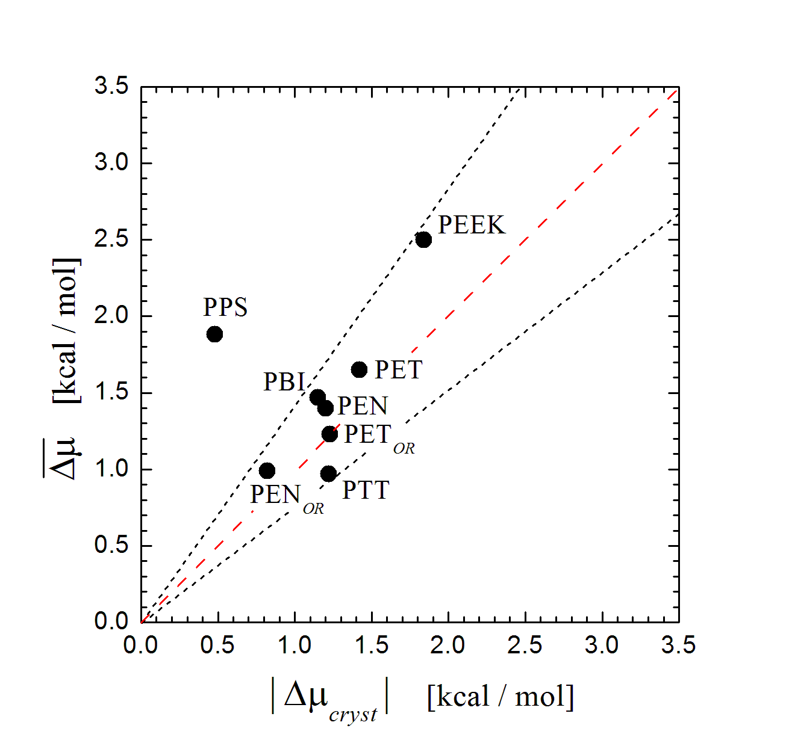
Fig. 3

The relaxation function (e.g. the polarization autocorrelation function in a dielectric spectroscopy experiment) can be expressed as a superposition of Debye processes, each one characterized by particular constraint conditions, say, parametrized by a variable ζ (which is zero in the absence of constraints):

$φ(t)=\int_{0}^{∞}{d\text{ζ }p(ζ)\text{ exp }}$ (2)

where p(ζ) is the stationary distribution of constraints, z is the number of monomers in a static cooperatively rearranging region (SCRR).

The dynamical heterogeneity characterizing a relaxation is associated to a dispersion δ[Δμ] around the mean $\overline{Δμ}$. This heterogeneity, which is directly accessible by the experiment, carries information on $\overline{Δμ}$ because, due to the quasi-poissonian character of p(ζ) [3],

$δΔμ≈\overline{Δμ}$ (3)

The analysis of literature relaxation data on polymers which have completed their crystallization isothermally at temperatute T, revealed a correlation between $\overline{Δμ}(T)$ and the chemical potential change Δμ_{cr}(T) of a monomer in the transition from the melt to the crystalline state; this correlation is illustrated by Fig. 3 [5].
Since the segmental relaxation of any polymer evolves from a fast and narrow profile to a slower and broader one during crystallization (i.e. a progressive increase of $\overline{Δμ}$ takes place), the correlation shown in Fig. 3 strongly suggest that the thermodynamic state of the confined amorphous domains is influenced by the confining crystals.

A discussion on relevant aspects of crystallization and the confinement effects induced by it

Among the number of still unresolved problems concerning polymer crystallization, it is worth mentioning its arrest before complete crystallization is reached.
Intuitively, this is due to the existence of amorphous regions from which chain conformational “defects” (such as entanglements) cannot escape, due to the presence of the embedding crystals. However, this geometrical reasoning is rather naïve on several respects and cannot itself be of help when quantitative descriptions are needed.
Indeed, crystal growth is assisted by some chain mobility within the adjacent amorphous regions (not necessarily adjoining, in the presence of an intermediate mesophase). Crystallization arrest means that a progressive reduction of the thermodynamic driving force takes place. Possibly, this reduction may be also accompanied by a slowing down of chain mobility in the confined amorphous regions. How can this slowing down be related to the size of the amorphous domains and to the density of defects within?
Of course, confinement by crystals must also affect the character of chain dynamics, because when the size of the amorphous domains is large the constraints at their borders are rather uneffective and the situation does not differ significantly from an infinite undercooled relaxed melt. In this case the dynamics has a collective character and the correlations in the motions of adjacent units is not hindered by any “external” constraining. On the other hand, upon sufficient reduction of the size, the chain motion changes from collective to cooperative: for a unit to move, it is now necessary that a sufficient number of adjacent units happen to properly move concurrently. Then, what are the conditions (in this scenario) underlying the transition from a collective to a cooperative motion?
From the thermodynamic point of view, the growth of a crystal in a relaxed melt has a well defined character: it is associated to a progressive decrease of the overall thermodynamic potential associated to it (i.e. including both the volume and the surface contributions). However, when crystallization from an undercooled melt occurs, the progressive crystal growth sets constraints in the melt itself. Now, what is the thermodynamic criterion underlying the crystallization arrest? How is it possible to describe the interplay between, e.g., the hindering of lamellar thickening and the slowing down of chain dynamics, so to result in a simple pattern like that schematized in Fig. 1?
The above issues led to discuss in some detail aspects related to the relaxation model of ref. 3 and to the crystallization process itself, also assisted by the formation of a mesophase.

Aspects of the relaxation model

The data shown in Fig. 3 suggest that such a thermodynamic criterion might indeed be formulated, although detailed and systematic investigations in this respect need be planned (mainly because the relaxation data used to construct Fig. 3 have been drawn from the literature; a systematic and well controlled homogeneous procedure would instead be desirable). A central point of this issue is the confrontation between the segmental dynamics [e.g. ϕ(t)] and the thermodynamic state (e.g. the stability) of the source of the dynamic constraints (e.g. the crystals). For this reason, a central role is played by theoretical modellings such as the mean-field one developed in ref. 3 where, in particular, a key quantity is the distribution p(ζ). Its derivation assumes at the outset that the segmental motion has a cooperative character, and in this respect it is not predictive with regards to the transition from a collective dynamics.
There are two important conceptual points with regards to the relaxation function expressed by eq. 2. The first is the single-monomer character of p(ζ), which allows to extract directly z by simply fitting relaxation functions obtained experimentally (e.g. as reported in [3]). The other is the role of relevance attributed to the parameter ζ , which is the lower bound for an energy fluctuation per monomer in a SCRR, able to allow for any conformational rearrangement whatsoever between allowed states.
The single-monomer character of p(ζ) is a mean field concept: two monomers with different values of ζ belong by definition to SCRRs with different thresholds for rearrangement, thus they are independent. On the other hand, all monomers belonging to a certain class ζ are considered to be identical (but distinguishable), their specific partition function Z_{u}’ containing somehow the information related to cooperativity (which is of course connected to the existence of constraints, as indicated by the apex in Z), i.e. to the interaction with the other monomers of a SCRR that - by definition of cooperativity - must belong to the same class ζ .
Concerning the role of ζ it is worth noting that, in eq. 2, stress is put in the transition rate between different possible conformations, i.e.

$τ^{−1}(ζ)=[τ∗]^{−1}e^{ −zΔμ(ζ)/{k_{B}}T}$, (4)

rather than in the details of conformational dynamics or in the domain extension (within the conformational space) explored by a given SCRR. What is assumed instead, is that the SCRRs are evenly distributed in all possible conformational sub-domains, and where they are ergodic. This is done by assigning to each SCRR the same, average partition function [Z_{u}’] ^{z} : again a mean-field concept borrowed from the former Adam-Gibbs model [6].
With regards to the issue of ergodicity, it is important to point out that the stationary distribution function p(ζ) is derived in the hypothesis that an SCRR whatsoever is assumed to be ergodic with respect to the variable zζ, i.e. that the whole interval [0,∞[ can be explored by ζ without restrictions, independent of the actual configurational space spanned by the SCRR itself. This is one of the most important features characterizing ζ.
The chemical potential barrier height z ⁻¹ΔF associated to the transitions among different SCRR configurations consists of two main contributions. An energetic one is related to the minimum energy threshold for a fluctuation to be effective in a conformational rearrangement. The other is of entropic nature, connected to the limitation in the number of paths allowing for a rearrangement. Assuming for Z_{c} the phenomenological form

$Z_{c}≈\int_{\text{ ζ}}^{∞}{\text{dE}E^{n}e^{{−E}/{k_{B}}T}}$, (5)

( Z_{u}’ = Z_{c} |_{ζ=0} ) these two contributions are mixed to some extent, because on increasing ζ the states with E ≤ ζ are excluded (this relates to the decrease of the available paths for rearrangement), but at the same time the average energy of the states allowing for rearrangement increase.
The integrand in eq. 5 describes a probability distribution of available states

$q(E,n)≡\frac{E^{n}e^{{−E}/{k_{B}}T}}{Z_{u}'}$ (6)

(for the units of a SCRR), whose profile shifts towards higher energy values upon increasing n, that is, when the constraints are more effective. This means that some low-energy states turn out not to be available anymore; but at the same time, that a higher number of high-energy states are introduced. This does not have an effect in the application of eq. 2 for data fitting, since only the ratio Z_{c} / Z_{u}’ is contained in it, but of course it is a point which needs be investigated further. More explicitly:

It is important to find a (simple) non-phenomenological form for Z_{u}’ from which Z_{c} can be obtained by excluding states with energy less than ζ and a (dense) subset of states with energy higher than ζ (i.e. introducing a more clear cut entropic effect of the constraints). Of course, this point should not be separated from the problem of finding out whether a relationship between ratios Z_{u}’ / Z_{u} and Z_{c} / Z_{u}’ exists.

Before ending this subsection it is worth stressing that in all the discussions above (and in refs. 2 and 5, of course), the approximation Z ≈ Z_{vib}⋅Z_{conf} is not adopted.

Aspects concerning crystal stability

The stability of crystals depends on the thermodynamic characteristics of the surrounding phase. This can be easily grasped by the schematic of Fig. 2: constraining a liquid (i.e. shifting its phase line upwards) increases the temperature value where its phase line crosses the lamellar line, above which the lamella itself looses stability. Intuitively, a less mobile liquid is less effective in de-structuring the surface of a crystal at a given T.
If the problem is considered within the framework of Equilibrium Thermodynamics, then this leads to ask oneself what are the conditions by which the system finds advantageous to loose mobility in some fraction of its body (without turning to a different state) in order to gain stability overall. Is this pathway possible? If yes, to what extent does confinement enter this mechanism?
On the other hand, the correlation shown in Fig. 3 also suggests that a sort of a stationary state might be looked for. In fact, Fig. 3 tells that the state reached at the end of the crystallization process, although not conforming to the common paradigm of a thermodynamic equilibrium, does in fact correspond to a condition where a generalized driving force for a transformation (in the sense of Irreversible Thermodynamics) tends to zero, and a sort of “kinetic” equilibrium is reached:
When crystallization stops, the drop Δμ_{cr} of chemical potential due to the amorphous-to-crystal state transition of a monomer, cannot provide anymore the free energy needed (e.g. by the others connected with it by cooperativity) to cross the barrier $\overline{Δμ}$ in the adjacent non-crystalline regions for a concurrent rearrangement.
Besides, also the conditions underlying the formation of the Rigid Amorphous Phase (RAP) should be considered in this context and, especially, with respect to confinement. This could help in better clarifying processes like the vetrification and de-vetrification of the RAP observed by C. Schick et al. in semicrystalline polymers [7]. In particular, when crystals are formed at a given (low) temperature, a fraction of RAP inevitably forms. Then, on heating up the system above the crystallization temperature T_{c} the mobilization (de-vetrification) of the RAP accompanies crystal re-organization. On increasing the residence time at T_{c} , the RAP seems to stabilize, as its de-vitrification appears to be less rapid (see ref. 1 for the case of poly-carbonate ).
Also interesting in this respect are the data collected in ref. 8 and relating to the change in temperature location of the annealing peak, T_{r}, of PET samples isothermally crystallized at different T_{c}s for different times. Indeed the authors found that the difference T_{r} − T_{c} increases linearly with the logarithm of crystallization time.
With specific reference to the effects of a mesophase, it is also worth mentioning the phenomenology of crystallization of s-Polypropylene from the glassy state [9]. In this case, the formation of a mesophase always appears to precede crystallization. When crystallization is carried at low temperatures, the mesomorphic component seems to stabilize, rendering more difficult (as time passes at low T) its conversion to crystalline when T is increased afterwards. This stabilization process has been considered as a possibility in the interpretation of the data of ref. 9, although this picture was considered unsatisfactory by that time. It is in the light of the new point of view brought about by the relaxation model, that this mechanism can be reconsidered.
Direct evidence of the interplay between the relaxation properties of the amorphous domains and the re-organization of the crystalline domains upon re-crystallization, is provided by the following mechanical analysis on semi-crystalline PET.
The mechanical relaxation behaviour of PET cold-crystallized at T_{c} = 100 °C for 7 h is shown by the isothermal DMTA pattern of Fig. 4.

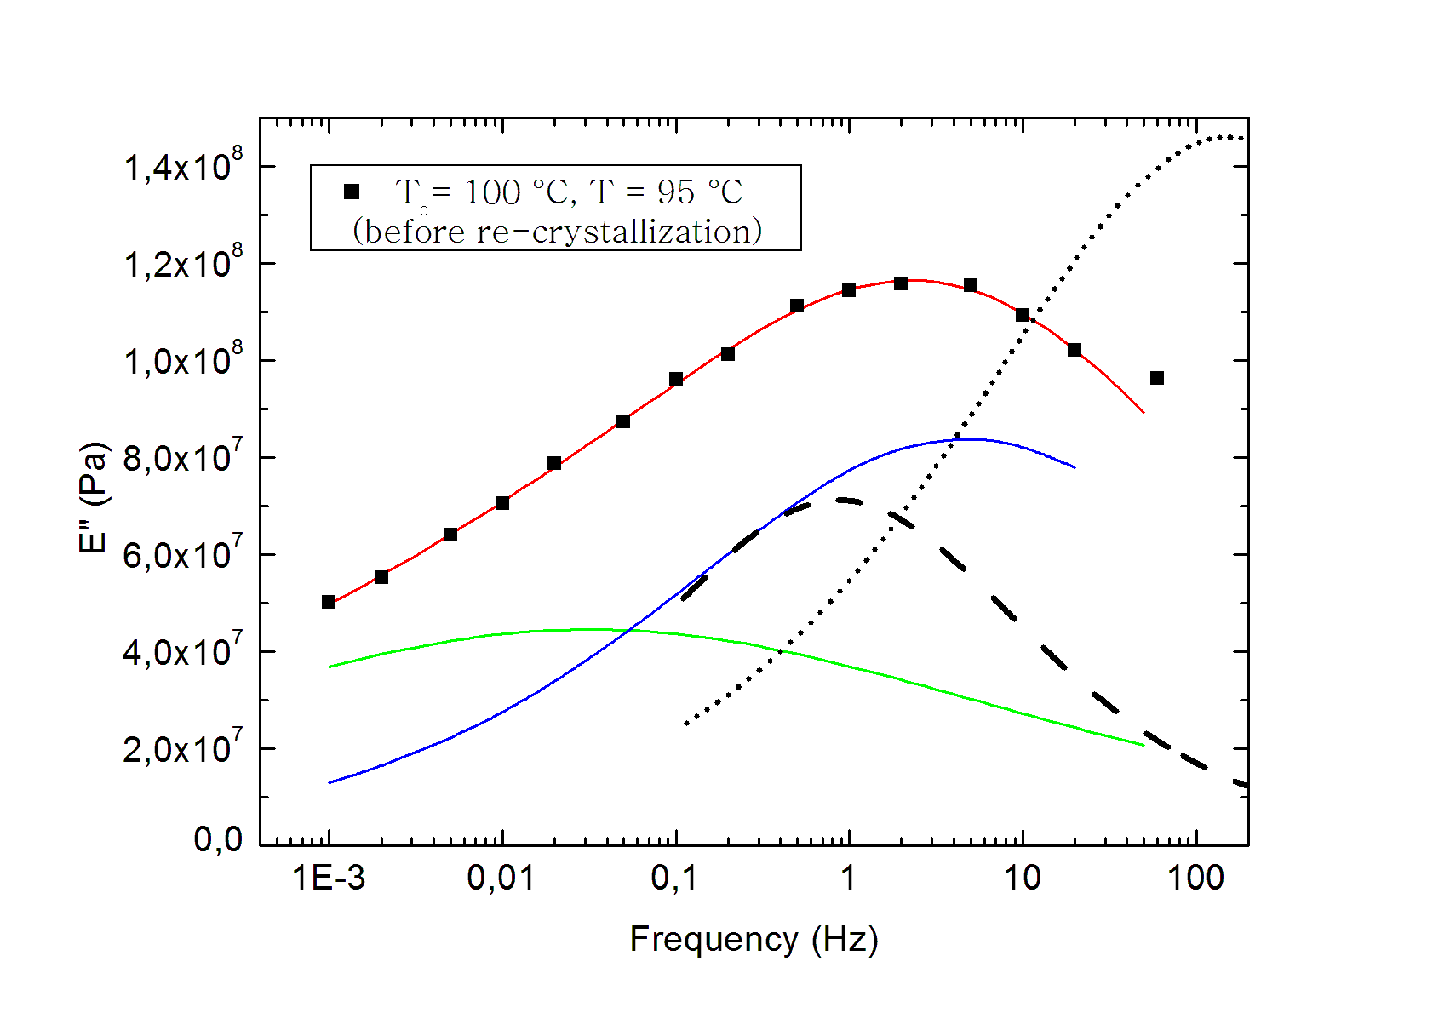
Fig. 4

The whole profile is decomposed into two main symmetric Havriliak-Negami contributions; the fast one (in blue) corresponds to the conformational relaxation of segments which mainly undergo strong confinement by the crystals. The black lines are suitably rescaled patterns of the imaginary part of the dielectric susceptibility, referring to strongly constrained (dashed) and weakly constrained (dotted) segmental motion. The fast mechanical relaxation is mainly associated to a strongly restricted segmental dynamics, but it includes as well contributions from amorphous regions which are less affected by crystal confinement. DMTA is not able to separate these two components. However, the clear cut maximum revealed by the E” pattern indicate that the relative contribution to the mechanical response due to the weakly restricted regions, is less important than in the case of the dielectric response. This is also supported by Fig. 5, showing the dependence of the E” pattern as a function of the temperature. The slow relaxation (green line in Fig. 4) is rather ill defined (in the sense that the errors in its fitting parameters are comparatively large as compared to the fast mode) and its origin is not known.

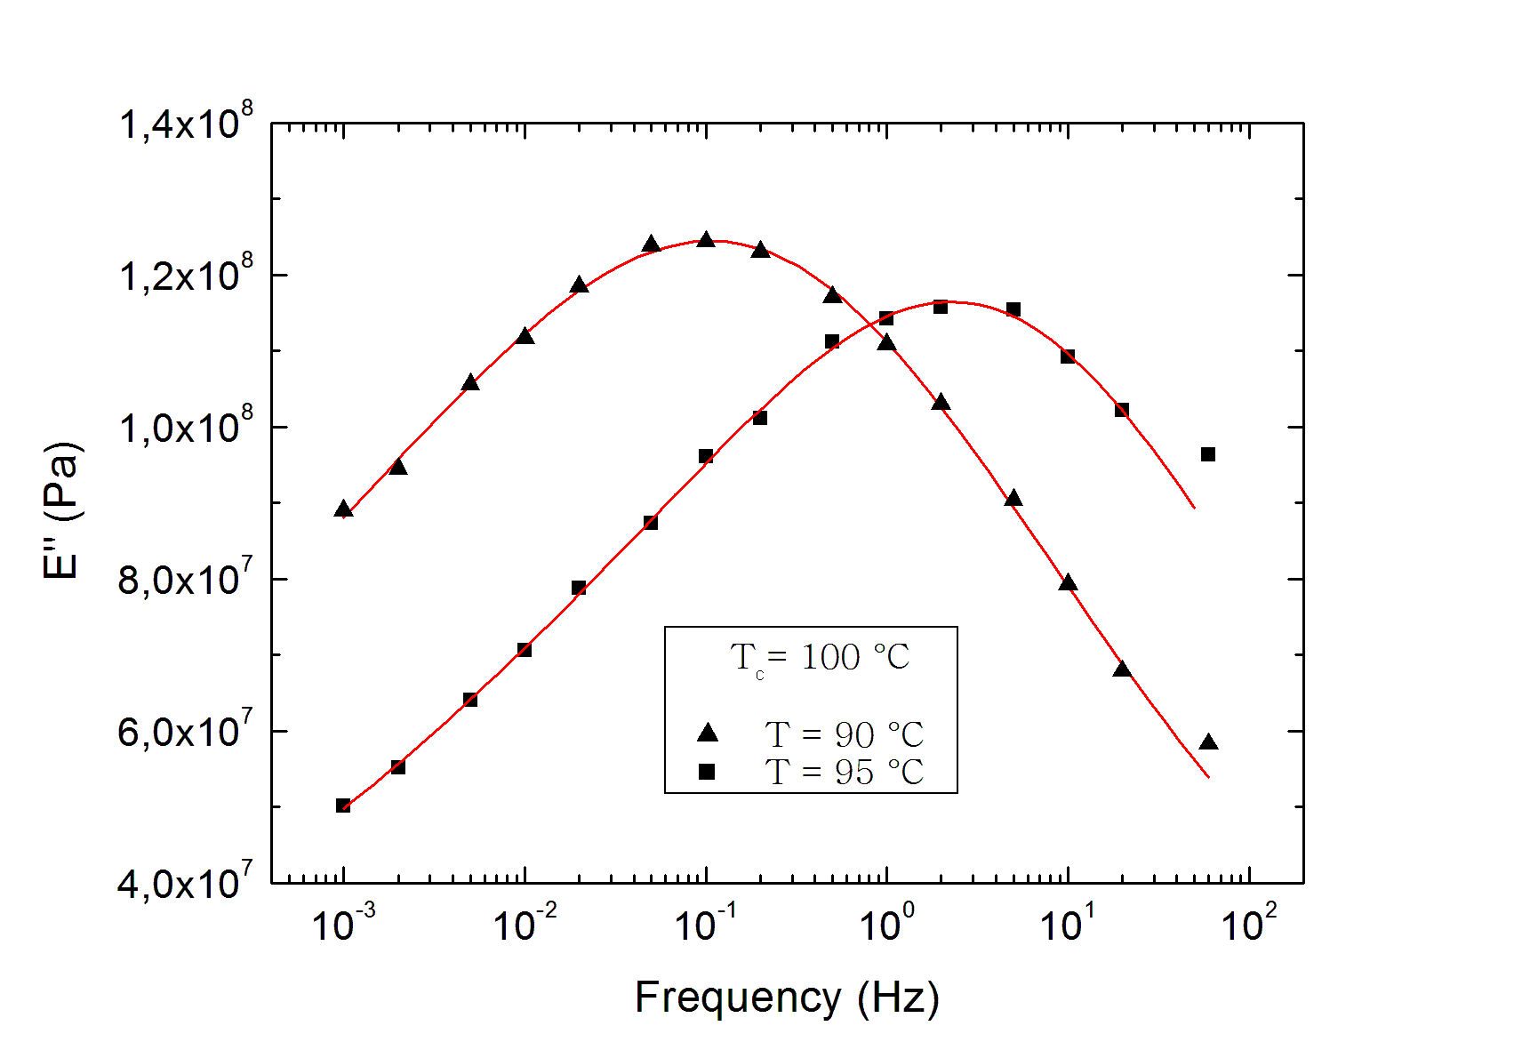
Fig. 5

Subsequent re-crystallization at either T_{r} = 115 °C or T_{r} = 125 °C for 2 h, show the patterns reported in Fig. 6, where also that of Fig. 4 (i.e. the filled squares) are reported for comparison.
Re-structuring of the semicrystalline domains is accompanied by a downwards shift of the fast mode, accompanied by a relative increase in the amplitude of the slow one. This is to say that the strongly constrained amorphous domains become more rigid overall. The nature of the slow mode is not clear at present, but the mechanism from which it originates must be central in the overall re-organization of the stacks during re-crystallization.
In any case, the progressive toughening of the amorphous domains seems to accompany the settlement of the crystal domains in a new, more stable morphology.

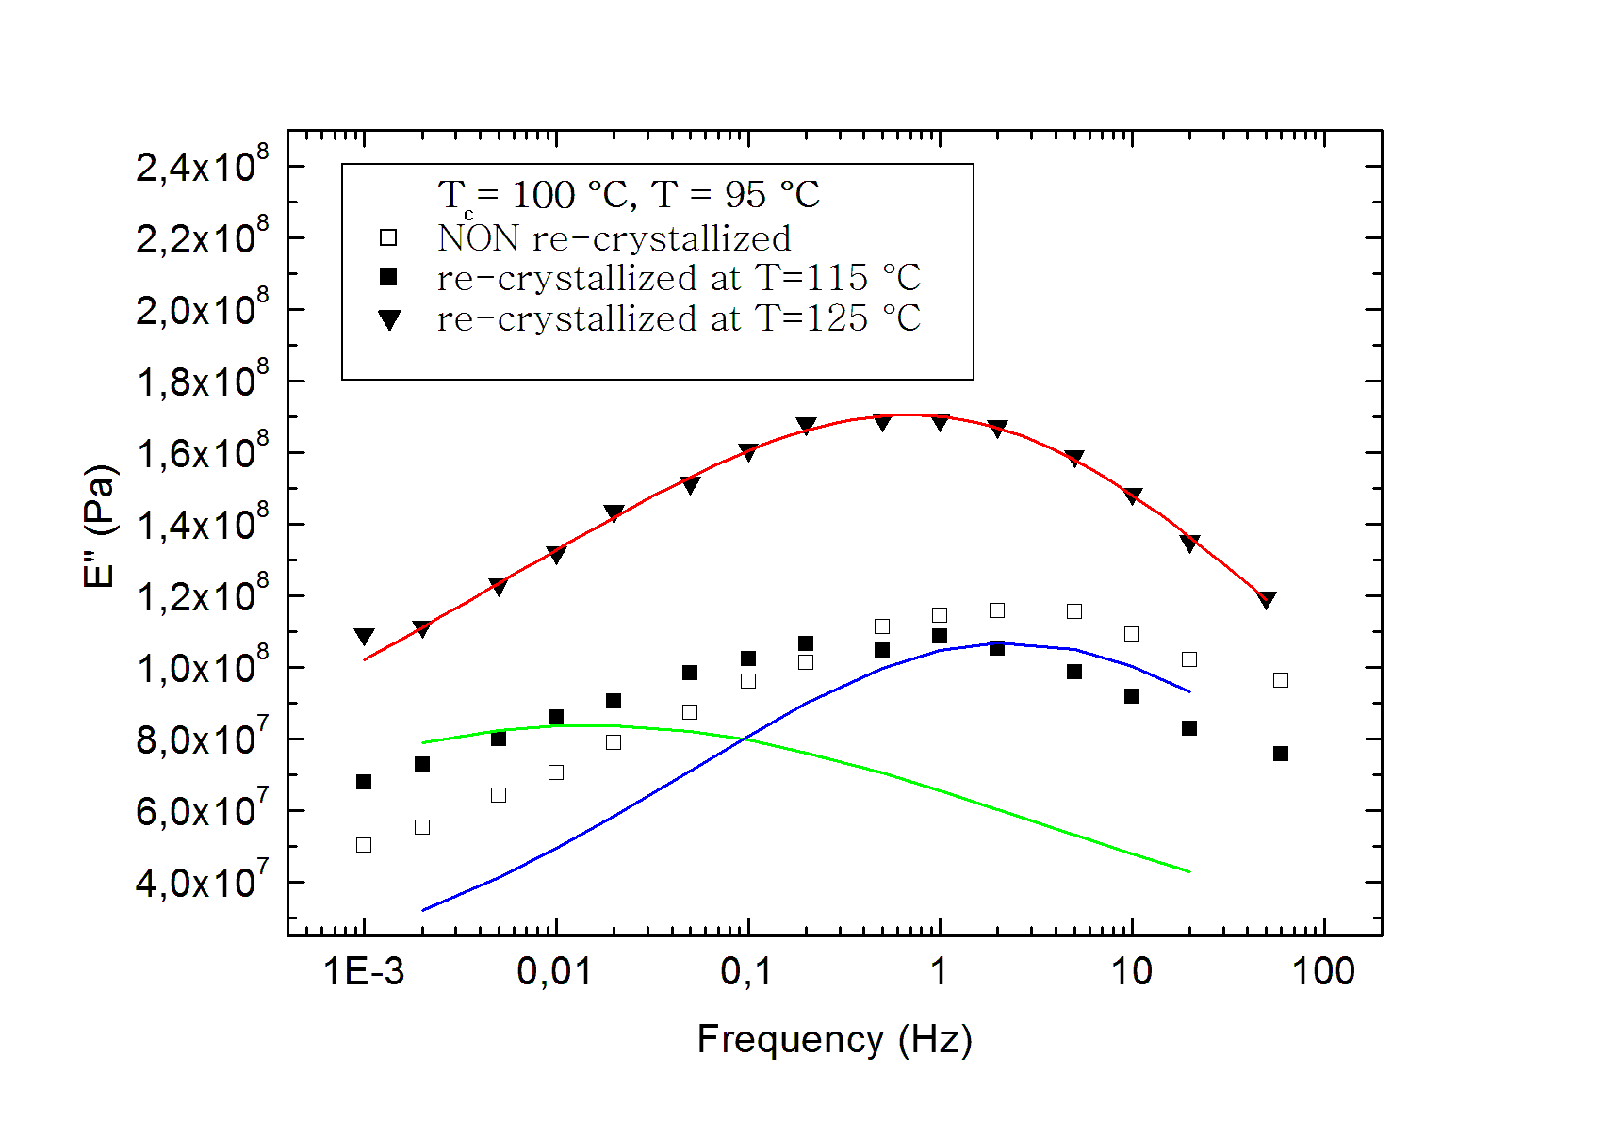
Fig. 6

A last example to be mentioned is the behaviour of a smectogenic polyester, which shows two competing crystallization modes [10]. At low enough T_{c} (e.g. 70 °C) crystals form from a smectic phase, whereas at relatively high T_{c} (e.g. 120 °C) an ordinary crystallization process takes place, giving rise to spherulitic structures. Upon re-crystallization, lamellae formed initially within a smectic phase undergo a sudden thickening when the temperature rises above the stability threshold of the interlamellar smectic phase. In other words, the lamellar thickness changes (and the crystals adjust to new stability conditions) when the interlamellar regions change morphology.

Plans for future work

Specific aspects

The above information pointed out some particular issues to be considered within short terms:

- The problem of crystal stability within a melt of reduced chain mobility
- The derivation of more appropriate forms of the monomer partition function Z_{u}’, i.e. not based on phenomenological reasonings
- The transition from a collective to a cooperative dynamics and the emergence of an average size of regions where cooperative motion is confined.
- The re-interpretation of well known key experiments related to polymer crystallization, in the light of the scheme proposed by the relaxation model (see e.g. Fig. 3).

These problems are of general interest and are actually under consideration. With regards, instead, to the specific cases considered above, the investigation of the following issues is planned:
- The change of relaxation dynamics in the smectic-to-amorphous transition within the semi-crystalline smectogenic polyester mentioned at the end of last section, when the temperature crosses the instability threshold.
- The nature of the slow mode in re-crystallizing PET.

Collaborations

In order to create solid grounds on which a new, comprehensive theory of polymer crystallization can be constructed, which includes also the observed changes in the thermodynamic state of the interlamellar amorphous regions, it is mandatory to set up a collaboration network among groups whose activities are focused on the following aspects
- Structuring of polymers (e.g. X-ray analysis)
- Relaxation dynamics (e.g. NMR techniques, DMTA, BDS and others)
- Statistical mechanical modelling
In this respect, previous contacts have been taken with the NMR group of the Dept. of Physics “A. Volta” at Pavia University, who also offered a PhD grant for enhancing its activity in the field of polymeric materials. Right after the conclusion of the scientific program to which the present report refers, contacts have been established with the Physics department of the University of Halle/Saale (Germany), and in particular, with Prof. Th. Thurn-Albrecht, head of the Experimental Polymer Physics group, with Prof. M. Beiner and with the NMR group through Prof. K. Saalwächter. In the same University, also the group of Prof. R. Krause-Rehberg (formerly headed by Prof. G. Dlubek), whose main activity focuses on positron annihilation lifetime spectroscopy, manifested interest for a collaboration in the field of conformational relaxation under confinement.
Previous collaborations with the Instituto de Estructura de la Materia C.S.I.C. in Madrid, concerning in particular X-ray analysis the use of BDS for investigating structure and relaxation processes in polymers, are still active and will be continued in this respect (see e.g. the literature below). In the same field of activity, a further collaboration with Dr. M. Viviani, of the CNR-IENI in Genova has been recently started.

Prof. Gert Strobl

Emeritus Professor of Experimental Physics - Polymer Physics
Institute of Physics, University of Freiburg
79104 Freiburg, Germany

Dr. Marco Pieruccini

Researcher
C.N.R. Istituto per i Processi Chimico-Fisici
V.le F. Stagno d’Alcontres n.37
98158 Messina, Italia

References

[1] G. Strobl; Prog. Polym. Sci. 31, 398 (2006)
[2] G. Strobl; Rev. Mod. Phys. 81, 1287 (2009)
[3] M. Pieruccini, T.A. Ezquerra; Eur. Phys. J. E 29, 163 (2009)
[4] M. Pieruccini, A. Flores, U. Nöchel, G. Di Marco, N. Stribeck and F.J. Baltá-Calleja; Eur. Phys.
J. E 27, 365 (2008)
[5] M. Pieruccini, A. Flores; Coll. Polym. Sci. 288, 365 (2010)
[6] G. Adam, J. Gibbs; J. Chem. Phys. 43(1), 139 (1965)
[7] C. Schick, A. Wurm and A. Mohamed; Coll. Polym. Sci. 279, 800 (2001)
[8] G.C. Alfonso, E. Pedemonte and L. Ponzetti, Polymer 20, 104 (1979)
[9] M. Grasruck and G. Strobl, Macromolecules 36, 86 (2003)
[10] B. Heck, E. Perez and G. Strobl Macromolecules 43(9), 4172 (2010)

