In order to fulfill the guidelines from the “CNR – Short Term Mobility Program 2008” hereby I present my report. During my stay in Rome I worked to fulfill the proposed goals:
1. Study two centralized action selection models for the resolution of a robot foraging task with a nearby predator.
2. Develop an evolutionary centralized model of action selection in collaboration with the University of Veracruz (UV), in Mexico, and the ISTC-CNR in Italy. The selection model should be able to organize behaviors and the order of how they have to be executed.
We focus on how embodied and situated agents consisting of miniature mobile robots develop autonomously (i.e. without human intervention) a variety of behavioral skills and the ability to select the right behavior at the right time in order to accomplish the task for which they are rewarded. Thus, the development of the evolutionary centralized model of action selection was our main goal during this stay. Mainly, we carried out a review of the state of the art, experimental setup, development of robot architecture, improvement of computational tools, and experimentation. As for the analysis of the results we are still working on this part to produce original publishable results. The architecture that was developed allows the integration of a commercial robot simulator Webots with a copylefted simulator evorobot*.
Evorobt* is a robot simulator devoted to the design of experiments related to the use of the evolutionary robotics approach, whereas Webots is a commercial simulator that facilitates the use of a 3D environment for the modeling of the robots e-puck and Khepera. In the laboratory in Mexico we have seven Khepera robots and one license of the Webots simulator. Therefore, the implementation of a common platform is an important development because allows researchers at the ISTC-CNR in Italy to develop experiments with the e-puck robot and also permits researchers at the Universidad Veracruzana to work with the Khepera robot using an identical architecture.
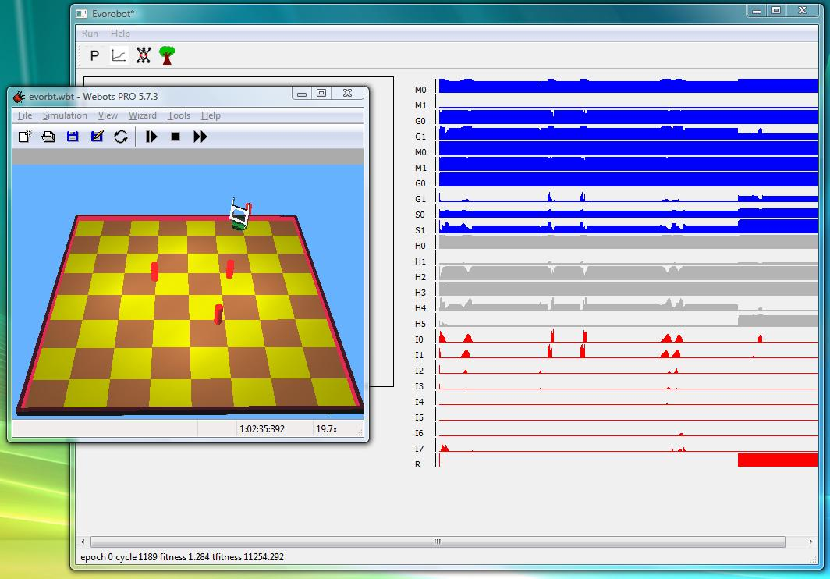
Figure 1. Integration of Evorobot* and Webots for an experimental setup of
evolvable action selection.
The next step will be to develop robotic experiments with selectable behavior optimized by the use of genetic algorithms employing a single platform built from free and commercial robot simulators. The goal of studying two centralized action selection models for the resolution of a robot foraging task with a nearby predator will be further studied in Mexico with the use of the integrated evorobot* and Webots Simulator.

Fernando Montes Gonzalez
fmontes@uv.mx

