

From: Robert Stone^{1,2}

¹ Cooperative Institute for Research in Environmental Sciences (CIRES)
University of Colorado – Boulder
² National Oceanic and Atmospheric Administration (NOAA)
Earth System Research Laboratory, Boulder, CO

Submitted: 9 June 2008

To: Virginia Coda Nunziante, Head
Developed Countries and Interanational Organizations Office

RE: TERM MOBILITY Program Travel Grant - 2008
Sponsored by: dr. Vito VITALE, ISAC-CNR - Bologna

Dear Ms. Nunziante,

Following, please find a brief report pertaining to my recent visit to ISAC-CNR, Bologna under the 2008 Short-Term Mobility Program that provided travel to/form Bologna from the U.S. and living expenses during my stay in Bologna.

Dr. Vito Vitale was my sponsor, submitting application for the grant, amounting to 1600 Euro.

I arrived on an overnight flight 12/13 May and departed on 25 May, for a stay of 12 days, of which 10 were spent working in collaboration with Vitale and his colleagues at ISAC.

I give permission to use this report in any way deemed valuable to CNR, including posting it on your website, and further agree to acknowlege CNR for its support in any subsequent publication of analyses undertaken with ISAC researchers, expressing sincere appreciation for the opportunity to collaborate under CNR support.
Report on Accomplishments during a visit to ISAC-Bologna; 13-24 May 2008

R. S. Stone
Cooperative Institute for Research in Environmental Sciences (CIRES)
University of Colorado – Boulder
in affiliation with
Earth System Research Laboratory, Boulder, CO
National Oceanic and Atmospheric Administration (NOAA)

Motivation

My research visit to ISAC-CNR, Bologna was motivated by a long-standing collaboration between NOAA and ISAC prompted by mutual interests by Vito Vitale and myself pertaining to Polar research. Our interests focus on both Antarctic and Arctic climate studies involving aerosol research and aspects of the surface radiation budget. I have managed NOAA programs at South Pole and Barrow, Alaska for several years that have more recently been implemented at Dome Concordia, Antarctica and are planned for Ny-Alesund, Svalbard. The primary purpose of my visit was to analyze data sets collected coincidentally at South Pole and Dome C, and further to discuss ongoing and future activities of mutual interest, including preparation for and participation in a circum-navigation of the Arctic during April 2009 by the German research aircraft, Polar-5.

Following find:

1) a summary of preliminary findings from our comparative analysis of albedo measurements made on the Antarctic Plateau (to be published)

- current status of planning for the 2009 circum-Arctic aircraft mission

- future plans to collaborate on polar research

Background

ISAC and NOAA make many similar measurements at their respective polar observatories, including components of the surface radiation budget (SRB) and also spectral photometric observations used to derive or infer optical properties of atmospheric aerosols that affect the SRB. There is great interest by the satellite community in utilizing ground-based data collected at the bi-polar network of stations for validation of retrievals. In particular, the albedo, or surface reflectivity, measured from space has been problematic, showing a low bias. Dome C was considered a better prospective target than South Pole, which is off-nadir from polar orbiting platforms and has a slightly sloped and much rougher surface. Encouraged by NASA, albedo measurements were instigated during austral summer 2007/2008 at Dome C. To verify their accuracy and representativeness, comparisons with ongoing measurements at South Pole were undertaken during my visit.

Similarly, measurements of the optical properties of aerosols from the network of ground sites are invaluable for quantifying the radiative (climate) impact of aerosols on the SRB and are needed for validation of satellite retrievals as well as to improve model parameterizations of aerosol properties. The joint activities being undertaken by several groups, led by ISAC, are critical to these efforts. During this International Polar Year (IPY) much focus is being placed on improving methodology to assure that future assessments of the climate impact of aerosols in Polar regions are valid. ISAC has worked closely with NOAA in this effort, developing a portable sun photometer system that will be used during the first-ever circum-Arctic flight. Its integration on Polar 5 and pre-calibration of the system were also discussed during my visit.

- Comparative analysis of Albedo measurements made on the Antarctic Plateau. (the following analysis forms the basis for a letter to Geophysical Research Letters).

The problem of determining snow albedo from space is illustrated in Figure 1, which shows a comparison for one day of measurements made at South Pole and those derived from satellite radiances measured by the MODIS sensor on board the Terra polar orbiter.

Figure 1. Example of diurnal cycle of clear-sky surface albedo as derived from Terra satellite radiance measurements and by ground-based radiometers at South Pole (CMDL).

It is clear from Fig. 1 that the satellite data are biased low. However, South Pole (SPO) is off-nadir from the orbiting satellites by 10s of degrees, is prone to having farily large sastrugi caused by prevailing, downslope winds and has a slightly sloped surface. This makes SPO a less than ideal validation target. Polar orbiters pass nearly directly overhead Dome Concordia (DOMC) several times a day providing an excellent target that is virtually level and almost flat due to the light winds. This makes DOMC an ideal target or validation location. An albedo rack (Figure 2) was installed there prior to austral summer 2007/2008. Its addition, including deployment of a down-facing pygeometer to measure upwelling, longwave irradiance brought DOMC into full compliance as the second Baseline Surface Radiation Network (BSRN) site (with SPO) on the Antarctic Plateau. Albedo is simply the ratio of upwelling to downwelling solar irradiance, measured by a like pair of (nearly) co-located, broadband radiometers. The measure is made using one-minute average data, enabling high temporal variations to be monitored at the respective sites. At SPO, a similar rack is used to measure upwelling irradiance (flux) and also there is a second measurement made from about 22 m on a high tower. The tower measurement at SPO was begun in 1998 in order to mitigate effects of sastrugi on the upwelling signal.

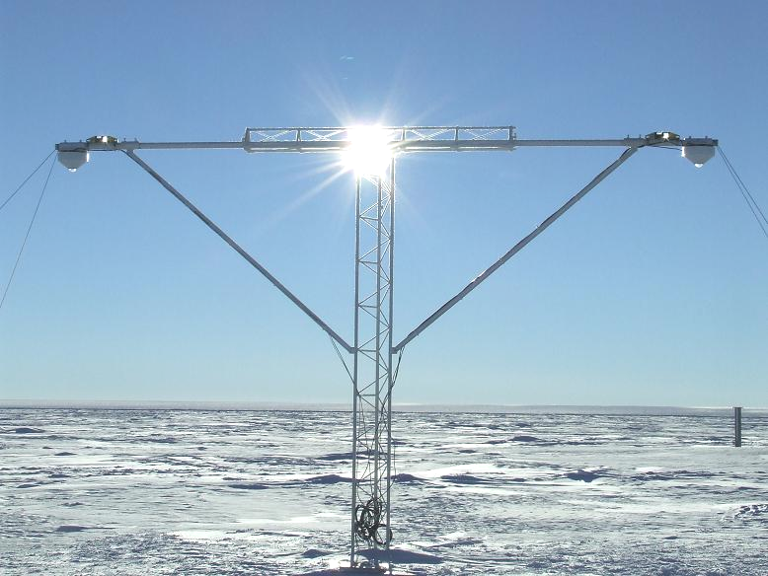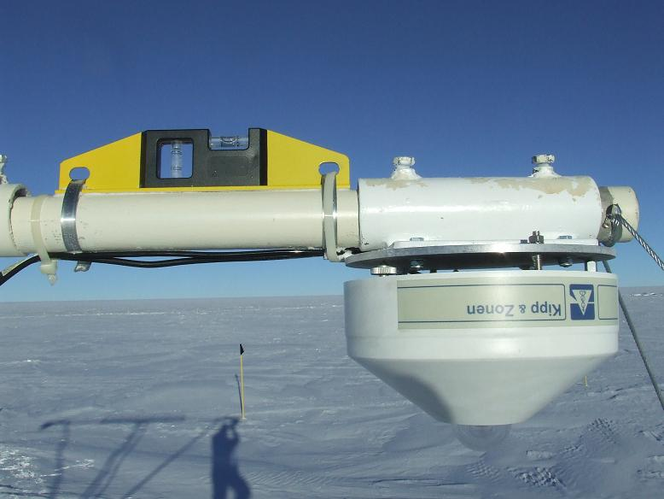
Figure 2. The recently installed albedo rack at Dome Concordia; inset – detailed view of one of two down-facing pyranometers used to measure upwelling solar irradiance (or flux) at the station.

While at ISAC, I worked closely with Vitale’s Team to assimilate and analyze albedo measurements from the two Plateau sites, performing a comparative analysis of the short- to seasonal-term variations. We looked at similarities and differences that affect the respective time series that will provide context for future satellite validation studies. Figure 3 shows time series for December 2007 at two locations. Each show time series of albedo α derived from 5-minute samples of shortwave up (SWU) and shortwave down (SWD) data, where α = SWU/SWD. It is clear that the albedo is highly variable on diurnal time scales and differs at the two locations. SWU is measured from either an albedo rack, 2 m above at SPO or 3 m above the surface at DOMC, or from 22 m at the SPO tower. SWD is measured either by a single instrument (GLOBAL) or as the component sum (TOT) of direct beam + diffuse solar irradiance.

At SPO, the diurnal cycle depends on which radiometers or combination of instruments are used to compute the ratio. At DOMC, the diurnal cycle is strongly linked to the solar elevation angle. These features are better illustrated in Figure 4, which show diurnal cycles for sequences of clear days, the portions of each record highlighted within the light yellow rectangles in Fig. 3.
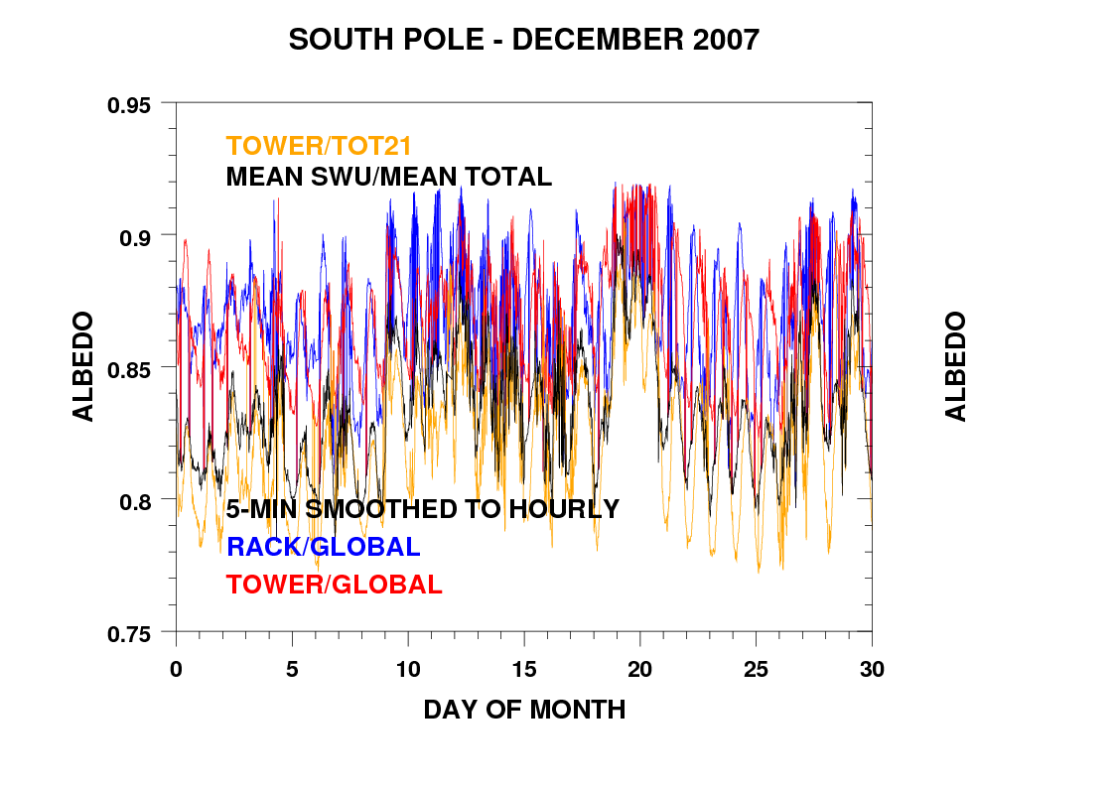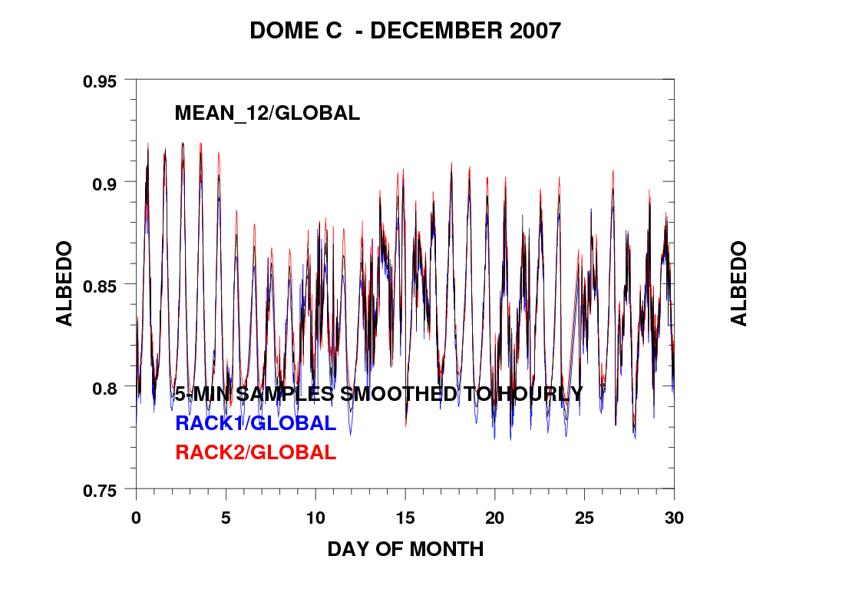
Figure 3. Time series of 5-minute resolved surface albedo at South Pole (top) and at Dome C (bottom) for December 2007. Each trace represents a different computation made based on combinations of downward and upward facing radiometers to illustrate the high variability in the diurnal signals. Clear periods, highlighted by light yellow rectangles, are shown in Figure 4 to illustrate better this daily variation.

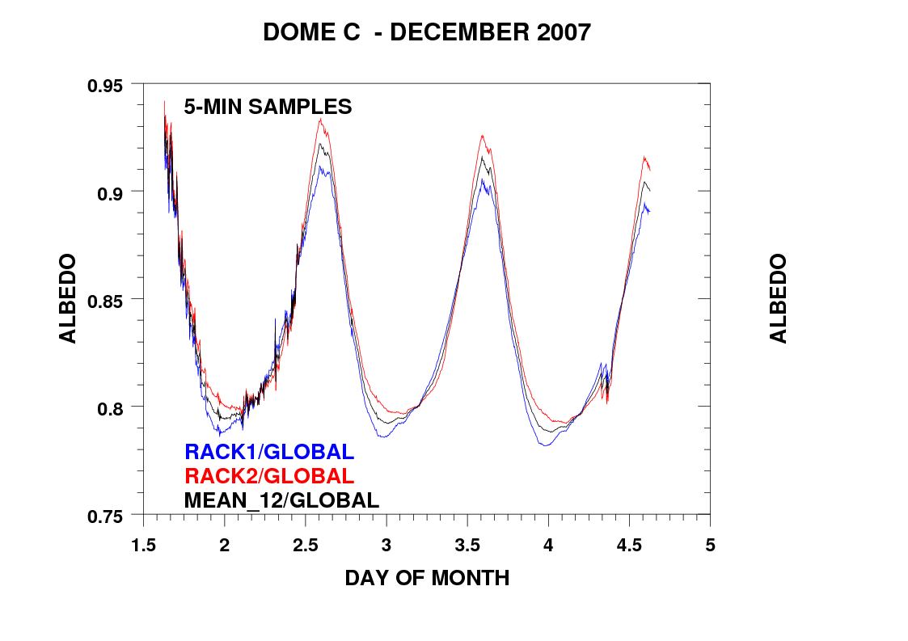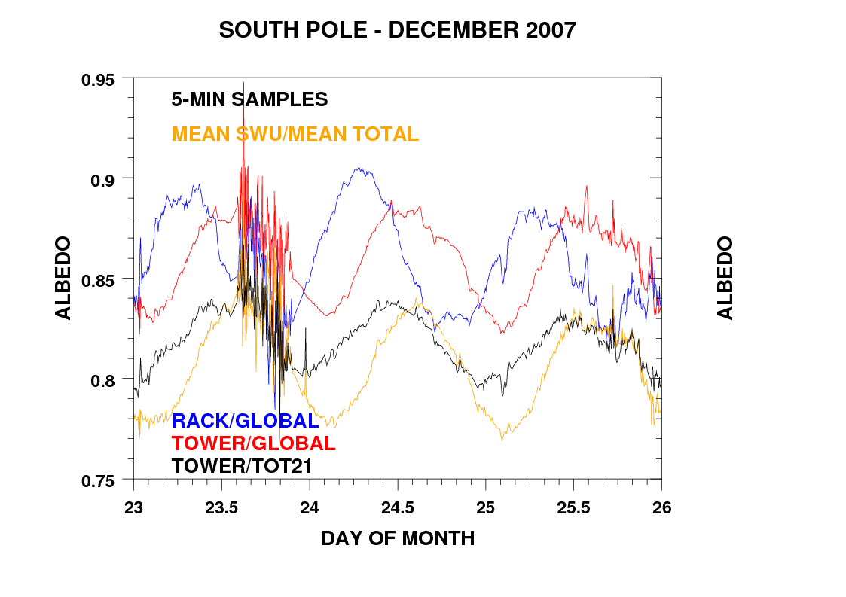
Figure 4. Examples of clear-sky, diurnally varying albedo at Dome C (left) and South Pole (right), December 2007. Each time series is computed on the basis of different combinations of down- and up-facing radiometers at the respective sites to highlight the high variability in derived values.

The diurnal cycle of albedo at the two sites differs markedly but can be of the same order of magnitude, ranging from < 0.80 to > 0.91 on a clear day during summer. It is critical to recognize that evaluations vary over time and from place to place when utilizing ground measurements for validation purposes. At DOMC, the large variation is due to the solar geometry that varies over the day. Large values occur at sun rise and sun set or when the sun is low on the horizon due to enhanced specular reflection of sun off of the bright surface. At SPO this is not the case, however, because the sun’s zenith angle on any given day varies very slightly. The apparent cycles, which vary depending on the measure of SWU used in the computation, depends on the surface roughness, that is the amplitude and orientation of the sastrugi relative to the field of view of the down-facing radiometer. Even from the high tower (black trace in Fig. 4, right), the effect of sastrugi and/or slope is significant. The distinctive features of the daily cycle of albedo at the two sties are further demonstrated in Figure 5, which higlights the zenith angle effect at DOMC, and anisotropic effects of surface reflection at both sites.

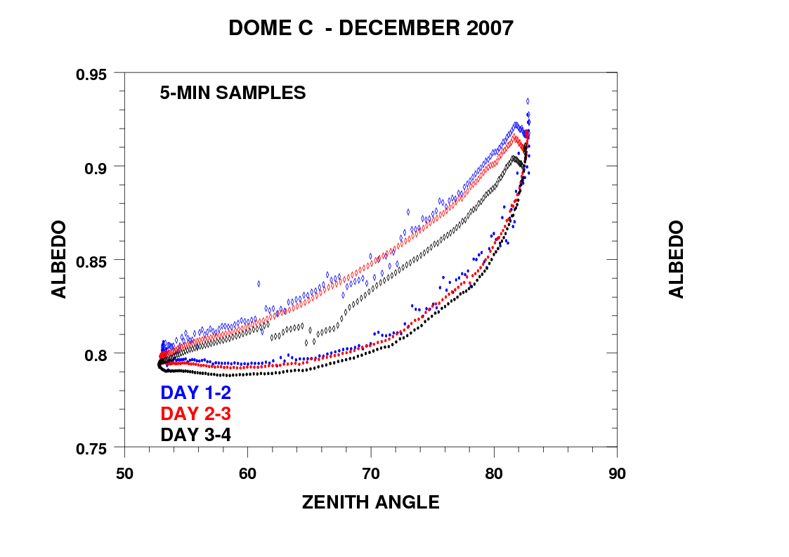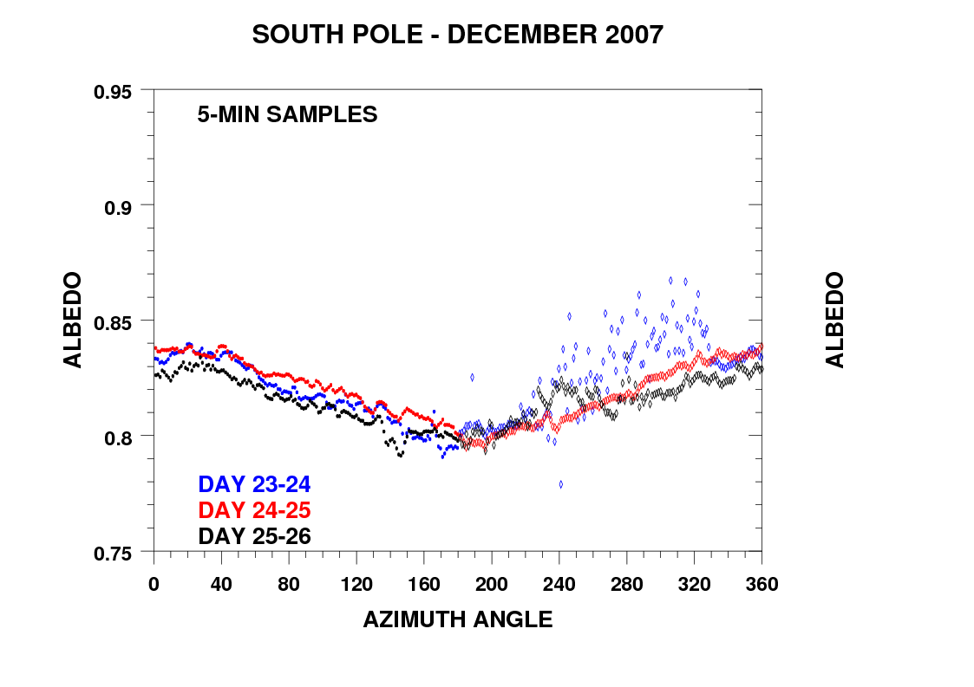
noon
rise
set
Clear-sky anisotropic effects
clouds
Figure 5. Plots of diurnally varying surface albedo at Dome C (left) and South Pole (right) for selected clear days in December 2007. At DOMC, high albedo occurs at sun rise and sun set but with systematically higher albedo in the afternoon. At SPO, the variation is with azimuth angle as the sun revolves around the station at nearly constant solar zenith angle. The hysterisis at DOMC and azimuth effect at SPO are mostly due to anisotripic effects caused by preferentially aligned sastrugi convolved with the changing solar geometry. Compromised leveling of instruments may induce small artifacts in evaluations as well. Futher complicating evaluations, during cloudy periods (right) albedo is enhanced owing to relatively greater absorption of solar radiation by cloud particles and multiple reflections between the surface and cloud base.

Fig. 5 reveals that instantaneous evaluations of albedo yield highly varying results depending on site, solar geometry relative to surface features, and the amount of cloud cover. When using ground measurements to validate satellite retrievals these factors must be given careful consideration.

Finally, to determine if there are any systematic differences in albedo at the two sites, monthly mean evaluations were compared. The averaging and smoothing of 5-minute data was implemented to integrate any surface effects, solar angle effects and/or artifacts of measurement. The results are meant to quantify the fundamental measure of reflectivity, on average, on month to seasonal time scales over the Antarctic Plateau. What portion of incoming solar radiation is reflected by the surface on average? Ultimately, this is the variable that is important for climate change studies and is one that satellite retrievals must be able to duplicate, and models must be able to simulate. We are interested to know if there is a measurable difference at SPO and DOMC, which might be indicative of systematic variations over the Antarctic Plateau. This is the first such evaluation and is thus preliminary. The resutls are summarized in Figure 6, which provides a comparative analysis of SPO and DOMC monthly mean albedo over the 2007/2008 austral summer.

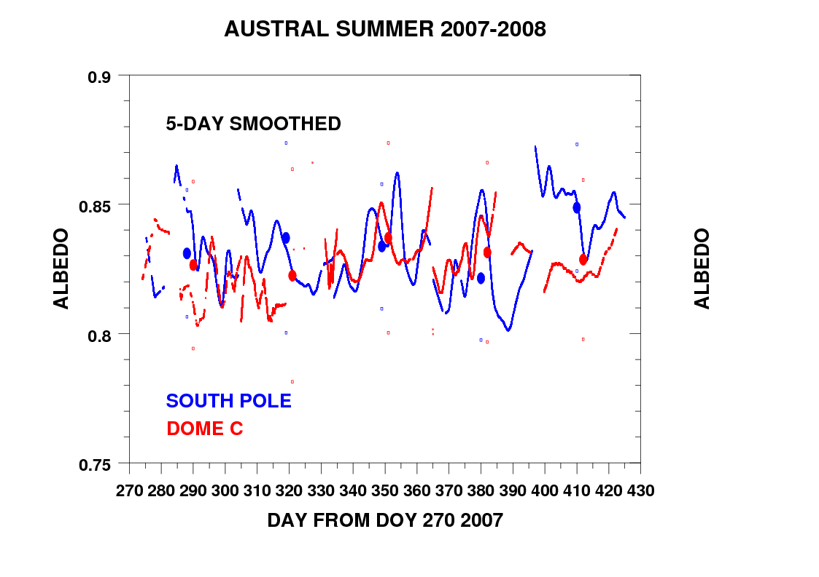
October November December January February
0.833 (0.015)
0.827 (0.001)
Austral summer broadband albedo at Dome C and South Pole
Figure 6. Time series of 5-day smoothed albedo, measured at South Pole (blue) and Dome Concordia (red) during austral summer 2007/2008. The filled ovals are the monthly means and the bars the one standard deviation computed from 5-minute samples used in previous analyses. At right are the overall seasonal values of albedo estimated from the 5-day smoothed data and their respective standard deviation (in parenthses).

We find that the albedo, on average over the season, at the two locations is about 0.830 ± 0.003. Until similar analyses are made in the future, this is the best evaluation we can make using surface measurements. The finding is significant if verified by future observations and should provide a guideline for satellite and model validations. It is clear, however, that surface measurements can and should be improved in the future. Calibration of all instruments in use must be precise, leveling and tracking accurate and the higher the down-facing radiometer the better for integrating effects of sastrugi. It is also obvious that there may always be effects of sastrugi that must be accounted for when interpreting satellite data. Even the diminished sastrugi at DOMC are manifest as artifacts in the computed, instantaneous albedo for a given solar zenith angle as is evidenced in Fig. 5 (left). Sastrugi effects are very likely to be seen in retrievals of surface (skin) temperature as well, where brighter appearing surfaces are slightly warmer than dimmer surfaces. In the future, we will endeavor to work with the satellite community to verify these conjectures.

- Current status of planning for the 2009 circum-Arctic aircraft mission.

ISAC and NOAA have collaborated on matters related to Polar aerosol optical depth (AOD) since 1998. At that time we recognized the potential value in creating a bi-polar network of sun photometers to monitor spectral irradiance (later adding Star photometry), establishing an archive of AOD data and collaborative analyses of that data to characterize the physical and optical properties of aerosols at high latitude; and further, to determine their radiative impacts on climate, directly and indirectly. The project evolved until which time the Polar-AOD project was approved as a cluster activity during the International Polar Year (IPY); see, http://classic.ipy.org/development/eoi/proposal-details.php?id=171. Under ISAC leadership, with co-sponsorship of the Alfred Wegener Institute (AWI), the first comparison campaign was conducted at Ny-Alesund, Svalbard during March/April of 2006. I was invited as representative of the U.S. and subsequently analyzed data collected by participants from the nine countries during a similar Research Visit to AWI in September 2006. One recommendation made upon reviewing the data was that a second campaign be organized with a focus on inter-calibration of photometers being used throughout the network. This second campaign will be held in October 2008 at Tenerife – Canary Islands. This is deemed an important preliminary activity leading up to a proposed circum-Arctic flight by the German Polar-5 research aircraft. Providing funding is secured, Stone will fly that mission and make airborne sun photometer observations using the system developed jointly by NOAA and ISAC in 2002. A schematic of the proposed flight is shown in Figure 7, and the system to be deployed in Figure 8. The 8-channel system will provide the first “snap shot” of AOD on an Arctic-wide basis, both in the horizontal and vertical domain, from which characterizations can be made of aerosol optical properties and their radiative impacts on climate. While at ISAC, we assembled and operated the system successfully and discussed strategies for its use during the circum-Arctic flight. The same system has served well at Dome Concordia and we also began the analysis of data collected there. The inaugural mission in April 2009 will pave the way towards future flights in which an ISAC-AWI robotic sunphotometer will be deployed for even greater spatial and temporal coverage over the next five years. Each year an April and September flight is planned. As follow on to our discussions, Andreas Herber (AWI), Chief of the aircraft program, will visit ISAC in June 2008 to acquaint himself with the system and determine how best to integrate it into the Polar-5.

Figure 7. Tentative track of the AWI research aircraft, Polar-5, during the inagural circum-Arctic flight planned for April 2009. The NOAA-ISAC 8-channel sunphotometer (Figure 8) may be flown as part of the scientific payload, enabling horizontal and vertical characterization of erosols on an Arctic-wide basis

. 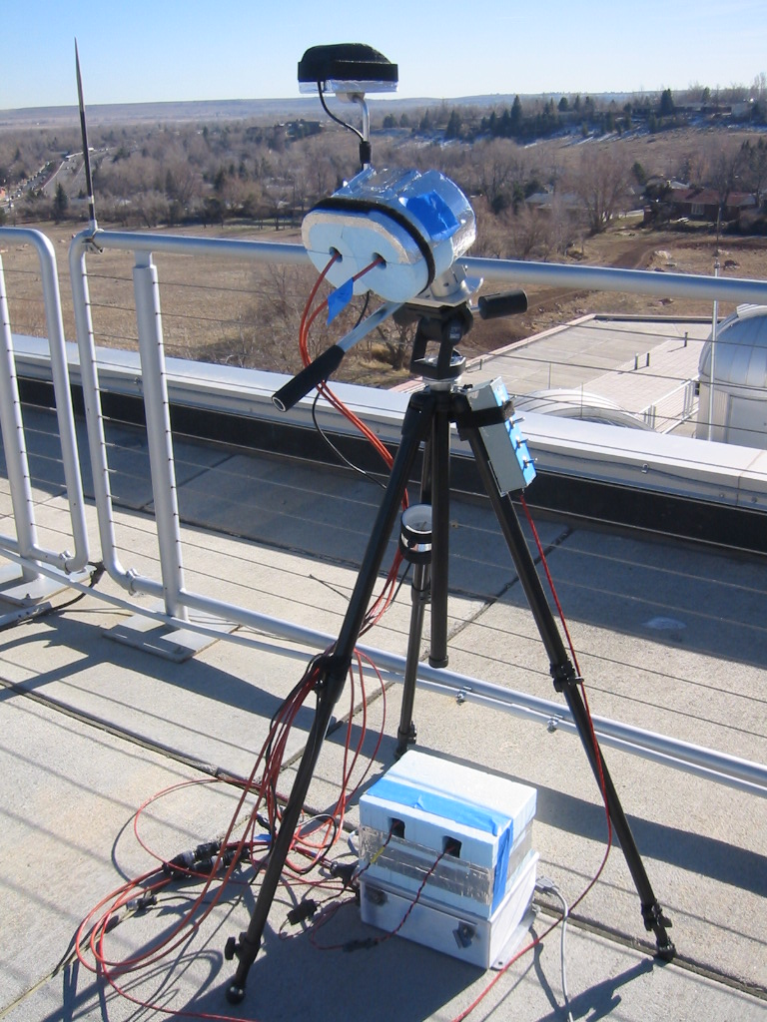

Figure 8. The NOAA-ISAC 8-channel sunphotometer system, designed for portable use, or continuous monitoring application as was made at Dome Concordia during recent austral summers. The system will be re calibrated as part of the Polar-AOD organized campaign this October (2008) at Tenerife, and configured for deployment on the AWI Polar-5 for its inagural circum-Arctic flight (Figure 8).
- Future plans to collaborate on polar research

In addition to the above analysis of albedo and discussions pertaining specifically to Polar-AOD and the circum-Arctic mission, Vitale and his colleague met with Stone to discuss other possibilities for Polar research involving NOAA. We identified topics that are of mutual interest and will exploit the combined measurements made at South Pole and Dome Concordia, as representing the Antarctic Plateau. In particular, combining the surface radiation and photometric data with lidar data shows great promise for the study of clouds and clear-sky ice crystal precipitation over the Plateau. Assimilated, these are unique data that can be used to determine how clouds and diamond dust affect the climate of the region; again, whether these may differentially or similarly affect the local climate. An analysis approach with the aim to publish on these topics was outlined in our final meeting. We will hope to reconvene once data sets have been assimilated by the respective groups.

Overall, my visit was most productive. The main objective was met; producing an outline for a paper on the SPO DOMC albedo comparison (roughly the summary given above). Further, we had fruitful discussions pertaining to October 2008 campaign at Tenerife and the circum-Arctic mission planned for April 2009. Each of these activities has strengthened the NOAA-ISAC collaboration in significant ways, which ultimately benefits the international community we are part of.

I am very grateful for the support CNR offered through this program and look forward to collaborating with dr. Vitale and his Team in the future.

