Report on the research visit to the CNR Laboratory, IMIP,Monterotondo

July 4th-18th 2008

by Professor Colm T Whelan, Old Dominion University, Virginia, USA

The purpose of the visit was threefold
a: to further the joint theoretical experimental research on electron impact ionization of atomic inner shells
b: to discuss further directions for collaborative research
c:for Professor Whelan to deliver a research seminar.

a:(e,2e) studies of inner shell ionization of Argon and Magnesium

Because of the smallness of the inner shell cross section it is only in recent years that experimental techniques have become sufficiently refined to make viable inner shell (e,2e)measurements. In our joint work we are concerned with ionization from the 2s and 2p shells of Ar and Mg. The first (e,2e) measurements on Ar(2p) were performed at quite high impact energies (of the order of 8keV)[1]
In [2] results were presented for Ar(2p) at very much lower impact energies. These experimental results could not be explained on the basis of a first Born or first Born type approximation, however allowing for elastic scattering of the incoming electron in the static exchange potential of the atom and ejected and scattered electron in the static exchange field of the atom/ion, Whelan and his collaborators were able to achieve near perfect accord with the experiment. Their approach is a variant of the distorted wave Born approximation,DWBA, [3].Very recently in a series of joint theory experiments we have investigated the inner shell ionization of Mg,[4]. Again good agreement was found between the DWBA calculations and the experiment.
In the earlier study of Argon,[2], an interesting structure was identified by theory in the recoil peak, the peak was split into two peaks of different heights. Unfortunately these structures were in a region which was not accessible to the original experiment.
During this visit we explored the possibility of studying the theoretically predicted using the Rome apparatus either for argon targets or magnesium. For this apparatus the most convenient is to keep the energy of the fast scattered electron fixed while simultaneously varying the energy of impact and that of the slow ,persumably ejected, to maintain energy conservation.
Whelan performed theoretical calculations, results below, in the DWBA approximation for a fast scattered energy of 500eV and scattering angle of 8 degrees,where the development of the split recoil peak can be clearly seen:

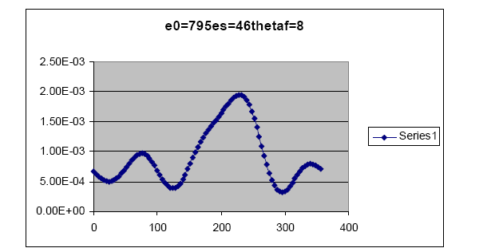

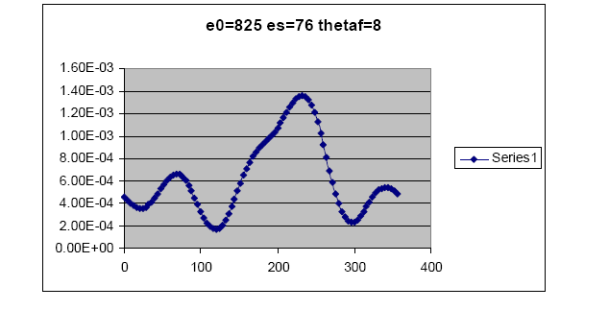
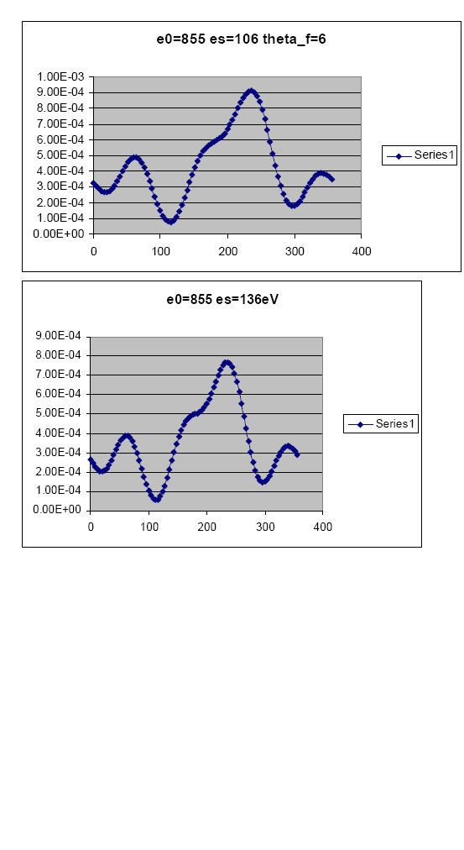

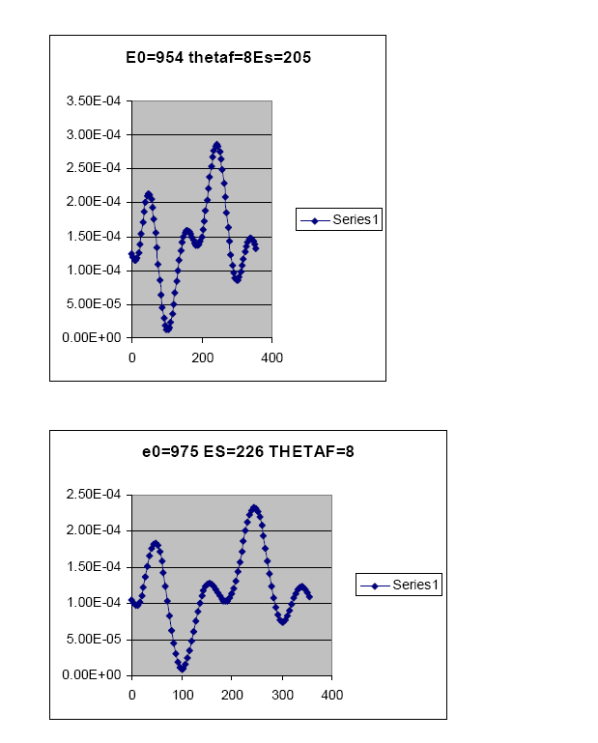

Much thought was given to measuring the cross sections for these kinematics, however it was felt that the absolute size of the cross section might be too small to make the experiment feasible. It was felt that Mg would be a better target. Whelan has begun a series of calculations to see if the effect can be demonstrated also in this case. Preliminary results for a scattered energy of 1keV are encouraging but more theoretical work needs to be done to get the optimum arrangement for experiment. Efforts to identify the origin of this split peak point to a strong quantum mechanical interference effect between the different distorted waves. This work continues.

b Futher collaboration
The possibility of Whelan performing calculations for the two photon ionization of Neon has been carefully discussed and the exact experimental conditions envisaged by the Rome group clearly defined.

[1] A Lahmam-Bennani et al,Phys Rev A,30,1511,(1984)
[2] X Zhang et al,J. Phys B,25,4325,(1992)
[3] see article by CT Whelanet al in CT Whelan et al,edited,"(e,2e) & related processes", Kluwer, pp 1-32,(1993)
[4] P Bolognesi et al,J. Phys B,41,255524,(2008);P Bolognesi et al,Phys Rev A,77,054704,(2008)

- A seminar was presented on the 17th of July

Fragmentation processes

Colm T Whelan
Department of Physics, Old Dominion University, Norfolk, Virginia, 23529-
0166

Abstract
In this talk, I will describe the theory that has been developed to describe kinematically complete collision experiments. In such experiments, all the fragments from an atomic collision are detected in coincidence with their angles and energies resolved. The technique offers both the possibility of a direct determination of the target wave function and profound insights into the nature of few body interactions. What information you extract from such an experiment really depends on the kinematics you chose and the target you use. What is measured is the cross section, i.e. the ratio of the number of measured event corresponding to the final state fragments being detected at fixed position in space with well-defined energies per unit time per unit scatterer as compared to the incident flux.
Technically, we are talking here about a multiply differential cross section as opposed to one where we have integrated over one or more of the fragment co-ordinates. Integrated cross sections can be crude things and you need the full power of a highly differential measurement to tease out the delicacies of the interactions. In the last few years, revolutionary advances in experimental techniques and spectacular increases in computer power have offered unique opportunities to develop a much more profound understanding of the atomic few body problem. I will pay particular attention to recent studies of inner shell ionization and processes with two active target electrons

