

UNIVERSIDAD NACIONAL AUTÓNOMA DE MÉXICO

CENTRO DE GEOCIENCIAS

Apartado Postal 1-742, Querétaro, Qro. 76001
Tels: Qro: (442)2381116, ext. 177 Cd. Mexico: (55) 56234116 ext. 177
Fax: (442) 2381101; http://www.geociencias.unam.mx

Santiago de Querétaro, 5 Agosto 2008

Si allega alla presente la relazione sull’attività svolta durante il soggiorno di ricerca effettuato da Gianluca Norini presso il CNR-IDPA di Milano nell’ambito del Short-Term Mobility Programme 2008, firmata dal fruitore del soggiorno di ricerca e controfirmata dal proponente italiano, Dr. Pietro Mario Rossi.

Si comunica inoltre che la partenza dal paese di residenza è avvenuta il 27 giugno 2008, la data di arrivo al CNR-IDPA di Milano è il 29 giugno 2008, la partenza dall’Istituto italiano è avvenuta l'8 luglio 2008 (la durata complessiva del soggiorno di ricerca è stata di 10 gg), il rientro in sede è avvenuto il 4 agosto 2008.

Infine, dichiaro sotto la mia responsabilità che mi impegno a citare il CNR in eventuali rapporti scientifici o pubblicazioni conseguenti all’attività di ricerca svolta.

Resto a disposizione per qualsiasi necessità di chiarimento.

Cordiali saluti,

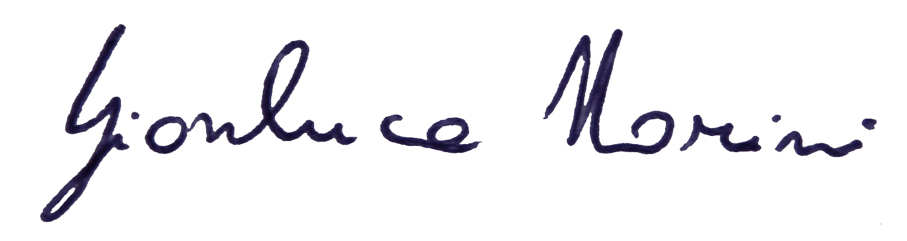
Gianluca Norini

---------------------
Dr. Gianluca Norini
Centro de Geociencias
Universidad Nacional Autónoma de México
Campus Juriquilla-UNAM
Querétaro, Qro. 76230 – MEXICO
Teléfono: 238-1104 Ext. 108
Correo electrónico: norini@geociencias.unam.mx
ANALOGUE MODELING OF VOLCANO-BASEMENT INTERACTION
To gain insights about the evolution of the stratovolcanoes, the geological and structural data from the field were applied to construct a brittle-analogue model of a cone made of granular material on a sheared basal layer. The movement vector is at an angle relative to the long dimension of the basal plate, and a transtensive motion is generated mimicking that of the faults which deforms Colima and Jocotitlan (Figure 1). The experimental apparatus consists of a basal plate attached to a vertical side plate that in turn is fastened to a screw jack. Rotation of the screw, controlled by computer, induces movement of the basal plate. Both the cone and substrate were made of stratified layers, alternately dyed in contrasting colors, consisting of the identical mixture of two sizes (0-70 and 70-200 μm) of dry quartzose granular sand. This mixture has an angle of internal friction (Φ) of ~30° and cohesion (C) of ~25 Pa. Resting on the base plate, the substrate for the cone was simulated with a 3.5 cm thick layer of the mixture with plan dimensions of 50 x 40 cm. The experiments were photographed to record the structures that developed during progressive transtensive movement. Completed experiments were wetted and then sliced parallel and perpendicular to the fault strike, to reveal the structures within the cone in three dimensions as seen in deformations of the colored layers.

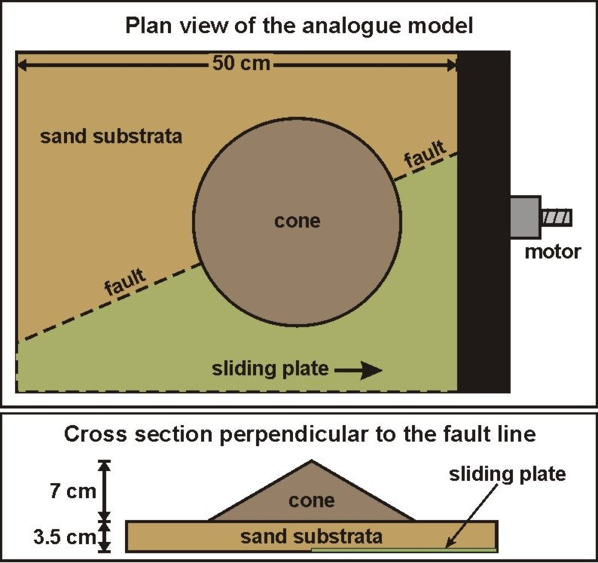
Figure 1: Schematic plan view and cross section of the analogue model, showing the substrate layer of sand and cone which represent volcanic edifice.

Model Scaling
Model parameters have to be geometrically, kinematically and dynamically scaled in order to ensure similarities between natural prototype and experimental results (Hubbert, 1937; Ramberg, 1981; Galland et al., 2006). The main forces to consider for correct scaling are body forces due to gravity, and stresses. The dimensionless ratio between body forces and stresses can be defined:

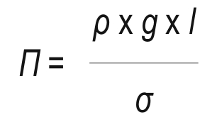

where ρ is the rock density, g is the gravity, l is the linear dimension and σ is the tectonic stress. The ratio Π must be similar in nature and in the model for the scaling of the analogue experiment to be correct. Therefore, the stress ratio (σ*) between model and nature can be calculated from:

σ* ≈ ρ* x g* x l*

where ρ* is the density ratio, g* is the gravity ratio and l* is the length ratio between model and nature. The experiments were conducted in the Earth's field of gravity; consequently the model/nature ratio for the gravitational acceleration (g*) was unity. The length ratio, which is on the order of 10⁻⁵ – 10⁻⁴, varies with the model dimension and can be used to fit the required stress ratio considering the density of the analogue material. The height of the volcanic cone is about 2000 m in nature. The experimental cone was 7-8 cm high and the resulting length ratio (l*) was 4 x 10⁻⁵ (geometric scale 1:25,000). The rocks in a composite volcano include high density mafic lavas and pyroclastic deposits of very low density (Bellotti et al., 2004), and so the mean density is difficult to estimate. An andesitic-dacitic stratovolcano reasonably similar in dimension, composition and eruptive style is Mount St. Helens (Lipman and Mullineaux, 1981), for which a mean density of 2.15 g/cm³ was calculated using geophysical methods (Williams et al., 1987). The sand used in the analogue experiments has a density of 1.4 g/cm³ and so the density ratio (ρ*) was 0.65. Therefore, the dimensionless stress ratio (ρ*) between the brittle analogue model and natural protothypes was about 2.6 x 10⁻⁵, meaning that the model was about 38,000 times weaker than its natural counterpart. For the rocks of the volcanic edifice, we assume a linear Mohr-Coulomb failure criterion, where the parameters are the cohesion C and the angle of internal friction Φ (Byerlee, 1978). For competent volcanic rocks the cohesion is in the order of 10⁷ – 10⁸ Pa and the angle of internal friction is ~ 30°-35°, but for incompetent rocks the cohesion can be more than two orders of magnitude smaller (Schellart, 2000). Stratovolcanoes of the Trans-Mexican Volcanic Belt are primarily altered and a faulted/fractured volcanic edifices composed of alternating lava and unconsolidated volcaniclastic deposits (Capra and Macías, 2000; Bellotti et al., 2004), and so the cohesion we assumed was 10⁶ Pa. As the cohesion has the dimension of stress, the ratio for cohesion C* is in the same range as ρ*. In our experiments C* must be scaled at about 2.6 x 10⁻⁵ to be equal to the stress ratio ρ*. This requires the use of a material with C ≈ 26 Pa, which fits the properties of the granular material we used to simulate the volcanic edifice (C ≈ 25 Pa, Φ ≈ 30°). The fault velocity in the experiments was 1 cm/h and the total amount of displacement was 2 cm. Considering the geometric scale of the analogue model (1:25,000), the equivalent fault displacement in nature was 500 m. The mean slope of the natural protothypes is about 10°-15°, but we chose to build the analogue cones at the ~30° maximum angle of repose in order to introduce an incipient instability in it. As demonstrated previously (Norini and Lagmay, 2005), this was necessary because the very low mass of the collapsing sector in analogue models implies that the correct scaling is valid for the structural analysis, but it became less accurate in the analysis of the collapse event. In practice, the mass of the analogue cone is much too small for gravitational pull to induce enough acceleration to simulate the flow of debris avalanches. Also, the steep flanks and the consequent higher mass of the cone slightly improves the correct scale of the model, with better reproduction of the effect of volcanic edifice load both on the volcano itself and on the basement.

Modeling Results
Five experiments were conducted in which a cone was subjected to basal left-lateral transtension. Boundary conditions, materials, and displacement rates were the same in all the experiments, and the results invariably show the same structures in terms of geometry and kinematics. Thus we state that the analogue modeling is repeatable. In the experiments after 3-4 mm of basal plate movement fractures and faults developed in the cone and basement above the underlying shear, seen both in plan views and cross-sections. The deformation in each experimental analogue cone and its substrate was confined to a narrow graben on its surface, bounded by faults parallel to the basal shear (Figure 2).

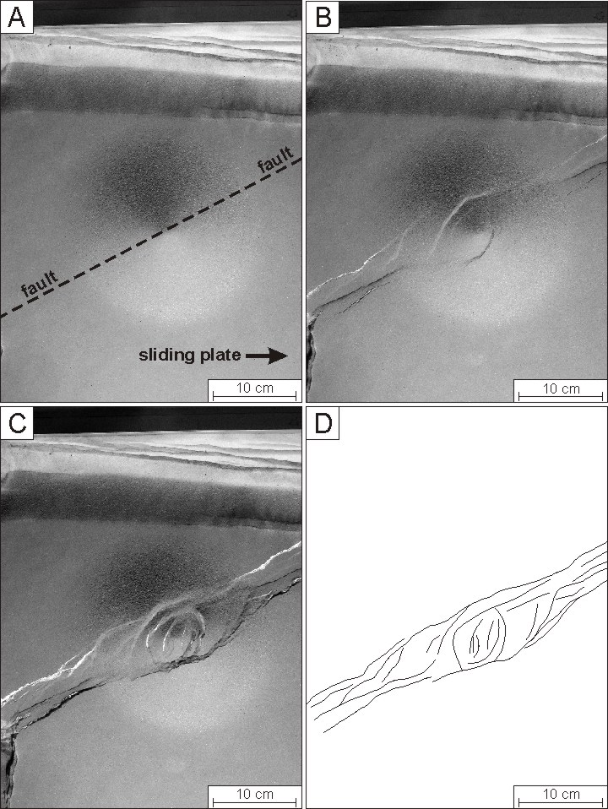
Figure 2: Stages of surface deformation of an analogue cone which is sheared at its base by a left-lateral oblique-slip fault.
In the basement, two sets of faults and minor fractures developed inside the graben, one oriented parallel to the basal shear, the other about 20°-40° from the main oblique-slip fault line direction. The structures at an angle relative to the basal shear are interpreted as R shears and T fractures, structural terms given to faults characteristic of, but not limited to, strike-slip faulting (Wilcox et al., 1973). As the cone was progressively deformed, the graben consistently bounded unstable areas, which were characterized by a complex set of evolving faults and fractures. At about 1 cm of basal displacement some curvilinear faults and fractures at an angle of ~30° with respect to the main graben boundary developed on the upper flanks of the cone and caused its summit to subside. Between 1 and 2 cm of basal faulting, these curvilinear faults rotated counter-clockwise to become perpendicular to the main shear. All the structures on the cone flanks and summit ended sharply at the graben boundary (Figure 2). Cone instability was promoted by the normal high angle faults perpendicular to the basal shear confined to the graben and directed toward the cone periphery; thus, sector collapses of the analogue cone were sub-parallel to the main shear. Orientations of fault and fracture sets developed on the analogue cone were analyzed from rose diagrams. At the model scale, the main azimuth direction of faults and fractures is about 115° and sub-parallel to the basal shear. In the summit area of the model cone, several structural trends became apparent. Rose diagrams depict four fracture trends at the summit of the cone, with azimuth directions of 15°, 45°, 80°, and 115°. The azimuth 80° and azimuth 115° fractures closely follow the first deformation step and are formed only after 3-4 mm of basal shear. The 15° and 45° trends were last to form and developed after 1 cm of displacement (Figure 2). In terms of internal structure, the basement outside the cone periphery exhibits high-angle faults that displace marker levels. These structures form a narrow graben. Similar faults affect the basement beneath the cone flanks and throughout the cone up to the surface. Beneath the cone summit, several sub-vertical faults displace marker levels in the cone interior and basement, causing the upper part of the cone to subside (Figure 3).

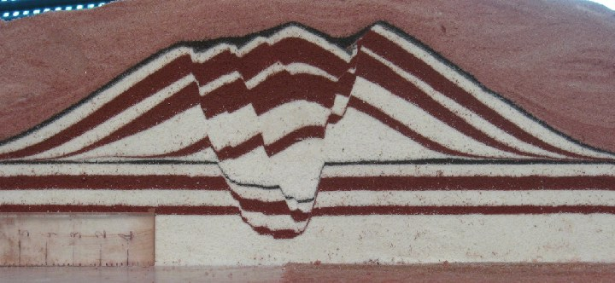
Figure 3: Vertical cross sections of a deformed analogue cone cut perpendicular to the basal shear.

NUMERICAL SIMULATION OF DEBRIS AVALANCHES FLOWS
Analogue modeling disclosed incipient instability of the volcanic cones in response to basement faulting and possible directions of lateral collapses. These failures have the potential to generate devastating debris avalanches flows, and better knowledge of invasion areas is definitively needed. Numerical simulation of this type of granular flows gives great benefits in the reduction of risk, providing reliable simulations of the flow paths, and was performed on a well known natural example to asses its usefulness in delineating the inundated areas in case of flank failure.

Methods
Different models have been proposed to explain the high mobility of granular flows and how the energy dissipates during flowage. The relationship between drop height and maximum runout, expressed as the H/L factor, describes their mobility, which generally increases as the mass augments (Hsu, 1975; Dade and Hupper, 1998). The numerical code we used to simulate the volcanic gravitational failures is Titan2D, a modeling algorithm developed for simulating granular avalanches and landslides on DEMs. Titan2D assumes continuum deformable volume parcels that are driven downslope by gravity and has proved to be particularly suitable for simulating such type of flows on real topography, with excellent reproducibility of the results (Patra et al., 2005). The parameters needed to produce a simulation are volume of the collapsed mass, basal friction angle, internal friction angle, and initial velocity. Values used for the basal friction angle were determined on the basis of the H/L factor of observed debris avalanche deposits, and compared with values used for similar flows in previous works (i.e. Rupp et al., 2005; Capra et al., 2008). The internal friction angle plays a minor role in such a small granular flow (Hutter et al., 1995) and was set on the base of the experimental results by Rupp et al. (2005). The initial velocity was set to 0 m/s for debris avalanche-like granular flows. The output of the simulations consists of time series of raster files showing flow thickness and speed during flowage.

Numerical simulation results
To simulate debris avalanche flows, we calibrated the simulation parameters for TITAN2D considering the El Zaguán and Arroyo Grande debris avalanche deposits of Nevado de Toluca volcano as prototypes. We choose the Arroyo Grande deposit to reconstruct the paleotopography and perform simulations to exactly reproduce its extent. In fact, debris avalanche deposits are capable of completely changing the topography, making it impossible to simulate past flows over actual DEMs. The paleotopography of the Arroyo Grande gully was restored by eliminating the thickness of the Arroyo Grande deposit, as measured in several stratigraphic sections, after which simulations with the TITAN2D routine were performed. The best-fit H/L was 0.14, from which a basal friction angle of ~ 8˚ was extrapolated. Simulations gave reliable results, with flows moving about 9 km from the source, and stayed confined into the valley where thicknesses of 100 m are observed on the proximal area (Figure 4). The simulations suggests that for such low-volume (~0.3 km3) granular flows, the traveled distance does not depend strictly on the mass volume, as previously generalized by other authors for large rock-falls (Dade and Hupper, 1998). TITAN2D was also used to simulate debris avalanche flows on others ravines, where known deposits crop out (Figure 4), giving similar results between simulated outputs and observed deposits. Considering that past sector collapses of Nevado de Toluca volcano where towards the NW, NE, and E, as the volcano responses to the geometry and kinematics of the active basement faults (Norini et al., 2006), the most feasible sector collapse directions will be from the east to the northwest with invasion areas up to 9 km from the crater area.

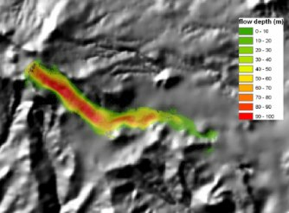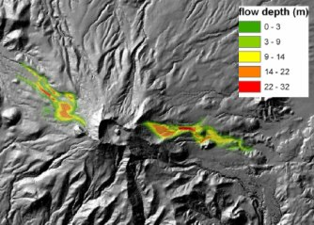
Figure 4: Image showing computer simulations of debris avalanches.

Il fruitore del soggiorno di ricerca Il proponente italiano
Dr. Gianluca Norini Dr. Pietro Mario Rossi
--------------------- ---------------------
Centro de Geociencias CNR-IDPA
Universidad Nacional Autónoma de México Via Mangiagalli, 34
Campus Juriquilla-UNAM 20133 - Milano
Querétaro, Qro. 76230 ITALIA
MEXICO

