Programma CNR/Università/Istituzioni scientifiche pubbliche italiane

ed Istituzioni di ricerca straniere: mobilità di breve durata

(Short-Term Mobility - anno 2007)

REPORT ON

“Photoionization experiments on plume produced by laser ablation of CdS”

“Esperimenti di fotoionizzazione su plume prodotta per ablazione laser di CdS”

The scope of my stay was to collaborate with researchers of CNR-IMIP in optimizing an experimental instrumentation with the aim to study the composition and dynamics of laser ablated plumes using synchrotron radiation light and a Time of Flight (TOF) mass spectrometer. Thanks to the experience gained in my Institute in Spain (CSIC-Instituto Rocasolano), I have been able to contribute to the optimization of the building of the equipment and to define the best tests in order to verify the efficiency of the whole system.
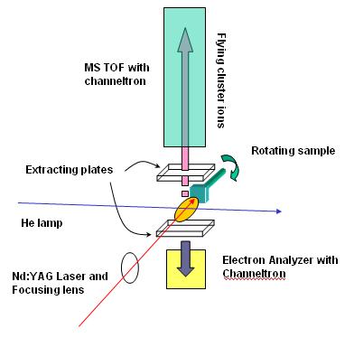
Figure 1. Set-up
The experimental apparatus is being assembled at Elettra, Trieste, in view of future experiments with synchrotron radiation. Since synchrotron beam time is precious in terms of both time and availability, we have planned test for all the components of our set-up and, in particular, a new Time of Flight (TOF) mass spectrometer with a He lamp. For our experiment, the He lamp worked as a continuous ionizing source of particles in the plume, mimicking the synchrotron radiation photon flux. The ablation of the sample was carried out using 10 ns pulses from the 4th harmonic (266 nm) of a Nd:Yag laser (Quanta System, mod.Handy 710, http://www.quantasystem.com/pdfenit/Handy.pdf).

EXPERIMENTAL
Figure 1 shows schematically the organization of our set-up which consisted of:
- He lamp to ionize the particles in the plume,
- TOF mass spectrometer to collect ions,
- Electron analyzer (EA) for coincidence experiments,
- Rotating 3D manipulator for the sample,
- Entrance window for the laser pulses,
- Pumps and vacuum gauges to control pressure (pressure limit < 1x10⁻⁷ mbar; during ablation at 10Hz P< 5x10⁻⁶ mbar)

It is important to note that the experimental station has also the possibility to include the instrumentation for absorption and optical emission spectroscopy.

The challenge of our study was to obtain a resolved TOF mass spectrum of species ionized at different times after the ablation. For that, we had to avoid the interference of the initial ions created in the ablation and to be able to collect only the particles ionized at a specific time from all the ions constantly created by the He lamp. Two different work schemes were implemented.

Coincidence scheme
The first approach was to use an electron-ion coincidence configuration in which at a determined time after the ablation, an electron was selected to start the mass acquisition routine. Under certain electron-ion production rates and after several acquisition cycles, this procedure would yield the desired mass spectrum.

To set-up the coincidence electronics we used Xe gas which was ionized by the He lamp. The TOF spectrometer voltages (Detector (-HV), Drift tube (-HV), Focal stage (-HV), Extracting plate (-HV) and Repelling plate (+HV)) and the Electron Analyzed voltages (Extracting (+HV), First mesh (+HV), Cup (+HV), Detector front / rear (+HV)) were set to work in counting mode (every particle is a pulse) and to provide an electron-ion ratio detection of 10/1 (5x10⁵ electrons per second, 5x10⁴ ions per second). Once we obtained the Xe mass spectrum, we moved on to the ablation of a Cu sample. In this case, we observed that the amount of electrons produced in the ablation was so high that we were unable to obtain a consistent mass spectrum. Additionally the burst of electron produced during ablation made the detector reach its saturation limit and, thus, we decided to stop trying with the EA and focused on our second option.

Pulsed extraction scheme
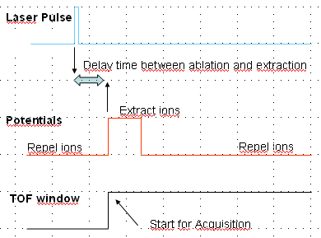
Figure 2. Temporal scheme of the pulsed extraction configuration
The second approach to obtain a TOF mass spectrum was to pulse the extraction fields. A constant repelling potential was applied to remove all unwanted ions which was pulsed for collection only when required (see figure 2). The first tests were again performed using Xe and the He lamp. With short extracting pulses (τ ≈1.2μs), which triggered the TOF acquisition, we were able to obtain a reproducible mass spectrum. In the case of the ablation of CdS pellets, the potentials used were those of a pure TOF (Detector = -2500 V, Drift tube = 0 V, Focal stage = 1600 V, Extracting plate = 1600 V and Repelling plate = 0 V for removal of ions and 2500 V for collection of ions).

Unfortunately, the obtained mass spectra were difficult to interpret (figure 3). The reasons were that:
- Initial ions produced during the ablation were not eliminated completely and contaminated our mass spectra. Simulations showed that, for the used repelling potentials, all the initial ions should have been removed in the first 4 μs after the ablation but we detected them even without triggering the extraction. The hypothesis that those ions came from CdS particles deposited on the extracting grid (so they were not affected by the repelling voltages) took shape when, after dismounting the chamber, we saw deposits of CdS on different parts of the TOF.
- In order to see signal from the species ionized by the He lamp we had to use long extracting pulses (4 μs) which affected badly the TOF mass resolution.
- The size of the interaction between particles and ionization source was also crucial and the He lamp was not properly collimated. Simulations predicted that ions created in the centre and in the proximity of the extracting plate would show a very different flight times (from 1μs in S to 2,5μs in Cd₂).
- The pulsing of the potentials produced a long noisy oscillation in the TOF signal (several μs) which deformed the initial part of the mass spectra.

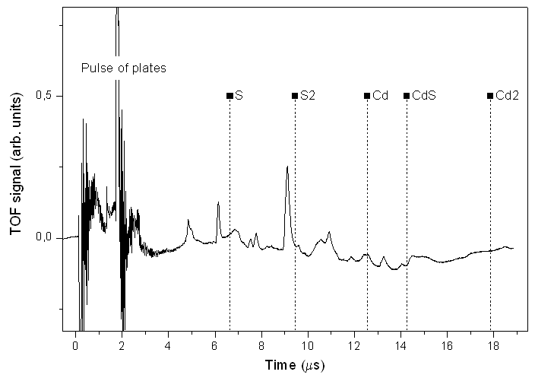
Figure 2. TOF mass spectrum of ablated CdS. The initial perturbations correspond to the extracting pulse (triggered 3 μs after ablation; duration of 1,6 μs). Dots represent the position of particles according to simulations.

CONCLUSIONS
Although we could not achieve our aim of collecting a good resolved mass spectrum from plasma ablated material with a continuous source of VUV ionizing radiation, we consider that these experimental tests have been extremely useful. They have let us draw quite important conclusions to improve our set-up in view of further experiments:

- The removal and extraction of ions has to be done as fast and efficiently as possible to improve mass spectrum resolution. Thus, the smaller the distance between plates and the higher the potentials between plates, the better. This has made us to re-design our TOF so that the distance between repelling and extracting plates is reduced from 30 mm to 15mm. The voltage difference between repelling and extracting plates will be set to the maximum our instrumentation allows (i.e. 3000 V). Under these new conditions, simulations have been already carried out which show that masses up to 228 a.m.u. should be extracted ten times faster (0,4 μs) than in this reported tests. This time window is quite convenient since it did match the minimum pulse width obtainable with our HV switch (some 300ns).
- The holes in the first two plates of the TOF (repelling and accelerator) will be reduced to about 15mm, in order to have a better defined extraction area for the ions and further improve rejection of native ions.
- The mesh from the extracting plate will be removed to avoid deposition of particles on it, so we expect an almost negligible background from initial ions produced in the ablation.
- The pulsing of the potentials will be un-coupled from the TOF signal to eliminate the observed oscillations.

Finally in further work which we are planning in the year 2008, we will also reconsider the initial idea of adopting a Quadruple Mass Spectrometer for ion detection. TOF-MS is in principle more efficient than Q-MS in synchrotron radiation experiments, since it allows collection of all produced ions in snapshot mode, whereas Q-MS must be used in scanning mode, being highly time consuming when a wide mass spectral range must be explored. On the other end in our proposed experiment the removal of native ions from the laser generated plume appears the hardest obstacle to be overcome and the use of a time correlation technique coupled to Q-MS ion detection appears a convenient alternative route that avoids the use of HV pulses that conversely degrade resolution of Ion TOF MS.

Acknowledgements

Our team acknowledges CNR for funding my stay under the 2007 Short Term Mobility project.
We also thank the “Laboratorio Getti Molecolari of University of Milan and the Elettra Storage Ring Free Electron Laser group of Sincrotrone Trieste ScpA for letting us use their laser and optical set up for the ablation project. Finally, we acknowledge Gilio Sandrin, Luca Romanzin and Christian Leghissa from the technical workshop of Sincrotrone Trieste ScpA for their continuous assistance in the assembly of the experimental set-up.

