REPORT ON THE VISIT OF PROFESSOR P. HODGE TO THE RESEARCH GROUP OF Dr P. STAGNARO AT ISMAC CNR, GENOVA

(i) Timing
PH left the UK on 29th October 2007 and left Genova for the UK on 8th November 2007.

(ii) Aims of the visit
We have collaborated on several projects for 2 – 3 years starting with Dr Paola Stagnaro’s 3-week visit to Manchester, supported by a STM, in 2005. Whilst in Manchester Paola learned the skills required for working with entropically-driven ring-opening polymerizations (ED-ROPs). She then returned with these skills to Genova. The Aim of the present visit was for Professor Hodge and Drs Paola Stagnaro, Giovanna Costa and Lucia Conzatti, to review our joint work based on ED-ROPs, identifying areas where papers can be written and what needs to be done to complete them.

(iii) Background
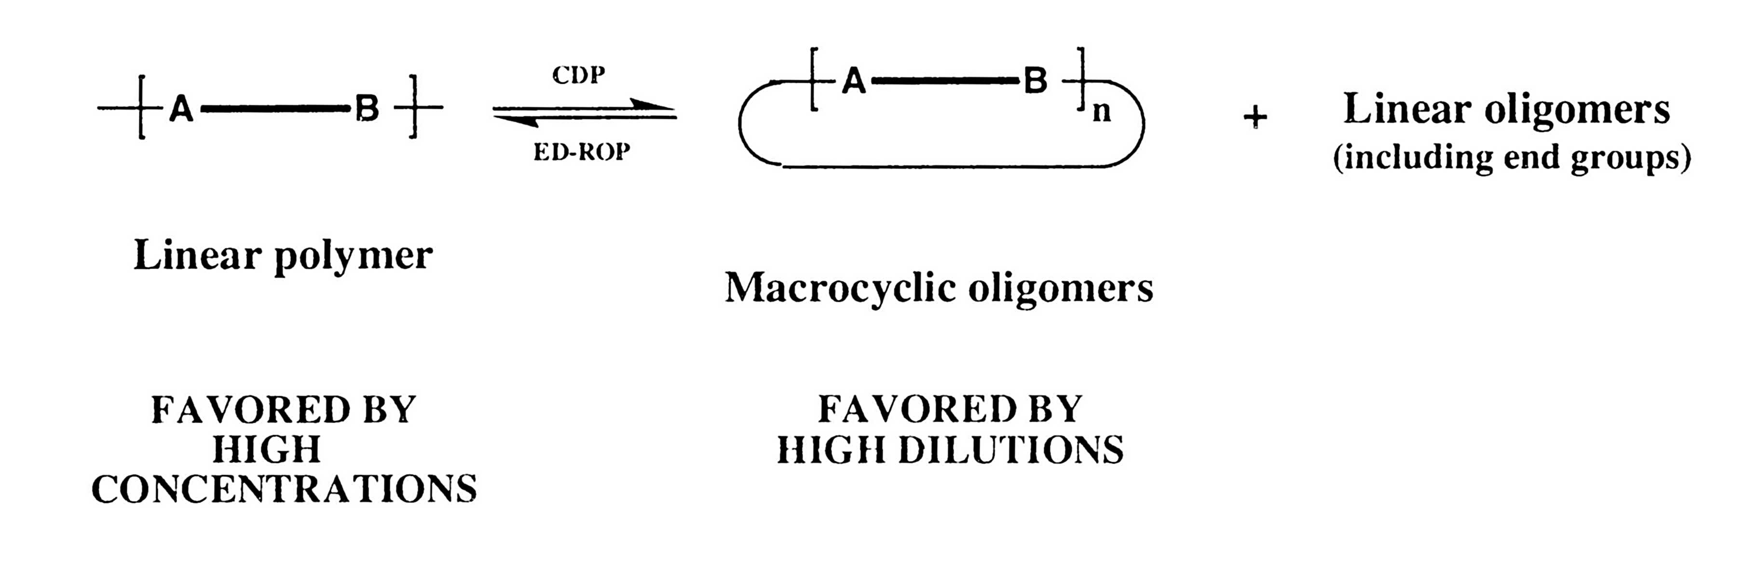
The various projects all exploit ED-ROPs. This relatively new type of polymerization exploits the classical ring:chain equilibria, i.e. the equilibria that, in the presence of a suitable catalyst, exist between a condensation polymer and the corresponding family of macrocycles (MCOs): see Scheme 1. The positions of the equilibria are very

sensitive to the concentration. As a consequence, if MCOs are taken at high concentration and equilibrium established, polymerization occurs. In this polymerization no heat is evolved and no volatiles, so that it is a green method. The reverse reaction, cyclo-depolymerization (CDP), is often a convenient method to obtain small quantities of the MCOs.

(iv) Specific projects

(a) High throughput (HT) synthesis of copolyesters
HT methods are currently of considerable interest because they allow research to be accelerated. Through our joint work we have developed an HT method for rapidly synthesizing 100mg quantities of copolyesters. No more laboratory work is needed on this project. Whilst in Genoa an initial draft of a paper was revised to the point where PH can now expect to submit it for publication in the next few weeks.

(b) Identification of a novel crystalline form in poly(ethylene terephthalate) (PET)/poly(trimethylene terephthalate) (PTT) copolymers
The Genova group have suspected for some time that a novel crystalline form exists in PET/ PTT 50:50-copolymers. This might allow two commercial materials to be turned into a useful new material. Using ED-ROP, a range of copolymers of PET and PTT were prepared rapidly. Their thermal properties were evaluated. A novel crystal form has been detected and further X-ray investigations are now in progress. Some more laboratory work is needed before the Genova group draft a paper on this subject.

(c) The effect of MCOs on PET, PTT and PBT properties.

The effect of MCOs on the melt viscosity properties of PET, PTT and PBT are being investigated. Initial results show that the melt viscosities of the polymers are significantly lowered by the presence of the MCOs. This may afford a new method for processing polyesters, i.e. fabricate items more easily with MCOs present, then after fabrication carry out ED-ROP of the MCOs. Since no volatiles are emitted in ED-ROPs no voids are created in the final material. Some more laboratory work is needed before the Manchester group draft a paper on this subject.

(d) Nanocomposites from clays.

We have met with some success in attempts to prepare nanocomposites by intercalating MCOs into clays then polymerizing the MCOs. However, other research groups have done similar work, albeit using different polymers, and it is now felt we should not pursue this approach further. Interesting new ideas for improved approaches to these composites were, however, discussed. We will all think about these ideas in depth before carrying out further laboratory work.

(v) The future

PH will return to Genova next Spring/Summer so that we can evaluate progress and work towards publishing further joint articles.

