Relazione Scientifica

Programma Short Term Mobility 2008

Methods for virtual environments design and their multimodal description to help blind users to access complex information

Dott. Fabio De Felice, ISSIA-CNR

Proponente: dott. GIOVANNI ATTOLICO Primo Ricercatore dell’Istituto di Studi sui Sistemi Intelligenti per l’Automazione di Bari
Fruitore: dott. FABIO DE FELICE, Assegnista di Ricerca presso dell’Istituto di Studi sui Sistemi Intelligenti per l’Automazione di Bari
Istituzione Straniera Ospitante: CERTEC research group, Department of Design Sciences at Lund Univerity's Faculty of Engineeing, Lund, Sweden.
Periodo trascorso presso l’Istituzione Straniera: dal 1 Settembre ’08 al 22 Settembre’08.

The research activity has been carried out under the supervision of prof. Charotte Magnusson Associate professor at CERTEC research group.
A first phase has been concerned with the comparison and the evaluation of the applications developed both the labs (at ISSIA-CNR and at CERTEC group) and with methods and results related to experimentation with visual impaired users. In a first meeting the research activity carried out at ISSIA-CNR has been presented; focus has been devoted to the description of applications related to main applicative domains such as Cultural Heritage and geographical maps. The tests conducted with visual blind users, in collaboration with Italian National Blind Association, shown how the system realized, called Omero, can act has a valid complementary tool for learning real environments and for acquire knowledge about spatial data such as maps. Analogous applications has been developed and tested at the CERTEC, especially in the field of assisted map exploration for blind mobility. This research has been done during two European Projects called Enabled and Micole.
These experiences lead to confirm how close are the research interests of both institutes in the field of multimodal exploration of spatial data in order to enhance the autonomy of blind people in real environment navigation and learning tasks. Another common hot topic emerged from the meeting is the design and development of virtual environments and of their rendering to visual impaired by means of haptic/acoustic displays.
Even if focused on the same themes, the approaches followed by the two labs show a substantial difference: while CERTEC is much more focused on design issues about usability and on analysing user feedbacks in particular interaction tasks, at ISSIA-CNR the research addressed architectural topics, developing a unique multimodal framework, OMERO, aimed at define a general purpose tool that could integrate various interaction techniques in a meaningful system behaviour. Therefore issues of architecture integration, software engineering choices and device (haptic/graphic/acoustic/…) independence has been considered.
This substantial difference between the approaches pointed out the short term objectives to be carried out during the second phase of the research activity: the integration of haptic/visual scaling and dragging techniques developed and tested at the CERTEC in the OMERO framework architecture.
The OMERO framework can be considered from two point of views: a high level architecture that loads the virtual scene and its relative multimodal description, integrate these information and initializes the interaction features, and a low level architecture that initializes the modal channels (haptics/graphics/acoustics/…) and integrates their interactions in a uniform behaviour. In this context the scaling and dragging functions can be considered inherently useful to virtual navigation of virtual worlds larger than the limited physical haptic workspace, simplifying the dexterity needed to reach some portions of the scene. Therefore it has been decided to integrate these functions as native features of the system independent from the particular virtual world at hand.
The scaling function developed at CERTEC performed the scale always with respect to the user probe position to prevent the user from being confused by uncontrolled movement of the scene, keeping a meaningful reference to the mental schema of the world. The same type of scaling is done even when the user is not in contact with the world, Prof. Magnusson reported how this resulted in user disorientation especially with people with a certain degree of vision. For this reason the scaling integrated in OMERO scales with respect to the user positions only when (s)he is in contact with the world, otherwise the scale is with respect to the centre.
Two dragging modalities have been developed at CERTEC. In the first the virtual world follows the movement of the haptic probe, allowing the user to drag the world by moving the haptic device stylus just as a sighted person would do with the mouse. The other mode exploits the containment-box that delimits the touchable portion of the virtual world, whose area depends on the dimensions of the physical workspace of the haptic device. By pushing against the box the user can virtually shift it to new portions of the world (actually the virtual world scrolls inside the containment box). Whenever the user push on a wall the world is scrolled, in the wall direction, inside the box with a pre-determined shift. The same modalities has been integrated in OMERO with some differences concerning the box modality. To avoid an accidental scene displacement, to drag the world the user must clicks the stylus button when (s)he is contact with the wall. A second difference concerns the way the box is shifted, it continue to shift along the touched wall direction as long as the user remain in contact with the wall an keep the button stylus pushed. A sound of a sliding rock outlines the dragging operation in both the modalities.
The modalities has been tested on a virtual model of the plant of Castel Del Monte, as it is shown in the following figures:
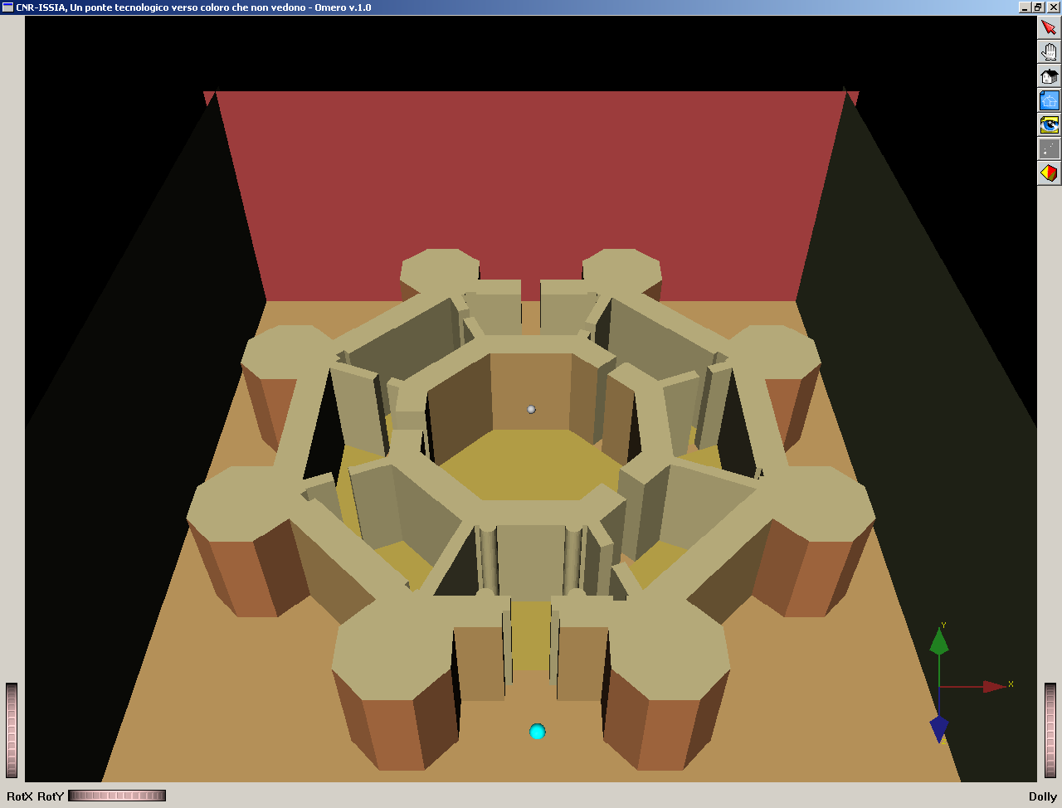

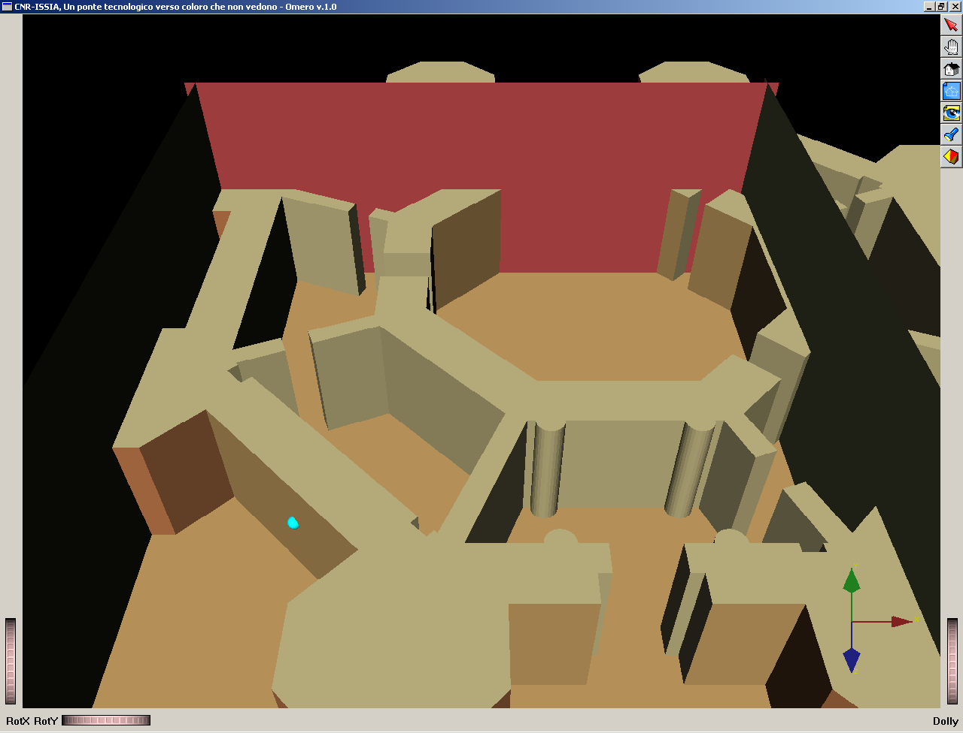
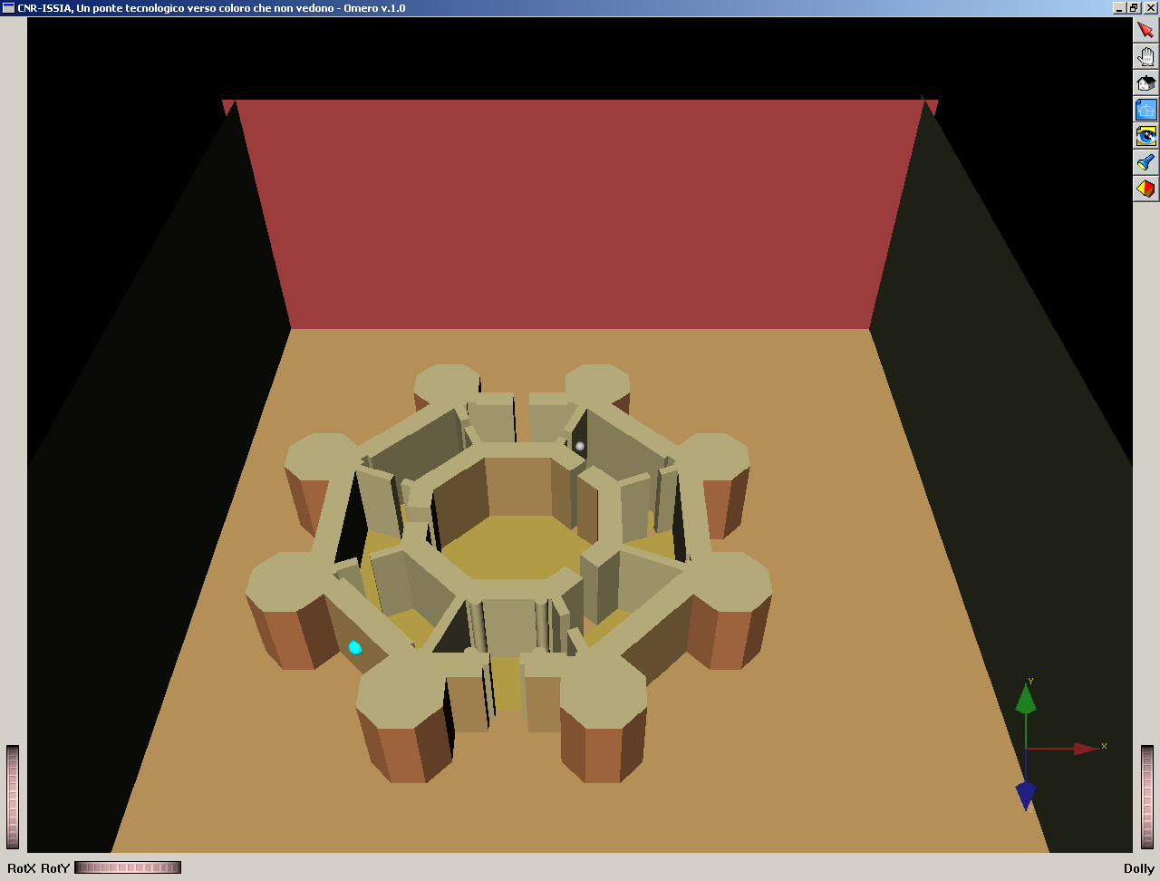
Figure 1. The initial virtual scene, the light blue sphere at the bottom represents the user avatar.

Figure 2. The scaling operation with respect to the probe position

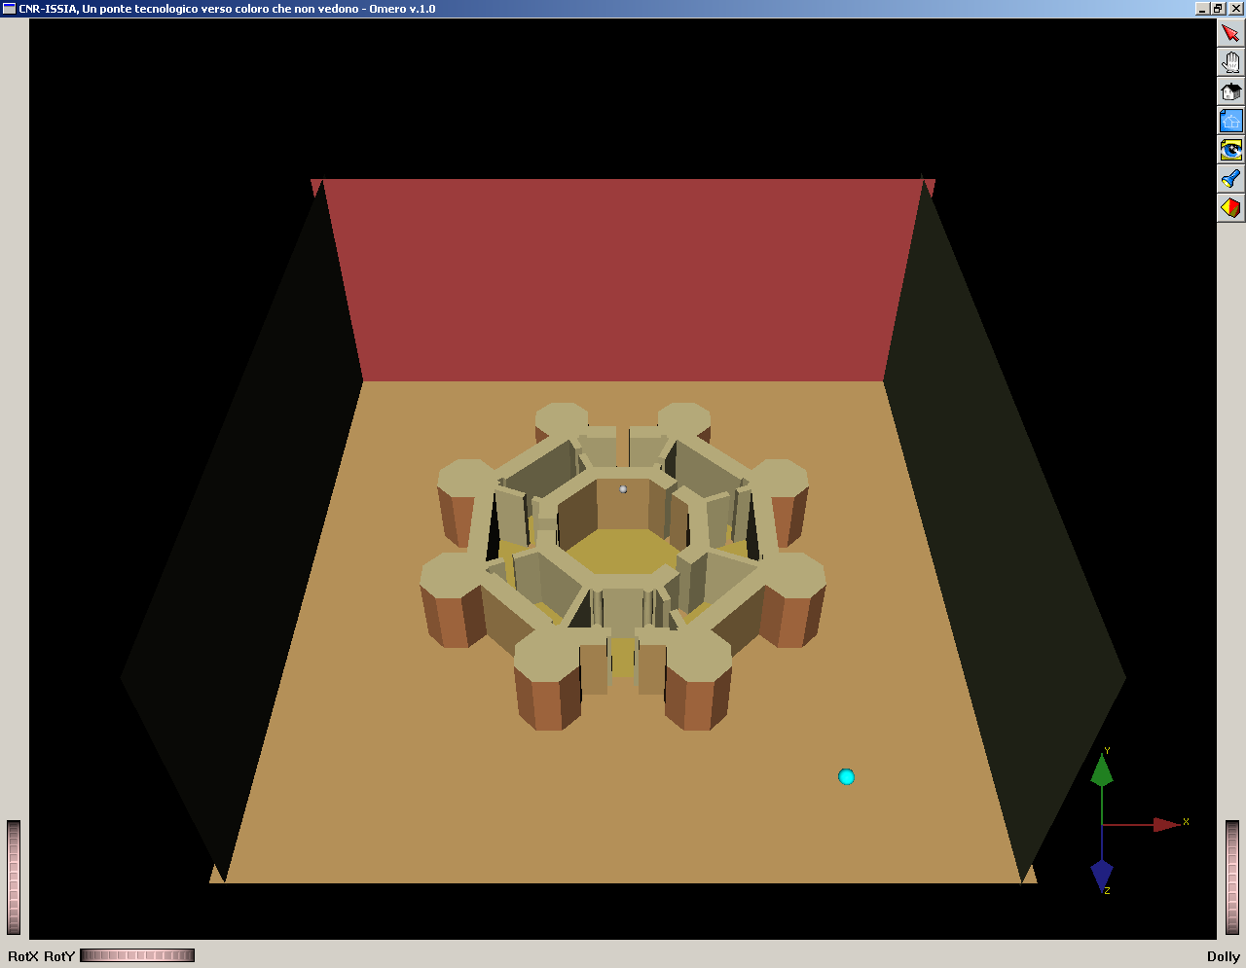
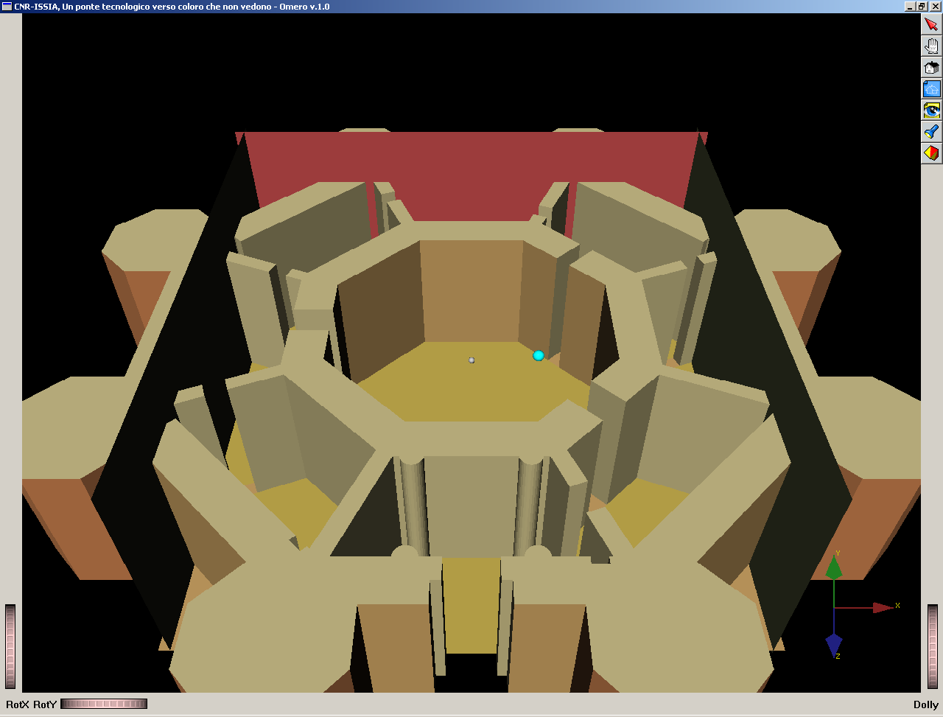
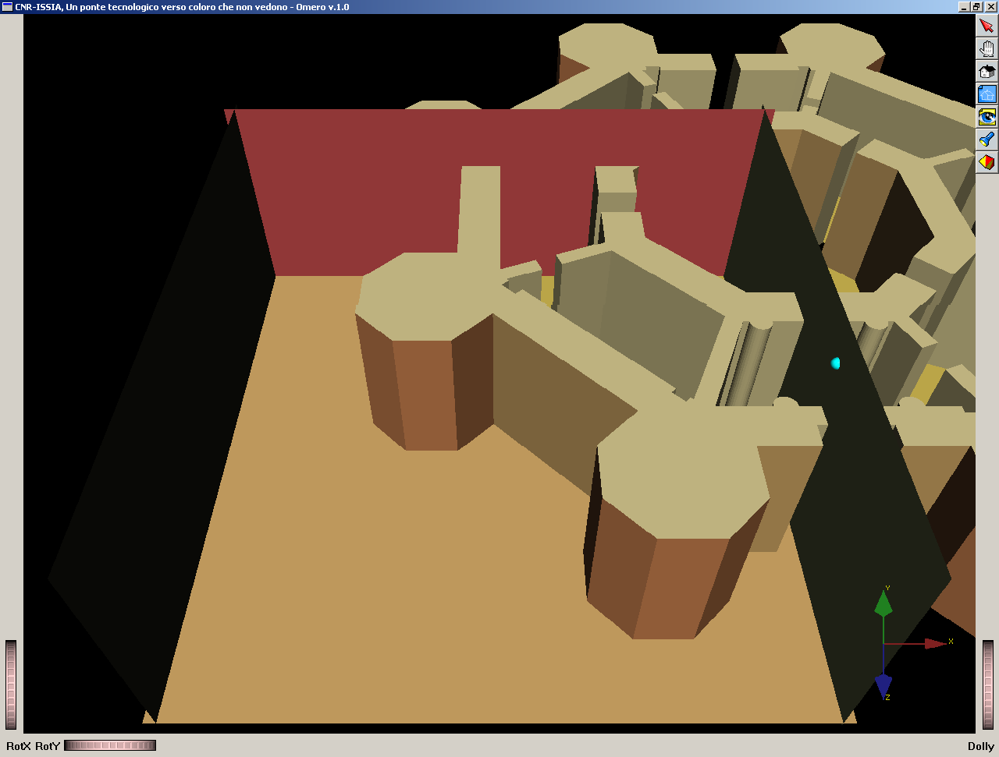
Figure 3. The scaling operation with respect to the centre.

Figure 4. The dragging operation. In the figure on the left the model is shifting from the right to the left following the probe movements. In the figure on the right the same dragging is accomplished by pushing against the right wall of the containment box and clicking the stylus button.

The third phase of the research activity concerned the definition of a long term collaboration between the two groups. Since the effort in the creation of complex virtual scenes is noticeable, the role of scene organization and integration with multimodal interaction is crucial. Making the virtual world authoring faster and easier is desirable and twofold useful: there is an increasing demand from the blind community for this type of experiences with more complex world. Moreover, it can enable domain experts, that are not experts in building interactive 3D virtual worlds, to expresses knowledge about their domain in a interactive 3D form augmenting the number of material that can be loaded and experienced with these type of systems. For this reason a first objective is the development of a visual editor to enhance the initial 3D virtual scene with multimodal features (haptic\acoustic effects, dynamic behaviours, … ) and to give an authoring tool to domain experts. A second long term objective is to test the modified scaling\dragging features with Italian visual impaired users in order to compare their feedback to those reported in [1] by Magnusson.

References:
[1] “Non-visual Zoom and Scrolling Operations in a Virtual Haptic Environment” C. Magnusson, K. Rassmus-Grhon. In proceedings of the third edition of EuroHaptics, 6th and 9th of July 2003, Dublin.

