Short – term mobility (2007)

RELAZIONE FINALE

Proposal of Dr Alessandro Venturini for a Collaborative Project on:

SAR STUDIES ON PUTATIVE INHIBITORS OF GLYCOGEN PHOSPHORYLASE VIA THEORETICAL STUDIES, COMBINATORIAL SYNTHESIS, ENZYME KINETICS AND PROTEIN CRYSTALLOGRAPHY

Research Partners:
Theoretical Studies: Dr Alessandro Venturini, ISOF, CNR, Bologna
Synthesis: Prof. Thanasis Gimisis, Chem Dept, UoA, Athens
Combinatorial Solid Phase: Prof. Nikos Ferderigos, Chem Dept., UoA, Athens
Kinetics & Crystallography: Dr Nikos Oikonomakos, IOPC, NHRF, Athens

During the Short-term mobility period, a collaboration has been initiated in the following lines of research:

- Studies on the mechanism of inhibition of various inhibitors of glycogen phosphorylase via molecular dynamics methods.

- Study of energy profiles of the ring contraction intermediates in the photolysis reaction of thymidine tatrazoles, putative inhibitors of glycogen phosphorylase.

- Theoretical study of the isomerization between closed and open forms of oxidative DNA damage products of thymidine (dihydrols, hydantoins) characterized by protein crystallography and independent synthesis.

a) A molecular approach that aims at the reduction of excessive glucose production from the liver in the case of type 2 diabetes,[1] involves the inhibition of glycogen phosphorylase (GP), a key enzyme in carbohydrate metabolism with great importance in the breakdown of glycogen reserves. The GP tertiary and quaternary structure has been determined via X-ray crystallography and the catalytic, allosteric and inhibitory regions, through which the enzyme action is expressed, have been determined (Figure 1). Glucose is a physiological regulator of hepatic glycogen metabolism that promotes inactivation of GP and acts synergistically with insulin, leading to reduced glycogen degradation and enhanced glycogen synthesis. (for a more detailed introduction see the corresponding short-term mobility proposal).
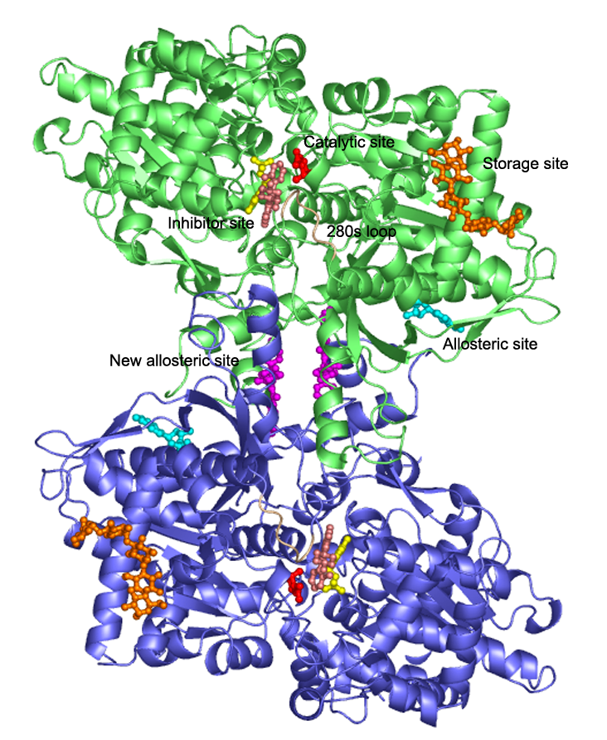
Figure 1. Glycogen Phosphorylase (GPb)

In this collaborative project, we have combined combinatorial techniques for fast synthetic access to a variety of β-D-glucopyranosyl peptides with theoretical calculations based on well-established molecular dynamics methods. [2] Our building blocks in both synthetic and theoretical studies will be mono-, di- and tri-peptides containing natural amino acids (Scheme 1).

Scheme 1

These derivatives have the advantages of (i) easy synthetic access through solid phase synthesis; (ii) great variety of functionality available for catalytic site interactions; (iii) high compatibility with the functional environment of the catalytic site which is based on the same raw material (amino acids); (iv) an expected high biocompatibility that renders these derivatives probable drug candidates.
Empirical force fields and molecular dynamics (MD) studies will be combined to define, within the binding pocket of the catalytic site, the favorable interactions of the various amino acid side chains of the guest glucopeptides with the surrounding enzyme functionality with the aim to elucidate the mechanism of imhibition.
A stochastic boundary simulation system was used for the protein–ligand complexes. It consists of the catalytic site region of one monomer of GP, one ligand molecule, and explicit water molecules. Initial protein heavy atom coordinates were taken from the crystal structure of the protein–hydan complex, determined at 2.36 Å resolution at a temperature of 300 K (accession code: 1GGN). An approximately spherical region was selected. The model included the water molecules that were visible in the crystal structure and additional water molecules were placed by overlaying a preequilibrated 24 Å sphere. The final protein–hydan complex model consists of more that 4000 atoms. All calculations were performed with the NAMD program.[3] Atomic charges, van der Waals, and force field parameters for the protein were taken from the CHARMM27 all-atom parameter set. The water molecules were represented by a modified TIP3P model. The strength of the restraining potentials was adjusted to reproduce atomic fluctuations, consistent with the crystallographic B-factors. The water was subjected to a stochastic boundary potential. The lengths of bonds containing hydrogens and the internal geometry of the water molecules was constrained with the SHAKE algorithm,as implemented in NAMD.

- Since 2005, our laboratory (University of Athen) has reported that the β-D-glucopyranozyl-analogues of natural nucleosides are inhibitors of glycogen phosphorylase. This fact creates the possibility of studying such compounds with protein crystallography, utilizing the “soaking method”, which does not require crystallization of the sample. The first aim of the present work, was to expand the application of this methodology in modified analogues of these natural nucleoside adducts and to establish it as a dynamic technique for easy crystallographic structure elucidation of small heterocycles. The photosensitive compound of 1-(β-D-glucopyranozyl)-tetrazolo pyrimidine was selected as an ideal system to study, in order to achieve this objective.
The synthesis of the later was accomplished trough a three step procedure, with 30 % total yield. (Scheme 2) This compound was photolysed leading directly to its β-D-glucopyranozyl-photoproducts, which belonged to the group of base expanded nucleosides. These compounds, apart from the significant synthetic and biological interest they exhibit as potential pharmaceutical substances, constitute in the same time new substrates of glycogen pho9sphorylase which can be studied crystallographically. This aim of the present work was successfully fulfilled. Furthermore, the crystallographic assignment of one of the photoproducts has led to an alternate structure proposed where theoretical calculations will be used to elucidate the mechanism. (Scheme 3)

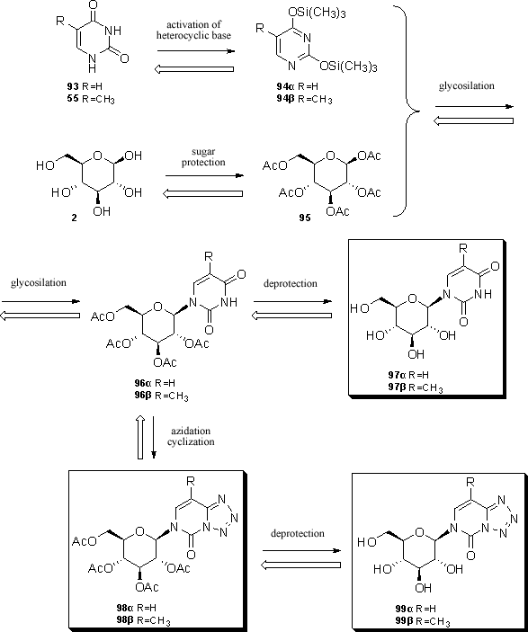

Scheme 2: General synthetic procedure – retrosynthetic analysis of tetrazolo-pyrimidines

- The third aim of this work was the structural characterization of the ozonolysis products of 1-(β-D-glucopyranozyl)-thymidine with spectroscopy and protein crystallography, as an application of the soaking method on a natural system with biological importance. The natural deoxy-ribonucleoside of thymine constitutes the most sensitive residue towards oxidation damage, when the macromolecule of DNA is subjected to low ozone concentrations. The complexity of systems concerning oxidative DNA damage, frequently renders their spectroscopic study, insufficient for structure elucidation of the oxidative products. In addition, the inherent instability of the lesions, makes the independent synthesis of the proposed structures difficult and time consuming. Thus, a convenient tool for crystallographic study of such compounds, which will provide structural information without the necessity of crystallization, is indisputably of great interest. The synthesis of 1-(β-D-glucopyranozyl)-thymidine with total yield 80 %, was followed by photolysis in solution and chromatographic purification of the oxidative products. For the oxidative products isolated in pure form, the methodology has worked and the electron density maps acquired, have revealed the three dimensional structure of the compounds.
As a conclusion, this methodology appears general enough to aid the structural elucidation of various small heterocycles and constitutes a structure assignment tool.

In both b) and c) lines of research, the task of the theoretical calculations will be to validate and yield further insight on the mechanism, product conformation and product stability of the reactions. All the calculations will be carried out at the B3LYP theory level using the Gaussian 03 program. The geometries will be fully optimized with gradient techniques and the final structures will be checked by frequency analysis. Moreover Gibbs free energy calculated. Preliminary calculations suggest that Intermediate 116 is the more stable product. (Scheme 3)

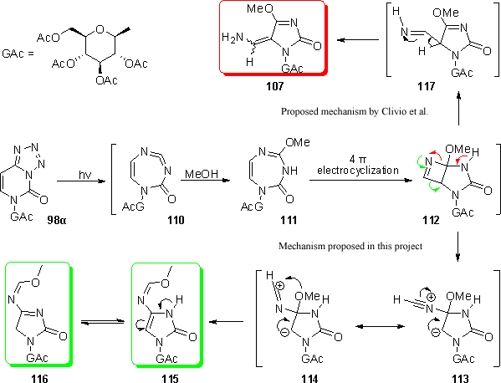

Scheme 3: Ring contraction photolysis.

References
[1]. S. Ross, E. A. Gulve, M. Wan Chem. Rev., 104, 1255-1282, (2004).
[2]. Brooks, B. R.; Bruccoleri, R. E.; Olafson, B. D.; States, D. J.; Swaminathan, S.; M. Karplus, M. J. Comput. Chem., 1983, 4, 187-217. (b) Foloppe, N.; MacKerell Jr., A. D. J. Comput. Chem., 2000, 21, 86-104. (c) Banavali, N.; MacKerell Jr., A. D. J. Comput. Chem., 2000, 21, 105-120.
[3] J. C. Phillips, R. Braun, W. Wang, J. Gumbart, E. Tajkhorshid, E. Villa, C. Chipot, R. D. Skeel, L. Kale and K. Schulten. Scalable molecular dynamics with NAMD. Journal of Computational chemistry, 26:1781-1802, 2005.

Il fruitore Il proponente

Dott. Alessandro Venturini Dott.ssa Giovanna Barbarella

