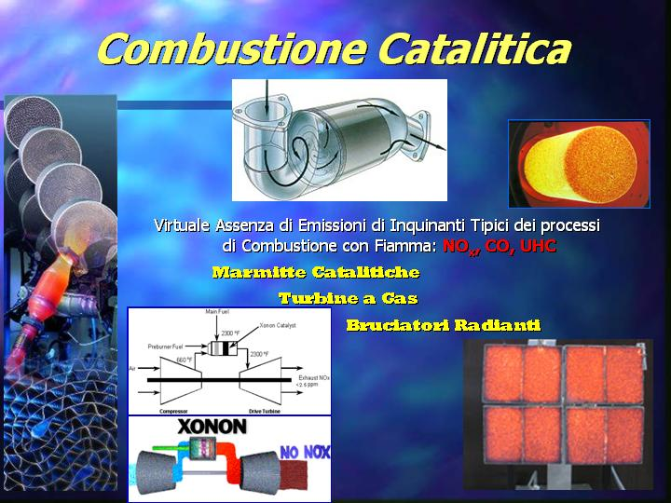

Fig. 1 Main advantages and applications of catalytic combustion.

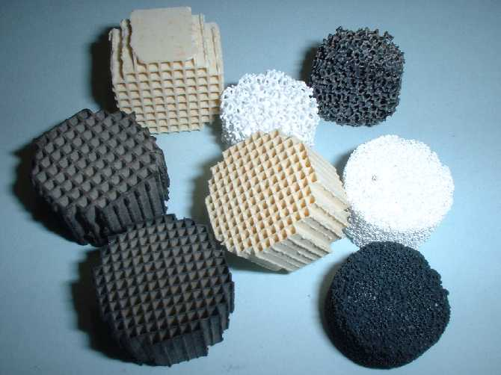

Fig. 2 Structured honeycomb and foam catalysts based on supported LaMnO₃ perovskite for high temperature oxidation of natural gas and light hydrocarbons.

