CNR – Overview of Activities at UNOC 2025

🗓 Key Dates & Events

June 5th – GAIA BLU Open Day & Project Presentations

Location: Port of Nice, Quai Amiral Infernet

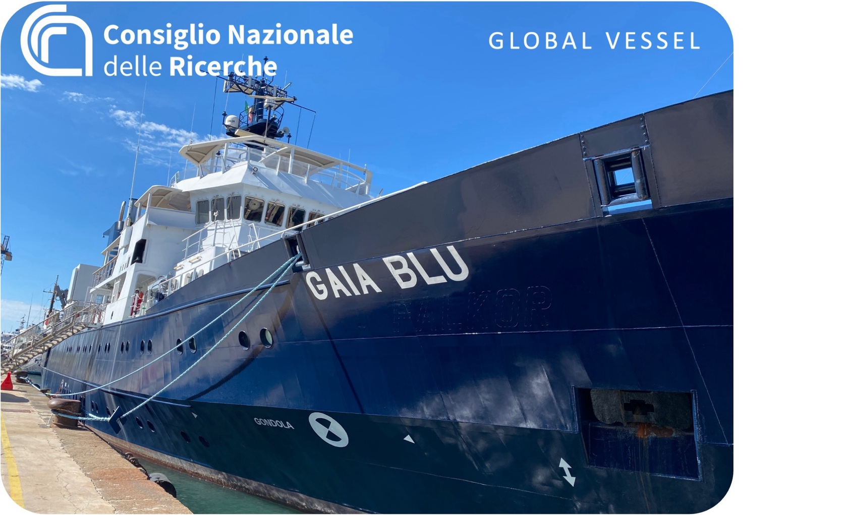
A day dedicated to exploring the ship's potential and showcasing leading-edge research and scientific projects in the Mediterranean sea’s initiatives. Activities will be conducted in small groups, with rotating 2-hour sessions for a maximum of 25 participants per slot.

Please register for your session here

10:30– 12:30
Morning Session: Ship Tour & Flagship Project Presentations
- Guided tour of the ship, with a focus on its technological capabilities and operational functions.
- Presentations of key scientific activities, including:
  - Marine Geology & Habitat Mapping
  - Coastal and Deep-Sea Ecosystem Restoration
  - Oceanographic Monitoring Systems
  - Marine Biodiversity Conservation
  - Management of Biological Resources
  - Italian Biodiversity Gateway Digital Portal
- Discussion on Innovation and future pathways.
- Networking & Aperitif
Limited to 25 participants – reservation required.

14:30 – 16:30
Afternoon session: Ship Tour & Flagship Project Presentations
- Guided tour of the ship, with a focus on its technological capabilities and operational functions.
- Presentations of key CNR scientific activities, including:
  - Marine Geology & Habitat Mapping
  - Coastal and Deep-Sea Ecosystem Restoration
  - Oceanographic Monitoring Systems
  - Marine Biodiversity Conservation
  - Management of Biological Resources
  - Italian Biodiversity Gateway Digital Portal
  - CNR Capacity Development (Women in Blue)
- Discussion on Innovation and future pathways.
- Networking & Coffee
Limited to 25 participants – reservation required.

17:30 – 19.30
Evening session: Ship Tour & Flagship Project Presentations and Networking
- Guided tour of the ship, with a focus on its technological capabilities and operational functions.
- Presentations of key CNR scientific activities, including:
  - Marine Geology & Habitat Mapping
  - Coastal and Deep-Sea Ecosystem Restoration
  - Oceanographic Monitoring Systems
  - Marine Biodiversity Conservation
  - Management of Biological Resources
  - Italian Biodiversity Gateway Digital Portal
  - Mediterranean Governance and EU Mission Ocean and Waters
  - The ITINERIS Infrastructure National HUB
- Innovation and future pathways.
- Networking & Aperitif
Limited to 25 participants – reservation required.

Events We Participate In as organisors, speakers or contributors
- 3 June – “Our Ocean Science 2025” (Nice)
Fantina Madricardo (CNR-ISMAR) will speak at the opening session, reporting on CNR and BlueMissionMed activities.

Beyond Borders Pavilion – 2 to 13 June
Title: Beyond Borders: Ocean Futures, Learning and Protecting Together
Location: La Baleine, Green Zone – UNESCO–CNR–OFB Pavilion (300m² shared space)
- CNR-ISMAR participates as part of the Biodiversity Gateway.
- BlueMissionMed will be featured with:
  - Exhibitions
  - Dialogue Sessions
  - Continuous Networking
  - Outreach and Ocean Literacy Content

🔹

BlueMissionMed Event in the Pavilion – la Baleine
- 06 June (10:00–11:30) – “Mediterranean in Action: Engaging Communities and Advancing Solutions to Tackle Pollution under the Mission Ocean and Waters”
Organized by BlueMissionMed, CNR DSSTTA Coordinated projec. Focus: actionable knowledge, innovation uptake, and community engagement. Link to programme here
Interviene il Direttore DSSTTA Francesco Petracchini e Fedra Francocci, coordinatrice BlueMissionMed project

UNOC High-Level Week | 9–13 June
- 11 June (morning) – “Navigating Toward A 2030 Clean And Resilient Mediterranean”
- WHEN: 11 June 2025, 9.30am – 11.00am
- WHERE: Onboard WWF Blue Panda Boat, UNOC, Nice
In the special Port Lympia area – access for accredited delegates. https://bluemissionmed.eu/join-bluemissionmed-and-wwf-onboard-of-the-wwf-blue-panda-boat-at-unoc/
Interviene il Direttore DSSTTA Francesco Petracchini e Fedra Francocci, coordinatrice BlueMissionMed project

🔹

Workshops in the Blue Zone
- 11 June (15:45–17:00) – Room 1
BlueMissionMed Co-hosted Workshop with MUR, MASE, and SBEP:
“Sharing Effective Lessons and Case Studies in the Mediterranean: From Regional to Global”
(Participation of CNR DSSTTA Director Francesco Petracchini and Fedra Francocci Coordinator BlueMissionMed project)
🔗 Event Link (MUR)
- 11 June (morning) – AMEC High-Level Event
Organized by LSB and co-hosted by BlueMissionMed. https://lasaisonbleue.com/cooperation-afrique-mediterranee-europe/
Interviene Fedra Francocci, CNR DSSTTA Coordinatrice BlueMissionMed project

