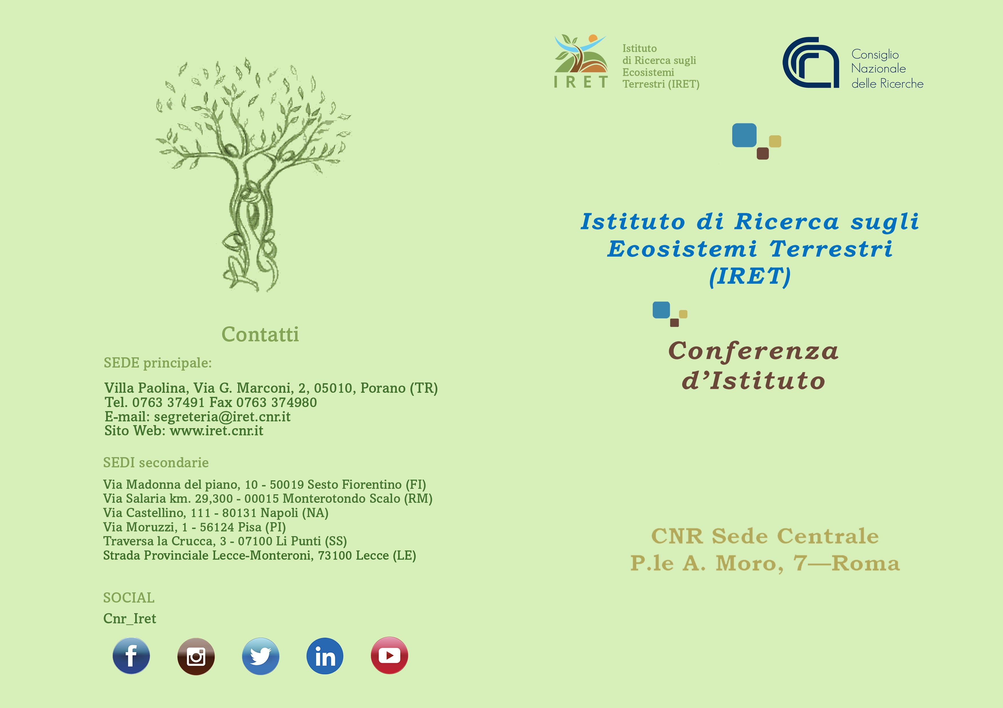

8 e 9 settembre 2022

Programma

# 8 settembre

Aula Convegni

|  |  |  |  |
| --- | --- | --- | --- |
| 10:00  10:30 | **Caffè di benvenuto** Saluti  MARIA CHIARA CARROZZA, *Presidente CNR*  FABIO TRINCARDI, *Direttore DSSTTA*  CARLO CALFAPIETRA, *Direttore IRET* | 15:30 | *Sustainable management of ecosystems (forestry, agroforestry, agriculture, urban areas, socio-ecology, nature-based solutions, green infrastructures)* Senior: **PIERLUIGI PARIS**; Junior: **OLGA GAVRICHKOVA**, **GIOVANNI TRENTANOVI, BRUNO DE CINTI** Discussione |
| 11:00 | Moderatrice presentazioni linee tematiche della mattina: ELENA PAOLETTI *Biodiversity at gene, population, species, community level (taxonomy, evolution, gene and data banks)* Senior: **TIZIANA DI LORENZO**; Junior: **PAOLA POLLEGIONI**, **FABIO CIANFERONI** Discussione | 16:00 | *Climate change and ecosystems (monitoring, impacts, mitigation, adaptation, forest resilience, decarbonization)* Senior: **ALESSIO GIOVANNELLI**; Junior: **ETTORE D’ANDREA** Discussione |
|  | | 16:30 | COFFEE BREAK |
| 11:30 | *Ecological processes and interactions (spatial ecology, remote sensing, modelling, environmental pressure, animal ecology, forest ecology)* Senior: **MAURIZIO SARTI**; Junior: **FRANCESCA CHIOCCHINI, FRANCESCO COZZOLI** Discussione | 17:00 | *Circular economy (green economy, bioactive molecules, agrifood wastes valorization, green chemistry)* Senior: **ALESSANDRA MORANA, LOREDANA MARCOLONGO**; Junior: **ILENIA DE LUCA, DAVIDE MANZI, GIUSEPPE SQUILLACI** Discussione |
| 12:00 | *Pollution and contamination of ecosystems (monitoring, impacts, emerging contaminants, mitigation and restoration strategies for soil, sediments and water)* Senior: **MASSIMO ZACCHINI**; Junior: **LAURA PASSATORE** Discussione | 17:30  18:00  18:30 | *Environment and human health (genetic, epigenetic and metabolic effects)*Senior: **FILOMENA ANNA DIGILIO**, **ANNA CALARCO**; Junior: **MAURO FINICELLI, ANNA VALENTINO**Discussione  Conclusioni  ***FINE LAVORI*** |
| 12:30 | *Soil health and resilience (nutrient cycling, C dynamics and sequestration, soil-plant system, mitigation)* Senior: **LUIGI PAOLO D'ACQUI, GRAZIA MASCIANDARO**; Junior: **FRANCESCA VANNUCCHI** Discussione |  | 9 settembre Aula Convegni |
| 13:00  14:30 | ***PAUSA PRANZO***  Moderatore presentazioni linee tematiche del pomeriggio: ROBERTO PINI  *Biodiversity and ecosystem conservation (conservation priorities, strategies and planning, natural, forest and agroecosystems, biological invasion impacts)* Senior: **FRANCESCA BRETZEL**; Junior: **FRANCESCO DE LEO, EMILIANO MORI** Discussione | 9:45  10:00  10:20  10:40 | **Caffè di benvenuto**  Introduzione 1: PNRR NBFC: **CARLO CALFAPIETRA** Introduzione 2: PNRR Infrastrutture – ITINERIS: **ELENA PAOLETTI** Tavola rotonda – Moderatore **ALBERTO BASSET**  Intervento dei principali referenti delle attività di ricerca:NBFC, Spoke 4 - Solar Dome: **FABRIZIO PIETRINI**NBFC, Spoke 5 - **GABRIELE GUIDOLOTTI**NBFC, |
| 15:00 | *Experimental plant sciences (physiology, biochemistry and genetics, biotic and abiotic stresses, agrospace, biofortification, environmental biotechnology and bioprocesses)* Senior: **ALBERTO BATTISTELLI**; Junior: **VIRGINIE MURIEL GAUDET, SILVIA TRAVERSARI** Discussione | 13:00 | Spoke 6 - **GIANFRANCO PELUSO**NBFC, Spoke 7 - **FRANCESCA BRETZEL**CN AGRITECH – **ALESSANDRA MORANA** Discussione ***FINE LAVORI*** |