**LIVE WEB STREAMING EVENT - SAVE THE DATE AND FOLLOW US!  
  
What’s new in nanoscience and nanotechnology?   
Get your free access to the widest arsenal of cutting-edge methods and tools. Don’t miss out!**

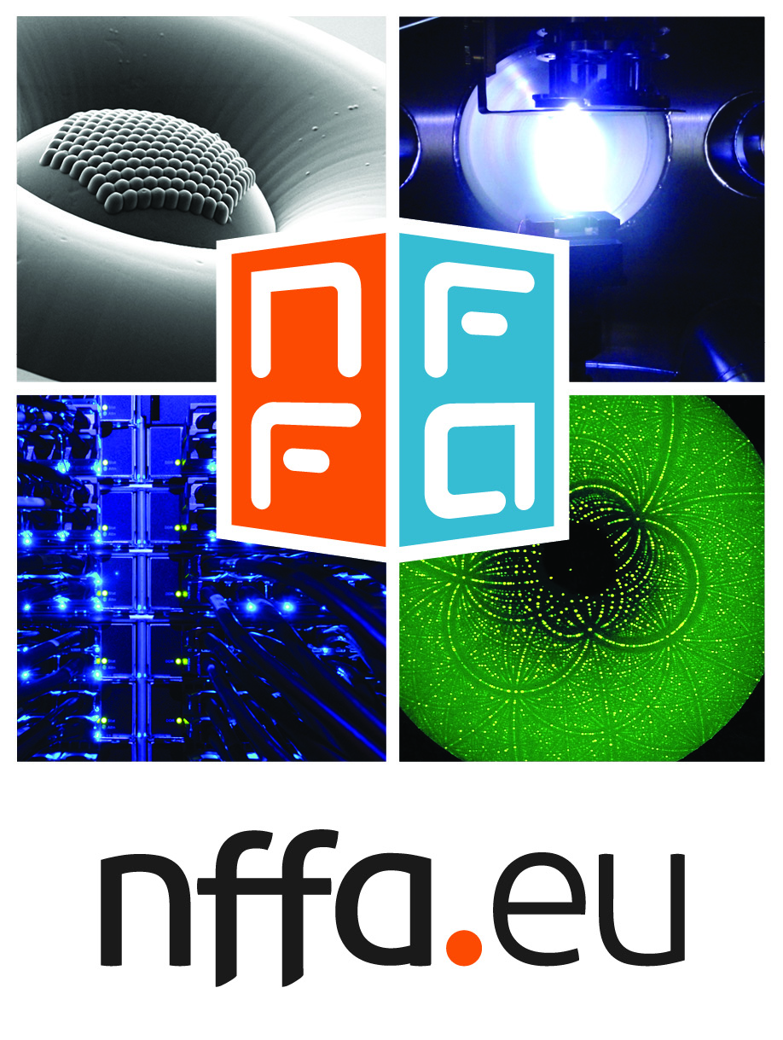

Download Hi-Res image   
[www.nffa.eu/imgNFFA.jpg](http://www.nffa.eu/imgNFFA.jpg)  
Image credits: CNR-IOM, DESY, ANL.gov

A gamut of unique opportunities for academic and industrial research at the nanoscale will be presented at the kick off meeting of the EU funded project NFFA-Europe, the first integrated, distributed research infrastructure for multidisciplinary nanoscience research.

Follow us in live streaming on [www.nffa.eu](http://www.nffa.eu) on 12th April at 9.00 am

The international team of NFFA-Europe, a research infrastructure funded by the European Commission under the Horizon 2020 Programme, will convene in Milano, Italy, **on 12th April**, to mark the start of operation of  **the first full suite of key infrastructures for nanoscience research to the public**.

The European scientific and industrial communities of potential users and other stakeholders will be given the chance to learn about and discuss the NFFA-Europe infrastructure and its innovation network**, the unique integrated opportunities of nanoscience foundries and fine analysis**, as well as how to apply. To maximise the spread of this information and the impact of this launching event, a general presentation and highlight talks will also be **streamed live on the web**.

Nanoscience research and innovation for the design and engineering of functional smart materials is critical for modern high technology products in a circular economy, and has an increasing weight in many sectors of the EU economy. But **access to the underlying enabling nanotechnologies and characterisation is missing for a broad community of actors**. The need to have access to many knowledge- and capital-intensive infrastructures is one of the hurdles impairing research at the nanoscale on the fundamental properties of matter, or the design and engineering of functional nanosystems. Indeed, these infrastructures enable key steps in the creation and smart deployment of advanced nanomaterials, such as the control of their synthesis, the nano-characterisation of their properties and the advanced research on their dynamic and functional behaviour. **From integrated circuits and microchips, to energy conversion and storage, to the design, growth and synthesis of novel functional materials, the tools offered by NFFA-Europe serve a broad range of applications**.

Financed by the EU Commission as an H2020 Research and Innovation Action to enhance European competitiveness in nanoscience research and innovation, NFFA-Europe will address the key bottlenecks in this process and let nanotechnology fully fulfil its promises.

How? NFFA-Europe represents the first European overarching Research Infrastructure integrating the, hereto dispersed, **capital-intensive facilities for synthesis, nanofabrication and nano-characterisation, and the large scale facilities for fine analysis of matter**. It will allow scholars and engineers from universities, government or business-oriented laboratories, to **easily and freely access advanced instrumentations, protocols and methods, for growth and synthesis, nano-lithography and nano-patterning, nano-characterisation, theory and simulation as well as fine-analysis with synchrotron, FEL and neutron radiation sources**.

20 partner institutions across Europe, including nano-foundry and nano-characterization laboratories linked to analytical large scale facilities, and an all-new theoretical distributed facility, make all of this possible.

This multi-site combination of resources provides users with a unique, integrated access. Moreover, a number of joint research activities within the NFFA-Europe consortium will be devoted to the development of new methods and tools at the frontier of nanoscience research, thereby assuring a continuous improvement of the offer.

Last but not least, **facilities will be available free of charge**, and NFFA-Europe will also support the travel and living costs for users. Scientists and industrial researchers from all regions of Europe, including those less equipped with nanoscience facilities, will strengthen their research programmes by controlling all relevant phases of their research and expand their results.

For 4 years, which is the lifetime of the funded project, it is estimated that **about 1,000 users will have the opportunity to benefit from NFFA-Europe**.

Getting access is made to be simple - only a few steps are needed through the **online Single Entry Point. Browse the catalogue of all NFFA-Europe tools and** **methods**, build and submit a personalised access programme for rapid evaluation by the international peer-review panel. During all the steps of the proposal, from experiment design to submission, final evaluation and performance, **NFFA-Europe experts will assure assistance**, thereby opening the door also to those users that are not familiar with the potential of the infrastructures and their performance.

The Italian partners are from Milano, the **Università degli Studi di Milano** offering theoretical analysis and cluster-based materials facilities, from Trieste, the **Consiglio Nazionale delle Ricerche**– **Istituto Officina dei Materiali** offering a large suite of experimental and theoretical facilities based at the TASC laboratory for materials synthesis and atomic characterization, a dedicated integrated laboratory exploiting synchrotron radiation from Elettra (trieste.nffa.eu), access to several beamlines at Elettra and to theory and nanoscale-simulation at the DEMOCRITOS center, and **Promoscience Srl**, a dynamic SME based in AREA Science Park, specialized in the development and implementation of strategies to enhance and maximize the dissemination of scientific projects. Promoscience is in charge of supporting the continuous dialogue with the various stakeholders, designing a set of communication tools for an effective dissemination strategy.

This is just a snapshot of NFFA-Europe and of what is being presented. Testimonials from the academic and industrial world will deliver keynote speeches on how advanced nanotechnology techniques and characterisation can speed up research and innovation. Among the invited speakers, John Wood (former ESFRI Chair), Rosie Hicks (CEO Australian National Fabrication Facility), Stephan Hofmann (University of Cambridge), Luca Giannini (Pirelli Tyres S.p.A.) and Luca Zanotti (STMicroelectronics SRL).

**Follow us in live streaming on** [**www.nffa.eu**](http://www.nffa.eu) **on 12th April at 9.00 am**

Project coordinator   
**prof. Giorgio Rossi**

Contacts  
[**secretariat@nffa.eu**](mailto:secretariat@nffa.eu) **| +39 040 375 6411**

**NFFA-Europe is funded by   
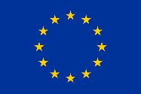**the EU's H2020 framework programme for research and innovation   
grant agreement n. 654360 from 1/9/2015 to 31/8/2019