Prot.

Ercolano, 15 Ottobre 08

Sig. ^{Ra} Rita Carbonetti

Al CNR
Direzione Generale
Paesi industrializzati-Organismi Internazionali
P.le a. Moro 7- 00185
Fax: 06 49932905
Roma

Oggetto: Relazione finale short term mobility prof. Antonio Coppola
11 settembre-5 ottobre 2008

Short Term Mobility of prof. Antonio Coppola to CAREERI-CAS – Lanzhou –China
September 11th – October 5th

Project Title
“Analysis of water and solute transport processes in soils of the Shiyang river watershed”
1. Premises
Soil salinization is a long-standing problem for irrigated agriculture in arid and semiarid regions. In the ShiYang River basin (Gansu province), the problem of soil salinization is a major concern, especially in areas with relatively shallow water tables. The water scarcity combined with a wrong water use and/or to an overuse of surface water, due also to the available irrigation systems, have determined in time an increase of groundwater abstraction, causing a decrease of groundwater level. Therefore the groundwater overexploitation and the decrease of groundwater level is a problem in the basin, with effects on the hydrological system and on the sustainability of ecosystems.
In the basin, and in general in areas with water scarcity, the overexploitation is aggravated by poor quality of underlining aquifers. The irrigated agriculture in this area has changed the dynamics of discharge and recharge to groundwater. The current water conveyance and distribution system leads to recycling of surface water through the aquifer, thus increasing solute concentration in the groundwater used for irrigation.. Salt loads of drainage water flowing back to the rivers or groundwater can considerably exceed those projected to occur from irrigation alone. Such waters obviously are an economic burden to those downward in the basin who have to use waters into which such exceeding salt loads have been disposed.
To safely use saline water in the basin, a better understanding of the water balance of the water resources is necessary to assess the sustainability of the current water management system. Regional studies of surface and groundwater and its salinization need accurate representations of water flow and salt loadings to groundwater from the overlying agricultural areas that are drained.
In this sense, we will develop a long-term strategy to minimize the volume of drainage water and dissolved salts to minimize the effects of reusing drainage water. The long-term feasibility of drainage water reuse will be evaluated by a modeling approach for water and salt transport processes, with different crop distributions, specifically developed for predictions at watershed scale. Volumes (storages) of water available at watershed scale, the distribution of salt concentration in the watershed and the economic value and acceptable yield of the crop to be grown are the main inputs to the model. The main aim is to improve irrigation management so that excess water is not applied over that needed for evapotranspiration and leaching. Through the proposed methodology, some different irrigation and drainage water management and crop sequences at watershed scale will be evaluated. Watershed management of drainage water could permit its reuse in dedicated areas to localize the impacts of use while other areas, such as up-slope areas, can be irrigated solely with better quality water.
A methodology coupling a mathematical model and modern measurement technologies will be delivered, which will allow, within a single context, to estimate evaporation and percolation losses, probable salt travel times and the evolution of groundwater resources at the watershed scale. Decision makers that need to be able to quickly assess the impact of salt build-up in soil and salt loading to groundwater resources or drainage systems will be provided with a tool for understanding the levels, distributions and patterns of salinity at watershed scale. The spatial information about soil salinity obtained with this methodology can be used to infer areas of irrigated lands where leaching rates are relatively high and where the major sources diffuse salt loading are located. Spatially referenced prediction mapping of soil salinity will be constructed based on different scenarios involving different crop distributions for delineating leaching rates and salt loading at the watershed scale.

2. Activity at the CAREERI-CAS in the period September 11th – October 5th
With these premises, the visit of Prof. Coppola is part of a larger project designed to provide scientific and practical knowledge towards sustainable use of saline water for agricultural production in the Shiyang river watershed. Salt loadings from irrigated areas in the basin through the vadose zone to groundwater will be estimated, for understanding the impact of long-term use of saline water on soil hydrological processes.
As a first step, during the visit the databases already available for the Shyiang basin has been analyzed in terms of volumes (storages) of water available at watershed scale, the spatial pattern of salt affected areas and the distribution of crops in the watershed, which will be the main inputs to the model. These referenced spatial information have been firstly used to infer areas of irrigated lands where leaching rates are relatively high and where the major sources diffuse salt loading are located.
During his visit prof. Coppola did:
- a seven days visit in the Minqin area for inspection of different representative sites of the watershed and for interviews to farmers;
- seminars at CAREERI on the methodologies to be used in the ongoing project;
- collection and study of the database already available at the CAREERI to be used to develop the water balance models for the Minquin basin;
- scientific meetings with CAREERI’s researchers to develop a Geographic Information System (GIS) to be used as a basis of a Decision Support System (DSS) to be applied in a scenario analysis framework for quantitative and qualitative predictions of the groundwater in the Minquin basin.

From the scientific meetings with the researchers of the Chinese side, the following document was developed to define the research agenda for the hydrological part of the project

3. Balancing the water budget for a sutainable agriculture in the Minqin basin
Potential evapotranspiration greatly exceeds precipitation in the Minqin basin. By not using irrigation, the quantity of water taken up by crops was limited and could not exceed precipitation. It was not until the proliferation of mechanized wells that farmers could consistently produce 2 crops (mainly wheat and corn) every year. Now, some horticultural crop is also grown (see pictures 1).

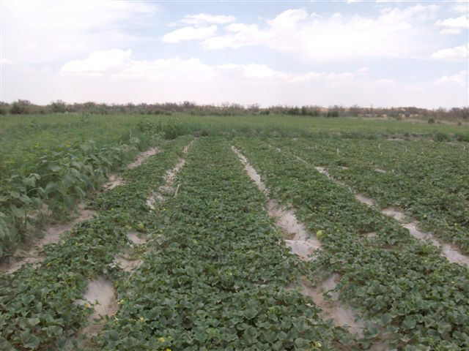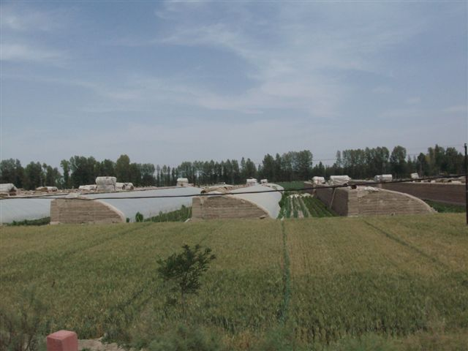

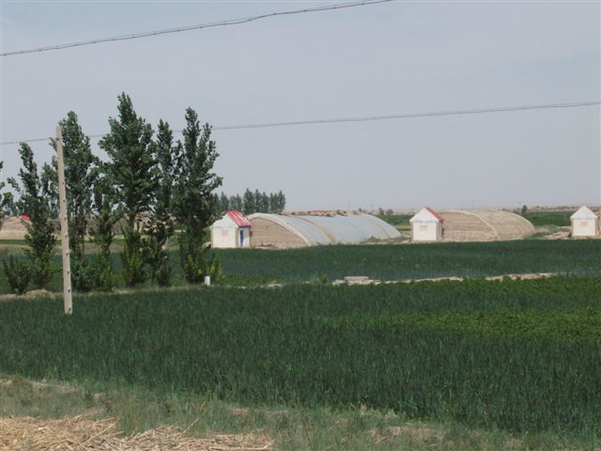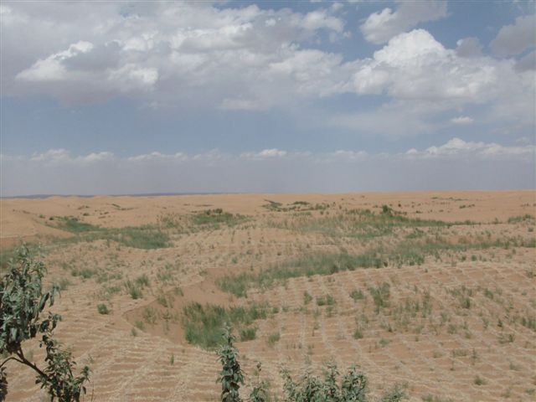

Pictures 1. Some agricultural landscapes of the Minqin basin

Reliable crop production in the Minqin basin depends on groundwater irrigation and sustainable agriculture could not exist without leaching and drainage.
The unsustainable nature of groundwater use development in the Minqin basin (already apparent in all the North China Plain) has been recognized when widespread water-table declines first were observed (60’s).
Since 60’s the depletion of groundwater has been incessant at a rate of about 1.0 m/y
Apparently, all the efforts to reverse the declines (better irrigation management) had no positive effects.
From the inspections in the Minqin basin and study of the database already available, we identified crop evapotranspiration as the single cause of groundwater depletion in the basin.
Accordingly, we calculated annual water balances for the Minqin Basin to identify the long-term hydrologic changes needed to isolate the root cause of groundwater depletion.
As a first preliminary calculation, the following water balance equation was applied to quantify hydrologic changes (see figure 1).

Inflows – Outflows = ∆S (1)
∆S= ∆Sr + ∆Sg

where ∆S, ∆Sr and ∆Sg are the change in water stored in the system, in the root zone and in the groundwater, respectively. All terms are expressed as volume/time.

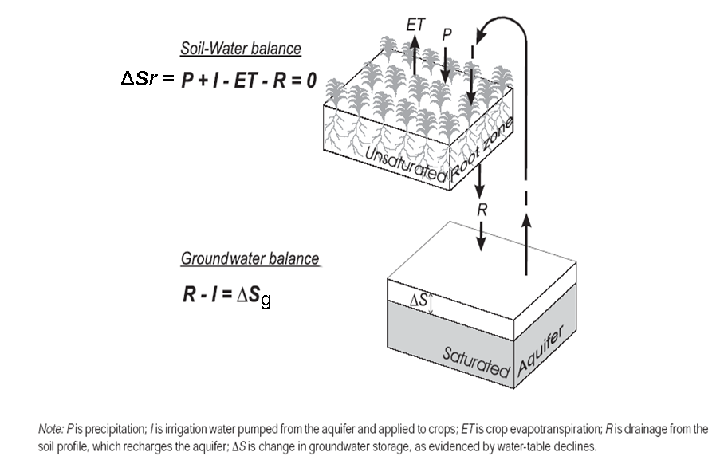
Figure 1. Main components of the hydrological budget in the Minqin basin (conceptualization)
A zone of unsaturated geologic material containing no plant roots is inferred between the top and bottom block diagrams. The thickness of the unsaturated zone has increased over time as the water table, which demarcates the surface of the saturated zone, has declined. Water flows vertically through the unsaturated zone, from the soil profile to the aquifer.
No storage changes were assumed in the unsaturated zone between the root zone and the groundwater

3.1. Root zone balance
To assess hydrologic changes in Minqin basin, we begin by examining the annual water balance of the crop root zone, or approximately the top 2 m of the soil profile. A simple soil water balance equation for the root zone of irrigated cropland is:

P + I – (ET + R) = ∆Sr, ∆Sr ≈ 0 (2)

where P is precipitation; I is irrigation water applied to crops; ET is crop evapotranspiration; R is drainage from the soil profile; and ∆S soil-moisture change, which is usually negligible over a one-year time span.
Now, consider values for these variables in Minqin basin. Average annual rainfall (P) is about 200 mm/year.
We shall assume that applied irrigation has varied significantly over time, so I will remain in variable form. The average crop assemblage in Minqin basin from 1959-2000 evapotranspired (ET) about 600 mm/year.
Rearranging the soil water balance (equation 2), we find that

R = P + I – ET = I – (ET-P) = I – (400)

That is, the amount of excess water that drains from the soil profile is always about (400) mm/year less than the amount applied as irrigation, regardless of the quantity applied.

3.2. Groundwater balance
Next, we move to a simple groundwater balance.
Ignoring all lateral inflows and outflows, a simple groundwater balance can be expressed as:

R – I = ∆Sg (3)

where R and I are defined the same as for the soil-water balance and ∆Sg is the change in groundwater volume stored in the aquifer.
Now we note that R represents not only drainage from the soil profile, but also recharge to the underlying aquifer, and that I is not only irrigation water applied to crops, but also the same quantity of irrigation water pumped from the aquifer. This is a realistic model for most of Minqin basin, which has no important other source of irrigation water.

Solving equation 3 for ∆Sg, we find that

∆Sg = (I – 400) – I = - 400 mm/year

This result is significant because it shows that, regardless of the quantity of water pumped from the aquifer, groundwater storage decreases by 400 mm/year.

Assuming the specific yield of the aquifer is 0.3 (Lin and Yang 1991), this equates to an annual water-table decline of

0.400(m/y)/0.3 = 1.3 m/year.

3.3. Proposal for Recharge estimation and measurement
The above calculation simply allows to identify the evapotranspiration as the key process determining groundwater depletion. However, it is only a preliminary estimation and is not suitable as a basis for regionalization of the recharge information nor as a basis for developing a Decision Support System to be used for scenario analysis for the optimal management and allocations of the groundwater resources in the Minqin basin..
We propose to carry out studies on the spatial variability of groundwater recharge using two systematic approaches:

- Experimental approach, for estimating the annual groundwater recharge,
- Numerical approach, based on numerical simulations, as a prediction tool for calculating annual groundwater recharge for different land cover scenarios. This approach will allow to predict changes in groundwater recharge in response to changes in spatial allocation of irrigation water;

3.3.1. Experimental Quantification of Recharge in the Minqin basin
Three points will be considered:

- Data Collection;
- Field investigations;
- Calculation of the recharge rates

A. Data Collection: Existing data (soil texture, soil units, land use, groundwater level, geological information, climatic and evapotranspiration information) will be examined to determine optimal sites for field evaluation of recharge rates.
B. Field Investigations: Boreholes will be drilled in the field and soil samples collected for laboratory analysis of: i) chloride concentrations in pore water and ii) soil hydraulic properties.

B1. Borehole Siting: Representative borehole locations will be chosen on the basis of GIS information on various parameters, including topography (DEM), soil texture, land cover and water table depth and aquifer saturated thickness.

B2. Sampling: Drilling in year one of the project will be conducted with a drilling rig. Maximum depths that can be attained with a normal drill rig are generally 10 to 20 m.
Boreholes will be spatially distributed throughout the study area to represent different topographic settings, geomorphic settings (distance from the river), and land use regions.

B3. Deep Borehole Drilling: On the basis of the results of this drilling, two additional boreholes will be drilled to the groundwater.

B4. Soil Sampling: Soil samples will be collected at varying depth intervals in each borehole, and these samples will be analyzed for soil texture, water content, and anions including chloride, cations, pressure head and soil hydraulic properties.

C. Calculation of Recharge Rates: Recharge rates will be estimated using the chloride mass balance equation and Richard’s equation

C1. Determine Chloride Concentrations: Natural chloride concentrations in soil pore water will be analyzed using ion chromatography. Chloride is an excellent tracer because of its conservative nature. The only source of chloride in this basin consists of dry and wet deposition from atmosphere. Thus, shifts in chloride concetration in soil moisture can be attributed to the changes in water mass flux. The following mass flux applies

$q_{\text{Cl}}=c_{\text{Cl}}q_{w}−D_{h}\frac{∂c_{\text{Cl}}}{∂z}$

where qCl is the chloride deposition flux at the surface (m L -2 T-l), CCl is the pore water chloride concentration (M L-3), qw is the water flux below the root zone (L T-l), and Dh is the hydrodynamic dispersion coefficient (L 2 T-1).

Pressure head data will provide information on the direction of water movement (upward or downward) at the time of sampling. The magnitude of the pressure heads will indicate soil wetness.

C.2. Determine hydraulic properties by the steady state centrifuge (SSC) method (Nimmo et al., 2002).

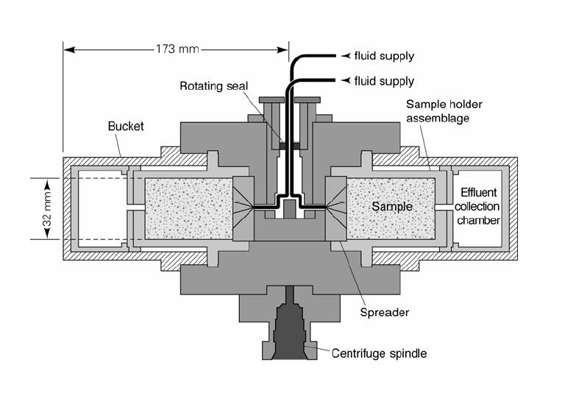
Figure 2. Nimmo’s centrifuge for soil hydraulic characterization

C3. Extrapolate Results to Study Area: Regionalization of the point borehole recharge estimates will be conducted by comparing recharge estimates from different settings with topography, soil texture data and land cover information. These comparisons will help determine the dominant controls on spatial variability in groundwater recharge in this region.
A technical memorandum will be prepared documenting the field studies, calculation of recharge rates, and the spatial variability or recharge across the study area.

C4.
- Analyse the relation between irrigation technology (drip, furrow, flooding irrigation) and water and solutes flow in the soil, particularly in the root zone, using a combination of field experiments and modeling.
- Characterize the impact of continued use of saline water on soil structure and soil hydrological processes. The soil degradation due to the salts soil accumulation determines a decrease on the soil total porosity. Such reduction determines a decrease of soil water infiltration rate and therefore water ponding that causes negative effects on the crop production. Moreover the salt accumulation combined with the high evaporation demand and the gravity irrigation systems (flood and furrow) determines the formation of soil crusts that have negative effects on the soil water rate infiltration and on the germination of seeds

3.3.2. Numerical Modeling of Groundwater Recharge in the Minqin basin

Unsaturated zone modeling will be conducted to estimate recharge in this region and to evaluate controls on groundwater recharge that would allow regionalization of point recharge estimates from borehole data. Modeling analyses will use a MathLab code developed by Coppola and Randazzo,2006 for the transport of water and solutes in unsaturated soils with vegetation.

The following point will be considered
A. Data Collection: Input data requirements for the model include meteorological forcing, vegetation parameters, hydraulic parameters for different soil types, and initial conditions. Precipitation data will be obtained from the National Climatic Data Center.

Potential evapotranspiration will be calculated using the Zhang equation (Zhang et al., 2001).

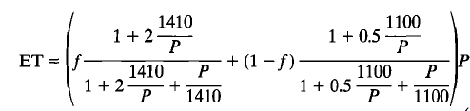

the above formula applies to catchments with varying proportions of forest (f) and agricultural (1-f) land use and requires precipitation data (P)

Vegetation parameters will be obtained from the literature and from discussions with local ecologists and agronomists.
Soil textural information for the upper 2 m will be measured on the samples from drilling.

Soil hydraulic properties will be measured by the SSC method. Measurements will be compared to hydraulic properties estimated by a pedotransfer function

B. Unsaturated Flow Modeling: Unsaturated flow modeling will be used to simulate drainage below the root zone, which is equated to groundwater recharge and assumes that climate and land use/land cover remain constant over timescales required for water to move from the root zone to the water table. Long-term precipitation will be used as the upper boundary condition for the simulations. The simulations are based on numerical integration of the Richard’s equation:
$\frac{∂θ}{∂t}=\frac{∂}{∂z}\left(K\left(ϕ\right)\frac{∂ϕ}{∂z}\right)−\frac{∂K\left(ϕ\right)}{∂z}±S$

C. Calculation of Recharge Value: A representative recharge value (average of 20-30 years) will be calculated using 1-D simulations for each different combination of vegetation and soil texture within the Minqin basin and spatially weighting each of these simulations on the basis of the area covered. Sensitivity analyses will be used to assess different controls on groundwater recharge. Variations in climate, vegetation, and soil texture will be examined using sensitivity analyses.

A technical memorandum will be prepared documenting the methodology, data collection, and results of the groundwater recharge modeling.

Il fruitore  (Prof. Antonio Coppola) | Il Proponente  Il Direttore  Prof. M. Menenti)

