Programma CNR/Università/Istituzioni scientifiche pubbliche italiane

ed Istituzioni di ricerca straniere: mobilità di breve durata

(Short-Term Mobility - anno 2008)

REPORT ON

“Photoionization experiments on plume produced by laser ablation of CdS”

“Esperimenti di fotoionizzazione su plume prodotta per ablazione laser di CdS”

The scope of my stay was to complete the construction and characterization of an experimental instrumentation with the aim to study the composition and dynamics of laser ablated plumes using synchrotron radiation light and a Time of Flight mass spectrometer (TOF-MS). This project has been a joint collaboration with the researchers of CNR, part of Elettra staff and my home Institute (CSIC-Instituto Rocasolano). My experience on laser ablation plumes and TOF spectrometry has been decisive in the optimization of the equipment and its final resolution and detection efficiency.
This second short-term mobility grant has allowed us to redesign and test the experimental apparatus, achieving the planned goal of ionizing and collecting the neutral components of the ablation plume without the interference of the direct ions generated in the ablation. Although the results on neutrals were obtained using a pulsed radiation source (a Nd:YAG laser) instead of the planned He lamp (which provides continuous radiation, more similar to the case of synchrotron sources), their quality makes us to be optimistic about its performance in future experiments at Elettra.

EXPERIMENTAL
The experimental system, already shown in my previous report, briefly consists of:
- An external Nd:Yag laser of 10ns pulses (Quanta System, mod.Handy 710) for the ablation. Photons used were of 532 nm wavelength.
- TOF mass spectrometer to collect charged particles,
- Electron analyzer (EA) for coincidence experiments,
- Rotating 3D manipulator for the sample,
- Entrance window for the laser pulses,
- Pumps and vacuum gauges to control pressure (pressure limit < 1x10⁻⁷ mbar; during ablation at 10Hz P< 5x10⁻⁶ mbar),
- He lamp / a second Nd:Yag laser for ionization of neutrals which will be substituted in future experiments by the synchrotron light to perform the spectroscopy of the ablated particles.

As stated earlier, the challenge of our study was to obtain a resolved TOF mass spectrum of neutral species ionized at different delay times after the ablation. For that, we had to avoid the interference of the initial ions created in the ablation and to be able to collect only the particles ionized at a specific time. Two ionizing sources were tested for these experiments.

He lamp
Following the original plan, we commenced the experiments using a He lamp for the ionization of the neutrals. Its performance resembles that of a synchrotron radiation source since it is a continuous radiation source (for our purposes the repetition rate of synchrotron pulses behaves as a continuous ionizing source) and it provides a similar photon flux.
However, no results were obtained with this source. It seemed that the radiation of the He lamp was far weaker than expected in the region where neutrals were produced. Since the radiation from standard He lamps is highly divergent, we had to make use of a glass capillary to collimate and guide the light but that same capillary absorbed most of the radiation. In a test in which we filled the experimental chamber with Xe at a pressure of 5*10⁻⁵ mbar, we could hardly detect more than 2000 ions per second. This count rate was incompatible with our experimental requirements which we calculated to be of some hundreds in the microsecond scale.
Thus, after some attempts changing the geometry and even using a second, more modern He lamp, we decided to use a higher-flux radiation source.

Nd:Yag laser
We attached a second Nd:Yag laser for the ionization of the neutral particles, using its nanosecond pulses of 532 nm photons. Even though the ionization with such low wavelength photons required the absorption of several of them, the number of ionized particles increased by several orders of magnitude. Under these conditions, we started to take some measurements and test the repelling/extracting field scheme to separate the direct ions coming from the ablation from the neutrals, later ionized by the second laser.

Pulsed repelling/extracting field scheme
The extraction and detection of desired particles in our system relies on the potential of the TOF repelling plate as described below. Initially, a constant negative voltage is applied to the repelling plate of the TOF spectrometer so that all the direct ions produced in ablation are removed from the interaction region. Then, once the second laser has been triggered to ionized neutrals, a positive potential is applied to the repelling plate so that the ionized particles are extracted and collected by the TOF-MS.

RESULTS AND CONCLUSIONS
An example of the ion selection efficiency (direct ions vs ionized neutrals) achieved using the repelling/extraction scheme is presented in figure 1. The typical potentials used were -100 V for direct ion removal and +1600 V for the extraction of postionized species. The postionization laser, synchronized with the extracting potential, was shot a few microseconds after the ablation.
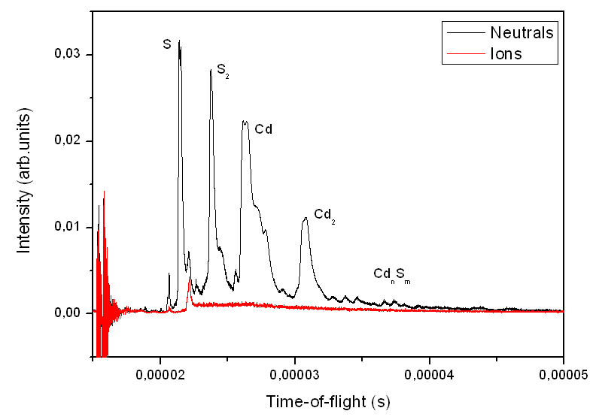
Figure 1. Intensity of direct ions (left from the ablation) and neutral species (postionized with the second laser) The repelling/extracting field scheme achieves an efficient separation of neutrals and direct ions.

With this experimental set-up we carried out some studies of the dynamics of the plume by pulsing the extracting field at different delay times after the ablation. Thus, we collected and integrated the TOF spectra of direct ions (postionization laser off) and neutrals (postionization laser on) at different delay times. Figure 2 shows the evolution of the intensity of both signals with time and also with ablation energy. A first analysis reveals that the dynamics and intensity of direct ions do not depend much on ablation energy in opposition to neutrals, which show a more intense and broader time distribution with fluence (there is emission of neutrals from the surface even 1-3 milliseconds after the ablation).

The performance of the experimental set-up indicates that the equipment is ready to be used in synchrotron experiments. Indeed, the team has already submitted a beam time proposal to the Gas Phase beamline at Elettra for the second semester of 2008 in which we plan to study the absorption of neutral Cd_{n}S_{m} species around the 2p edge of the sulphur atom.
Figure 2. Time distribution of direct ions (filled symbols) and neutrals (hollow symbols) at 3 different ablation fluences.

ACKNOWLEDGEMENTS
Our team acknowledges CNR for funding my stay under the 2007 and 2008 Short Term Mobility project. We also thank the “Laboratorio Getti Molecolari of University of Milan and the Elettra Storage Ring Free Electron Laser group of Sincrotrone Trieste ScpA for letting us use their laser and optical set up for the ablation project. Finally, we acknowledge Gilio Sandrin, Luca Romanzin and Christian Leghissa from the technical workshop of Sincrotrone Trieste ScpA for their continuous assistance in the assembly of the experimental set-up.

