Relazione Scientifica

Programma Short Term Mobility 2009

Semantic driven design techniques for multimodal interaction and querying of Virtual Environments

Dott. Fabio De Felice, ISSIA-CNR

Proponente: dott. GIOVANNI ATTOLICO Primo Ricercatore dell’Istituto di Studi sui Sistemi Intelligenti per l’Automazione di Bari
Fruitore: dott. FABIO DE FELICE, Assegnista di Ricerca presso dell’Istituto di Studi sui Sistemi Intelligenti per l’Automazione di Bari
Istituzione Straniera Ospitante: WISE research group, Department of Computer Science at Vrije Univeriteit Brussel, Belgium.
Periodo trascorso presso l’Istituzione Straniera: dal 1 Novembre ’09 al 22 Novembre’09.

Introduction

The research activity has been carried out under the supervision of prof. Olga De Troyer, prof. Beat Signer and Dott. Frederick Kleinermann at WISE research group.
A first phase has been concerned with the comparison and the evaluation of the works carried out at both labs (at ISSIA-CNR and at CERTEC group). In a first meeting the research activity carried out at ISSIA-CNR has been presented; focus has been devoted to the description of the work done after the end of the Project called “Un ponte tecnologico per coloro che non vedono”. In this project, ended in 2007, a number of hapto/acoustic application have been developed to help blind users to explore 3D VEs describing different informative contents of the physic world (castle, objects of art, geographic maps,…). The tests conducted with visual blind users, in collaboration with Italian National Blind Association, shown how the realized system, called Omero, can act has a valid complementary tool for learning real environments and for acquire knowledge. Furthermore has being outlined how: a) Visual impaired users asks for map-related application and high semantic information, b) The design and development of the VE is a time-consuming task in the overall application life-cycle: it needs to be made fester and easier, c) Proper tools should enable domain experts to be more involved in the design phase, d) Design of hapto-acoustic displays should exploits user feedback. To reach these goals a

conceptualization of a Virtual Environment System Interface has been defined, that integrates different interaction metaphors covering different users task such as Navigation, Object Selection\Manipulation and Scene Querying dedicated to blind users. The schema reporting this conceptualization is depicted in figure 1.
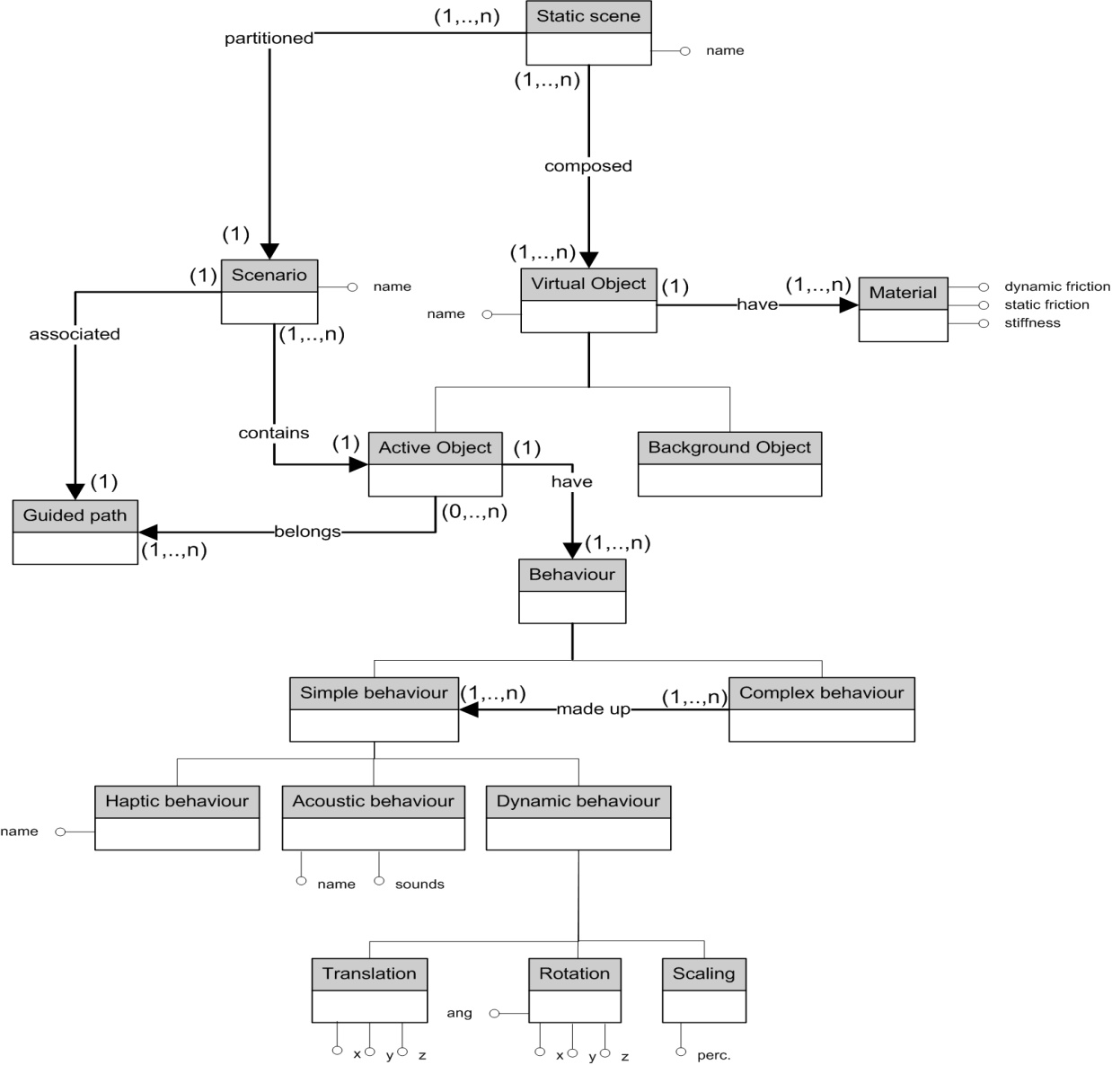

Figure 1. Entity relationship schema of the VESI
For a broader description of the integrated interaction techniques see [1].
A second meeting has been focused on describing the activities carried out at the WISE lab. Among other activities the lab is concerned with conceptual modeling of Virtual Reality and more in particular towards the design and development of VR web environments. This activity is conducted by Prof. De Troyer and Dr. Kleinerman. During their past research project called VR-WISE an applications framework called OntoWorld has been developed allowing the use of high level intuitive modeling concepts to specify Virtual Worlds in terms of the vocabulary and semantics of the application domain. OntoWorld is especially developed for non-technical persons. Beside the possibility to design the virtual static scene other tools allows to intuitively associate dynamic behaviours to the virtual object and/or avatars in the scene. In figure 2 is reported the development phases underlying the design process, see [2] for a detailed description.
Another interesting activity is conducted by Prof. Beat Signer and concerns interactive papers and cross-media information systems. Under this topics Prof. Signer investigated fundamental concepts for interactive paper and cross-media information spaces resulting in the general resource-selector-link (RSL) metamodel (figure 3) that generalises document and open hypermedia models.
The iServer platform represents the implementation of the RSL model that can be extended by different resource plug-ins for integrating different types of physical and digital media .
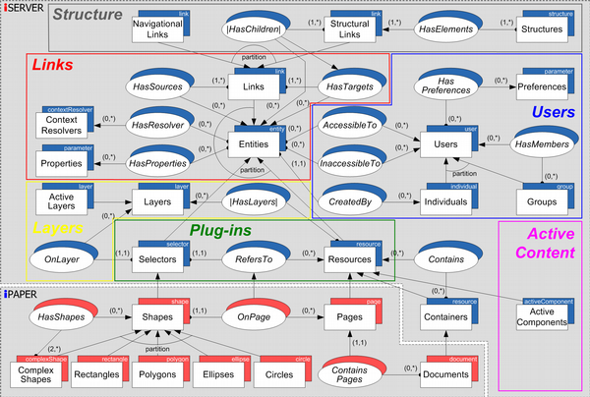

Figure 3. Resource-Selector-Link (RSL) model

Figure 2. VR-WISE development process

See [3] for details.
After this first phase of activities comparison and shared interests has been clearly evident that the work in multimodal interaction carried out at ISSIA could be a valuable integration into VR-WISE architecture, while the topics covered by the VR-WISE activities fit well with the new requirements of the OMERO framework, especially for the point b) and c). A first collaboration activity will concern the extension of the OntoWorld architecture with design techniques to add hapto-acoustic interaction to the VE. In this way a further high level tool could be supplied to the domain experts, besides those already available in OntoWorld to create the static scene and the virtual objects behaviours, in order to design hapto-acoustic interaction with VEs. In particular these techniques will allow an open access to the VE contents even to disabled users, as the visually impaired, by using the hapto-acoustic interaction conceptual model defined in the OMERO framework. This integration will involve the extensions of the Onto-World framework, in order to integrate it with concepts proper of a hapto-acoustic interaction and with concepts proper of the OMERO approach.
Another collaboration is the one with the Prof. Signer. To define an integration between the OMERO Multimodal Editor and the iServer platform. This integration will allow designers of the haptic/acoustic behaviours of the virtual environment, to add semantic metadata to the virtual objects by means of the services available with the iServer. Furthermore interesting application in the field of map-related application for blind mobility can be investigated to cover the point a).

OMERO interaction model integration into VR-WISE architecture

Lets now figure out how the OMERO VESI conceptual model described in the first paragraph can be integrated into the Onto-World framework. From Figure 1 we can define the VE Static scene as a set of virtual objects. In the Onto-World meta-level, Virtual Objects are conceptually defined by means of the Conceptual Modeling Ontology for its high level concepts, the Virtual Reality Ontology for its shape and the Meta Mapping Ontology for the concept-shape mapping. It is defined for the application domain with the Domain Specification Ontology and Domain Mapping Ontology. It is instantiated with the World Specification and World Mapping. The Conceptual Meta-level must be extended to add the following concepts of the OMERO framework:
- Attributes about physical material: stiffness, dumping, static and dynamic friction and sound values should be added. The first four could be associated with high level intuitive concepts such as slippery, rough, very rough, smooth, very smooth. The sound attribute will be time to time associated with an actual sound involved in the entity activity in the VE.
- Active Object: a Virtual Object with a behavior. It should be defined by means of the Virtual Object and Behavior concepts.
- Scenario: a set of semantically related Active Objects. A Scenario should be conceptually defined in the meta-level by means of the Conceptual Modeling Ontology. It should be defined for the application domain in the Domain Specification Ontology and Domain Mapping Ontology. It should be instantiated with the World specification and World Mapping.
- Polymorphous concept: It defines a concept that can have different shape representations in the VE. It should be conceptually defined in the meta-level by means of the Conceptual Modeling Ontology. It is defined for the application domain in the Domain Specification Ontology and Domain Mapping Ontology. It is instantiated with the World specification and World Mapping.
- Switch Node: A selective grouping node in the scene graph, should be defined in the Virtual Reality Ontology. It is related with the concepts of Scenario and Polymorphous concept. In the first case a given Scenario is mapped onto all the Switch Nodes in the scene, while for the second a Polymorphous concept represents a given concept with different objects with different features in the VE.
- LOD Node: A Level Of Detail node in the scene graph, should be defined in the Virtual Reality Ontology. It is related with the Polymorphous concept where a Polymorphous concept is mapped onto different Level Of Details of the same Virtual Object.
- Guided Path: a set of chronologically ordered Active Objects. A Guided Path should be conceptually defined in the meta-level by means of the Conceptual Modeling Ontology. It is related with the concept of VRConcept in the Virtual Reality Ontology, in the sense that a given Guided Path is mapped onto a set of object in the VE. It should be defined for the application domain in the Domain Specification Ontology and Domain Mapping Ontology. It should be instantiated with the World specification and World Mapping.
The Virtual Objects Behaviour is conceptually defined in the meta-level by means of the Behavior Modeling Ontology, composed by the Behavior Definition Ontology and the Behavior Invocation Ontology. It is defined for the application domain with the Behavior Specification Ontology, composed by the Behavior Definition Model and the Behavior Invocation Model. These steps are accomplished by using the Graphical Behavior Modeling Language. The Virtual Object Behaviour conceptual model must be extended with the concepts of haptic and acoustic behavours.
Interaction should be conceptually defined analogously to the behaviour concept: In the meta-level an Interaction Modeling Ontology, could be developed composed by the Interaction Definition Ontology and the Interaction Invocation Ontology. It is defined for the application domain with the Interaction Specification Ontology, composed by the Interaction Definition Model and the Interaction Invocation Model. These steps are accomplished by using the Graphical Interaction Modeling Language. This language could take advantages from the UML Use Case construct, as a way to design the first phase of the interaction. Further step should to integrate this first global level to graphs construct with the Behaviour graphical language.
Conceptually an interaction with a VE can be started by the user or by another virtual object. The interaction is with a given virtual Object in the scene (an Active Object in particular) and results in the selection and the manipulation of the object behaviours. Another type of interaction is with the entire scene when performing Scene Querying tasks. A user chooses an Avatar to be immersed in the VE and experiences the scene through it. An Avatar could be a humanoid character, a tool (such as a gun) or an object of arbitrary shape. In the case of hapto-acoustic interaction in a context of exocentric navigation the avatar is a simple sphere that reproduces the virtual position of the haptic manipulandum inside the VE. In this context we can resume both type of interaction, user or object, with object-object interaction where one is the Avatar of the user.
For this reason it is important to model the concept of the Avatar. We can define the Avatar as a Virtual Object associated with only a dynamic behaviour, whenever the Avatar collides with an Active Object the Avatar and the object share the same position and the Avatar inherits the dynamic behaviour of the Active Object.
The Interaction can be seen as a concept involving the following subjects:
- A Source: the concept that starts a given type of interaction
- A Modality: the perceptive communication channel used to interact. The communication can take place in two ways:
    - Input way: The Source sends data to the system
    - Output way: The Source receives data from the system.
There could be three type of Modality:
    - Haptic modality. Establish a bidirectional channel communication
    - Acoustic modality. An output channel communication
    - Graphic Modality. Establish a bidirectional channel communication.
- An Interaction: the interaction procedure. There could be two type of interactions:
    - Basic Interaction
    - Composite Interaction: composed by Basic and/or Composite Interactions.
- A Task: a type of Interaction. There could be
    - Navigation Task
    - Object Selection task
    - Object Manipulation task
    - Scene Querying task
- An Operator: Logical relation that allows combining interaction to obtains composite ones. There could by more than one Operator for a given interaction.
- A Target: a concept of the VE involved in the Interaction. There could be more than a Target for a given Interaction.

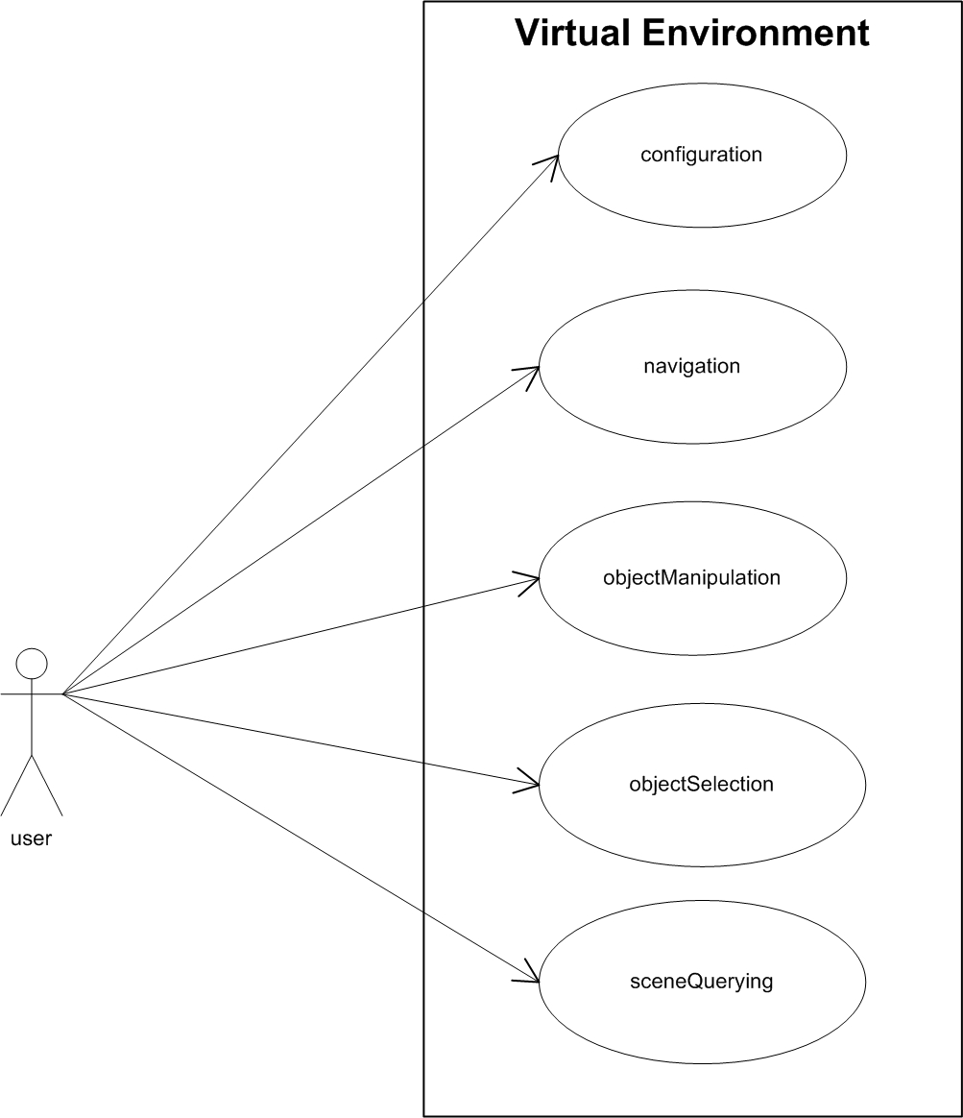

Figure 4. Interaction use cases

Hapto/acoustic interaction use cases

In the Onto-World approach a Graphical Behaviour Modeling Language has been developed in order to design objects behaviour in a high level way without handle the Ontology stuff, analogous approach could be used for the design of the interaction. As reported above, the Graphical Interaction Modeling Language could be developed by using the UML Use Case constructs. With the Use Case the designer can define which communication will be established between the system and the outside world. This first specification of the communication can be an entry point to a further schema in which the particular object behaviours diagram can be integrated to accomplish a particular user task. For this reason in figure 4, we define a first diagram that shows all the possible interaction types that can be accomplished.
The use case depicted in the figure follows the user's tasks reported in the previous paragraph. The Configuration Use Case concern the task in which the user must supply meta-data about the type of interaction, in particular in this phase the user choose the type of physical device, the Avatar, the type of rendering. For example in a Haptic interaction configuration the user can choose the type of haptic device (PHANTOM, Falcon,...) the type of avatar (sphere, a virtual pen or a user defined shape) and the type of haptic rendering algorithm to be used (God Object, Ruspini, others from a particular implementation such as CHAI3D).
This use case is reported in the following figure:

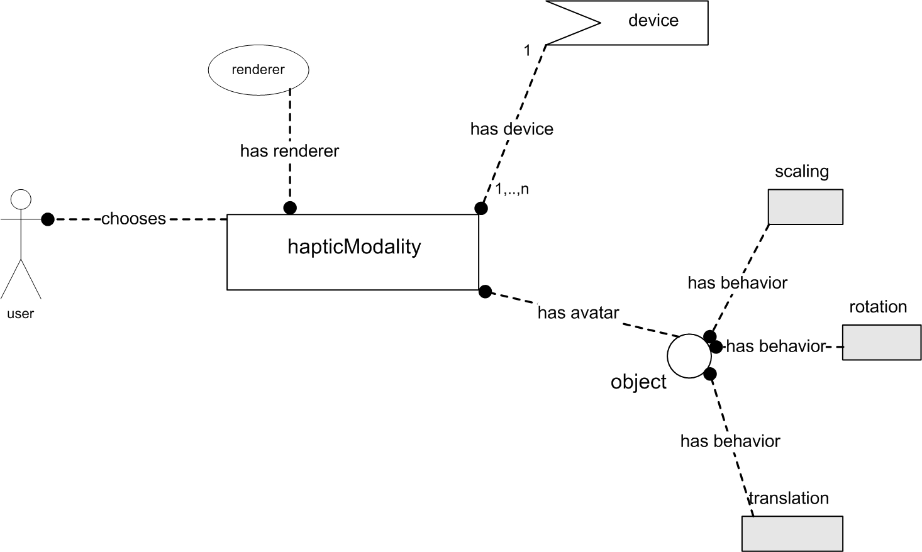

Figure 5. Haptic configuration use case
This diagram will be elaborated by the OntoWorld framework in order to produce the relative code.

Target Implementation Technology

In order to focus the efforts it is important to define a particular implementation technology. OMERO uses VRML models to describe the particular static scene at hand, while it uses an xml file (called OMDL) to describe the haptic platfom to be used, the data about the Scenarios and the Active Objects. Onto-World uses X3D instead of VRML and a Behavioural Script Language to implement the Graphical Interaction Modeling Language. To allow a more straightforward integration between the two approach it is convenientce to use X3D for OMERO too, X3D is the natural evolution of VRML 2.0 and allows a more flexibility. To modify OMERO in order to use X3D a haptic/graphic platform has been choosen to be integrated in the framework called H3D (www.H3D.org).
H3D API is an open-source, cross-platform, scene-graph API. H3D is written entirely in C++ and uses OpenGL for graphics rendering and HAPI for haptics rendering. H3D is built using many industry standards including:
- X3D - http://www.web3d.org - the Extensible 3D file format that is the successor to the now outdated VRML standard. X3D, however, is more than just a file format - it is an ISO open standard scene-graph design that is easily extended to offer new functionality in a modular way.
- XML - http://www.w3.org/XML - Extensible Markup Language, XML is the standard markup language used in a wide variety of applications. The X3D file format is based on XML, and H3D comes with a full XML parser for loading scene-graph definitions.
- OpenGL - http://www.opengl.org - Open Graphics Library, the cross-language, cross-platform standard for 3D graphics. Today, all commercial graphics processors support OpenGL acceleratedrendering and OpenGL rendering is available on nearly every known operating system.
- STL - The Standard Template Library is a large collection of C++ templates that support rapid development of highly efficient applications.
There are three levels of programming for H3D - using C++, X3D or Python. X3D and Python are high level interfaces to the API, whilst C++ gives you somewhat raw access to the API. The SenseGraphics recommended design approach is to break the application up into generic functional units that can be encapsulated as fields and scene-graph nodes - this maximizes reusability and encourages good application design. Geometry and scene-graph structure for a particular application is then defined using X3D. Finally application / user-interface behavior is described using Python.
Given this target technology the schema reported in figure 5 must be translated in the following X3D code:
<DeviceInfo>
<PhantomDevice positionCalibration="2 0 0 0
0 2 0 0
0 0 2 0
0 0 0 1" >
<OpenHapticsRenderer/>
<Shape containerField="stylus">
<Appearance> <Material/> </Appearance>
<Sphere radius="0.005" />
</Shape>
</PhantomDevice>
</DeviceInfo>

This will be the first step of the activity after which all the other use case could be designed and implemented.

Hypermedia Virtual Environments

The goal of the collaboration with the work of Prof. Signer could be to define an integration between the OMERO Multimodal Editor and the iServer platform. This integraton will allow designers of the hapti/acoustic behaviors of the virtual environment, to add semantic metadata to the virtual objects by means of the services available with the iServer. In particular the designer will be able to associate media links in two ways:
- By picking up an entire virtual object and to associate it to a particular hypermedia target
- By segmentate a portion (voxelization) of a given virtual object and to associate it to a particular hypermedia target.
The same two approaches can be used to define the virtual object as a target of an hypermedia source, in this way a bidirectional link can be established between the VE and other types of media available through the iServer (iPaper,iVideo,....).
To better focus on the collaboration, a position paper has been planned to be written in occasion of the Workshop Pervasive 2010, this paper will investigates the possibility of maps based application to help blind during mobility.

References

- De Felice, F., Attolico, G., Distante, A., “Configurable design of multimodal non visual interfaces for 3D VEs”, Lecture notes in Computer Science (HAID09 Haptic and Acoustic Interaction Design Workshop (LNCS series), Dresda 10-11 Settembre 2009.

- Kleinermann, F., De Troyer, O., Mansouri, H., Romero, R., Pellens, B., Bille, W. (2005). “Designing Semantic Virtual Reality Applications”. Proceedings of the 2nd INTUITION International Workshop., Senlis, France, 2005.

- Signer, B. and Norrie, M.C.. “An Architecture for Open Cross-Media Annotation Services”. Lecture Notes in Computer Science, Web Information Systems Engineering - WISE 2009

