


____________________________________________________________
Short Term Mobility Program of CNR
(1st February – 21st February 2009)
Final report
Improved Chipping Equipment for Mountain Biomass Production

User
Gianni Picchi ___________________
CNR-IVALSA (Consiglio Nazionale delle Ricerche, Istituto per la Valorizzazione del Legno e delle Specie Arboree)

Proposer
Prof. Ario Ceccotti ___________________
CNR-IVALSA (Consiglio Nazionale delle Ricerche, Istituto per la Valorizzazione del Legno e delle Specie Arboree)

Introduction
European economy heavily relies on fossil fuels as a source of energy. This condition proved many times its weakness due to the dependence on an international fluctuating market with frequent variations in terms of fuel availability and price. Furthermore fossil fuels are mayor responsible of the Green House Effect, due to gas emission when combusted (IPCC, 1990).
This situation is clearly unsustainable and many European and national programs within the UE are meant to cope with the application of alternative sources of energy, generally called renewable energies. Bioenergy is one of the main sources of renewable energy, due to its availability over the landscape, the carbon neutral balance and the sustainability if properly managed (European Commission, 1997).
Wood is the oldest and most common form of bioenergy: on this fuel rely most of the commercial bioenergy systems, both in developing and developed-industrialized countries. Leading countries in this field are Sweden and Finland, being the latter the most forest oriented. Finland is also a the world leader in development and manufacture of forest machinery and specialized equipment for biomass production and procurement . That is why the technology deployed in this country is always seen as the forefront in forest harvesting and wood processing. In spite of very different work conditions, Finnish machinery is getting more and more common in Italian forestry: most innovation and work optimization is due to the introduction of new equipment from the Nordic Country. This reason drove the researcher to apply for the CNR Short Term Mobility Funding, supported by the already established contact with the Faculty of Forestry of the University of Seinäjoki. The study period had two goals, one general and one specific. The first was to deepen the familiarity with Nordic bioenergy systems and all the commercial solutions adopted in this field, in order to find out new solutions suitable or adaptable for Italian conditions. The second goal, specific, was to study a chipping equipment and its subsequent logistic chain.
Bioenergy in Finland
During the 21 days of permanence in Finland the researcher carried out different investigations, being the main one the field study of a device for biomass production (wood chipper), which will be described in detail in the report, and the secondary one focused on understanding and describing the bioenergy market in Finland. This country shares with Sweden the role of wood-energy world leader both in the field of biomass procurement and its subsequent conversion technology. This was made possible by the importance that forests play in Finnish landscape and economy: covering 22,5 million hectares, almost 74% of the total area, and with a contribution to National GDP of 5,7, by far the highest in developed countries. (FAO, 2009). Wood products play an important role in the national economy. This long aged condition lead to the development of an impressive production chain including the management of private and public forests, harvesting systems, logistic structure for collection and transport of every wood assortment to the corresponding industry (mainly sawmills and pulp/paper factories). Contractors are available all over the country for professional forestry work with the most up to date machinery technology, working mostly for the three main forest companies: Metsäliitto, StoraEnso and UPM. These are countrywide firms, structured as cooperative of forest owners/industries, which buy timber both as standing plots (mainly) and piled assortments at roadside, delivering it to industrial users, generally run by the same company. The logistic organization is impressive, both for the equipment used as for the organization. Last innovation include GPS-GIS based systems which allow to map and track log piles characterized by any useful information, such as assortment, volume, landing or roadside accessibility, etc… This tool optimizes the logistic also in case of small, scattered piles as the one produced by small forest lots manually harvested by the owner, quite common in Finland where the average forest property does not exceed the 25 hectares (Hakkila, 2004). Bioenergy production chain beneficiated of this efficient production chain since its beginning in ‘70s. It slowly developed in years ‘80s and boomed in the last decade. Gradually the forest companies felt the exigency to provide to their customers a complete service, even if bioenergy was not a priority of their business plan. Metsäliitto was the first to create a bioenergy department, named Biowatti, soon followed by the other firms. This service was conceived at first as a complement of forest harvesting, and included stumps uplifting and removal together with slash: as a result the plot was already fit for reforestation. The main goal was to keep customer satisfaction, providing the most complete service in a highly competitive market, but this marginal activity turned in few years time to be a very profitable business. By the year 2008 the profit of UPM’s biomass department was the best of the whole company (Tapani, 2009), and a similar trend occurs in the other companies. Driven by the booming bioenergy market many small contractors and bioenergy firms rose all over the country:
- Contractors are generally family run, with an equipment limited to 2-4 machines and specialized in one or few of the forest works such as harvesting, forwarding, transport but also chipping or bundling of slash, stumps uplifting and transportation of biomass in different forms. They generally work mainly for the large forest companies which own a limited machinery park, preferring the flexibility of contractor work. Residues are generally transported as chips, bundles or split stumps, according to the end user facility: the first is a ready to use form, while the latter two require a second transformation with an industrial crusher before being used as a fuel, thus limiting the number of potential users.
- Bioenergy firms may be run by logistic contractors who specialize in biomass transportation with high volume trucks for chips or reinforced containers for stumps, these firms may be equipped with machinery for residues transformation or rely on contractors. In this case the activity mostly consists in buying the residues already piled at roadside from forest owners and transport them to final the user with or without previous transformation.

The chipper truck
A particular bioenergy firm is Biowatti, which separated from Metsäliitto and became the main Finnish firm specialized in biomass procurement providing a countrywide service with a network of agents and contractors almost in every province. This firm created a highly efficient work system of biomass production and transport, and in 2001 adopted a unique chipper model as standard unit, specifically designed for the company’s requirements, with a fleet of 7 machines (Hakkila, 2004). The peculiarity of this machine is the ability to perform both chipping and transport of biomass to the end user. This chipper configuration was not new in Nordic countries. Asikainen (1997) reported the performance of a chipper truck model MOHA compared with a mobile chipper and a grinder. The MOHA was a very mobile unit with particular stress on all terrain mobility being mounted on a SISU all-terrain truck bed equipped with an hydraulic power transmission on the three axes.
The main goal of the study funded by the Short Term Mobility Program (STMP) was to evaluate the work performance of the Biowatti wood chipper Heinola TT-97 RMS mounted on a Sisu E-14 truck (from now on called “chipper truck”). The configuration also includes a Loglift 75 ZT crane and the Multilift hook-lift container system. Such a layout on a 4 axles truck is made possible by the unusual chipper powering, using the very truck engine instead of an independent engine. This leaves room for crane and roll-off container providing an all-inclusive unit, agile and self-sufficient. Such a configuration could be a very effective solution for Alpine forest conditions, where biomass is typically distributed on scattered and poorly accessible landings. In these conditions, common chipping operations with a mobile chipper mounted on truck or trailer and supported by one or more transport units, operates in suboptimal situation. Furthermore, when the landing is not wide enough for two units, chipping is impossible, and more expensive solutions such as bundling or whole slash transport must be used (Spinelli, 2007).
During the time study the Chipper-truck was involved in a traffic accident, limiting its availability for the study. This forced the researcher to revise the planned activity, reorienting part of the study time on the second chipper used by the contractor. The device was the same wood chipper Heinola TT-97 RMS mounted in a different configuration, with an independent 294 kW engine. The unpredicted study provided interesting data, allowing the comparison of the same wood chipper in two different configurations and work systems (Table 1).

Truck model | Sisu E 14 | Volvo F 12
Service start | 2001 | 2000
Operative hours | 18900 | 7000
Truck engine (kW) | 390 | 294
Chipper engine (kW) | - | 294
Chipper model | Heinola TT-97 RMS | Heinola TT-97 RMS
Chipper type | Drum chipper | Drum chipper
Drum size (cm) | 90 x 70 | 90 x 70
Chipper feed opening (cm) | 45 x 70 | 45 x 40
Crane model | Loglift 75 ZT 84 | Kesla 700 T
Crane power input (kW) | 23-46 | 25-32
Crane reach (m) | 8,43 | 10,32
Loading system | Multilift LHS 260.5 | -
Container volume (m³) | 43 | -
Container weight (kg) | 3200 | -
Table 1. Main characteristics of the studied equipment

The two machines were studied for a total time of 46,25 working hours excluding transfer time from and to the firm centre (machines were never leaved overnight at the work site). Respectively the two units were studied for quite a different share of time: 33,85 hours for Sisu Truck, main object of the study, and 12,40 hours for Volvo truck, corresponding to two full work days. The work systems were as follows:

- Sisu; the chipper truck carried out chipping independently by other equipment, representing a “cold” work system. According to the site and organization of previous days at the morning start two empty containers were already available at the planned site. This corresponds to about 3-4 hours of working time. Approximately after this time span a container truck would approach the chipping site, carrying two empty container. Planning was such that truck arrival would be before the chipper could fill the second container. Container-truck operator’s dead time was reduced (generally eliminated) by a buffer time for unloading the two empty containers, load the full one(s), spray anti-frost liquid into the unloaded empty containers and fill documents into the chipper’s cabin. He would finally load the second full container landed in the meantime by the chipper and drive to the power plant for delivery. When no inconvenient occurred this work scheme lead to no waiting time for the chipper and very short ones for container truck.
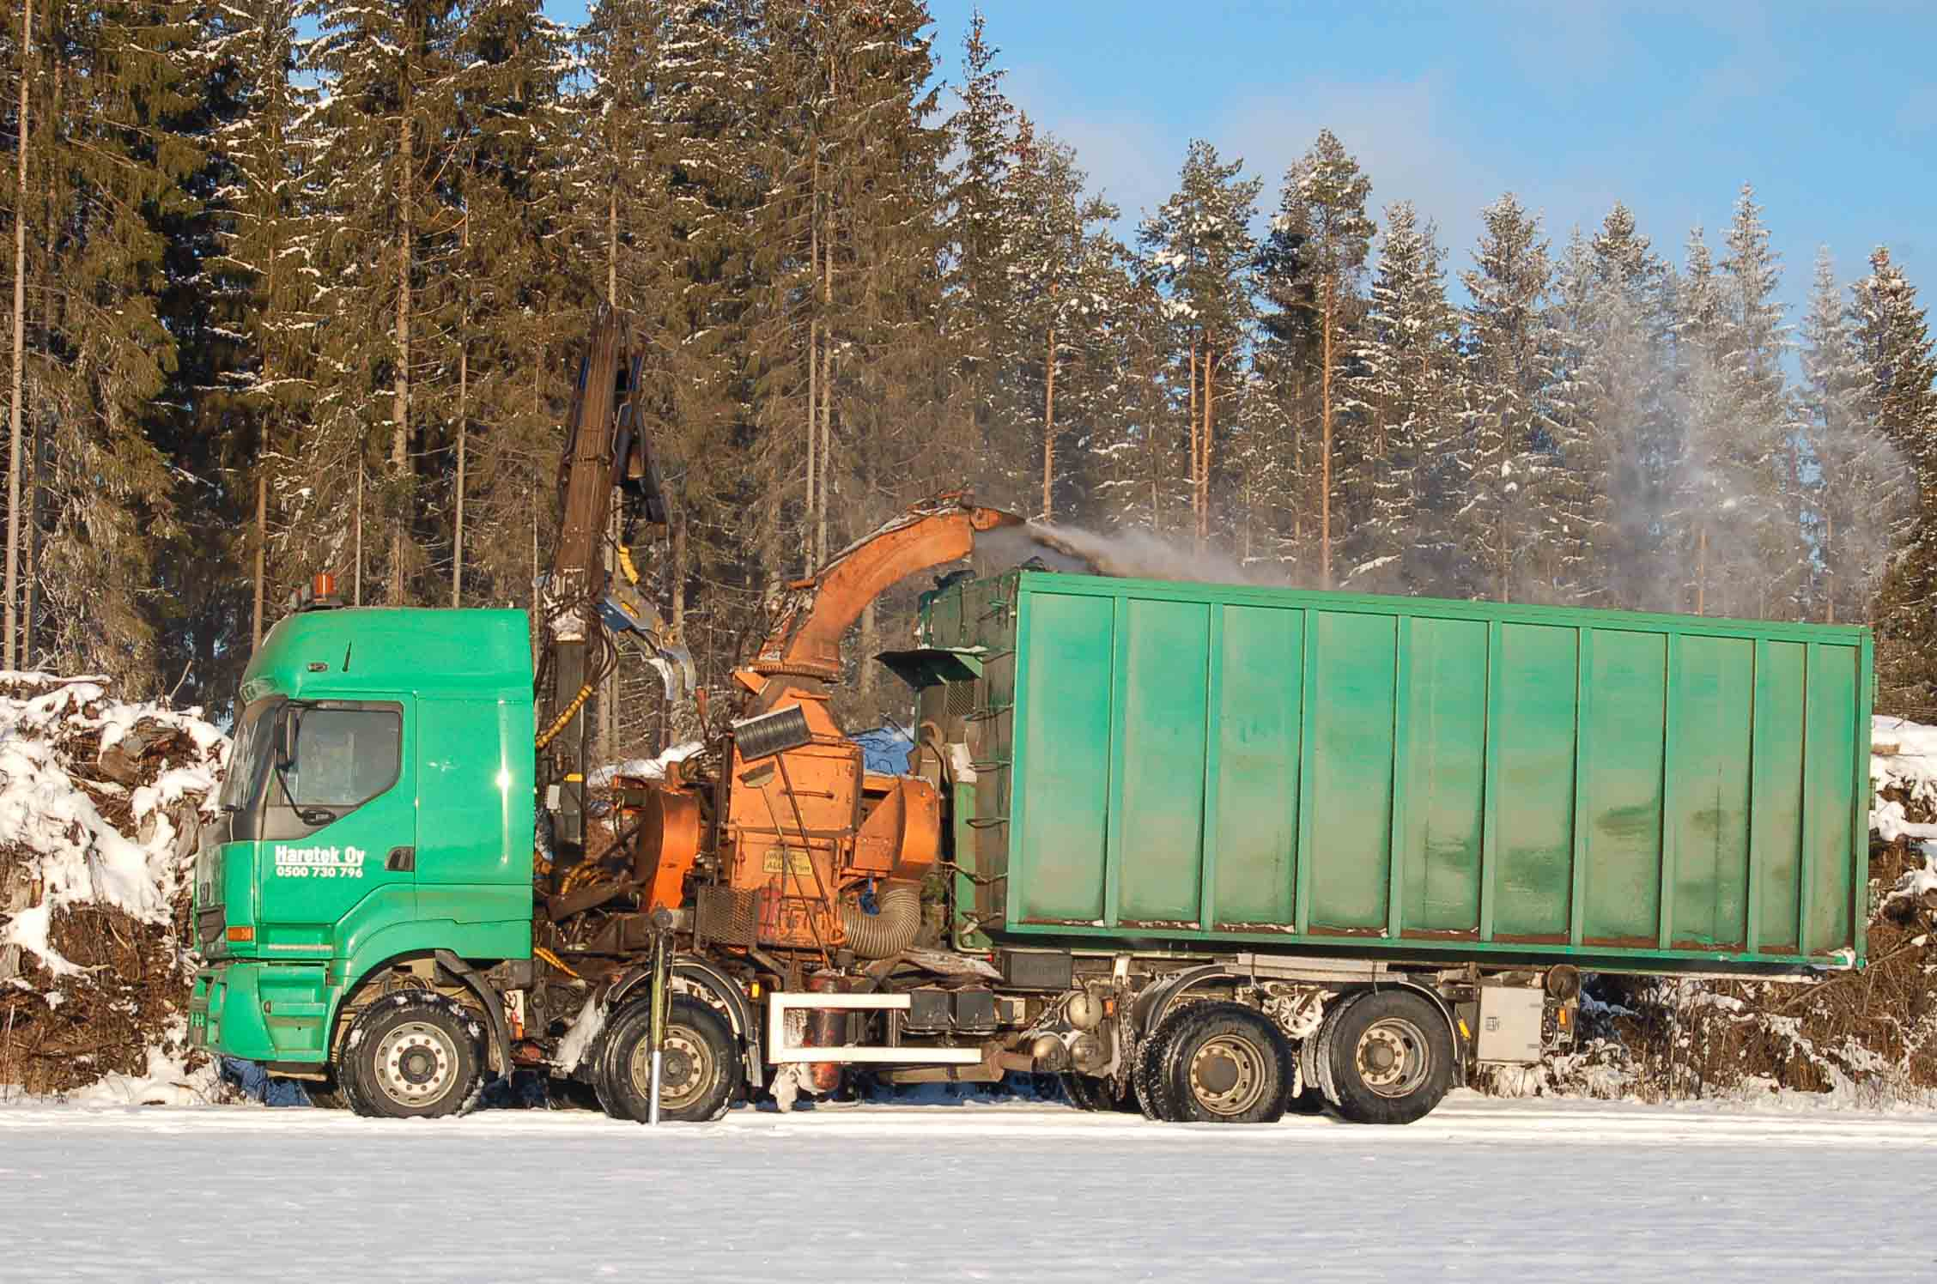
Figure 1. Chipper-truck configuration on Sisu chassis. Note the crane, the chipper and the roll-off container

- Volvo; the truck mounted chipper can chip either directly into a truck or into a container left on the ground, being in both cases a “hot” working system. For the first option a truck would wait under the chipper during the whole operation until complete filling and for part of this time a second truck should wait for replacing the former, in order to avoid chipper’s waiting time. The better performance of this chipper configuration (higher crane efficiency and collectable area, easier infeed), partly compensates the longer waiting time of transporting units. Leaving containers on the ground (second option) leaves the transport unit a partial freedom to operate, but only for unloading-loading containers on the trailer. Anyway it must be available for replacing or moving the container if the chipper has to change position. In both cases chipping efficiency and its share over other operations is higher respect to the Sisu system, but overall dead time is much higher when also transport units are included.
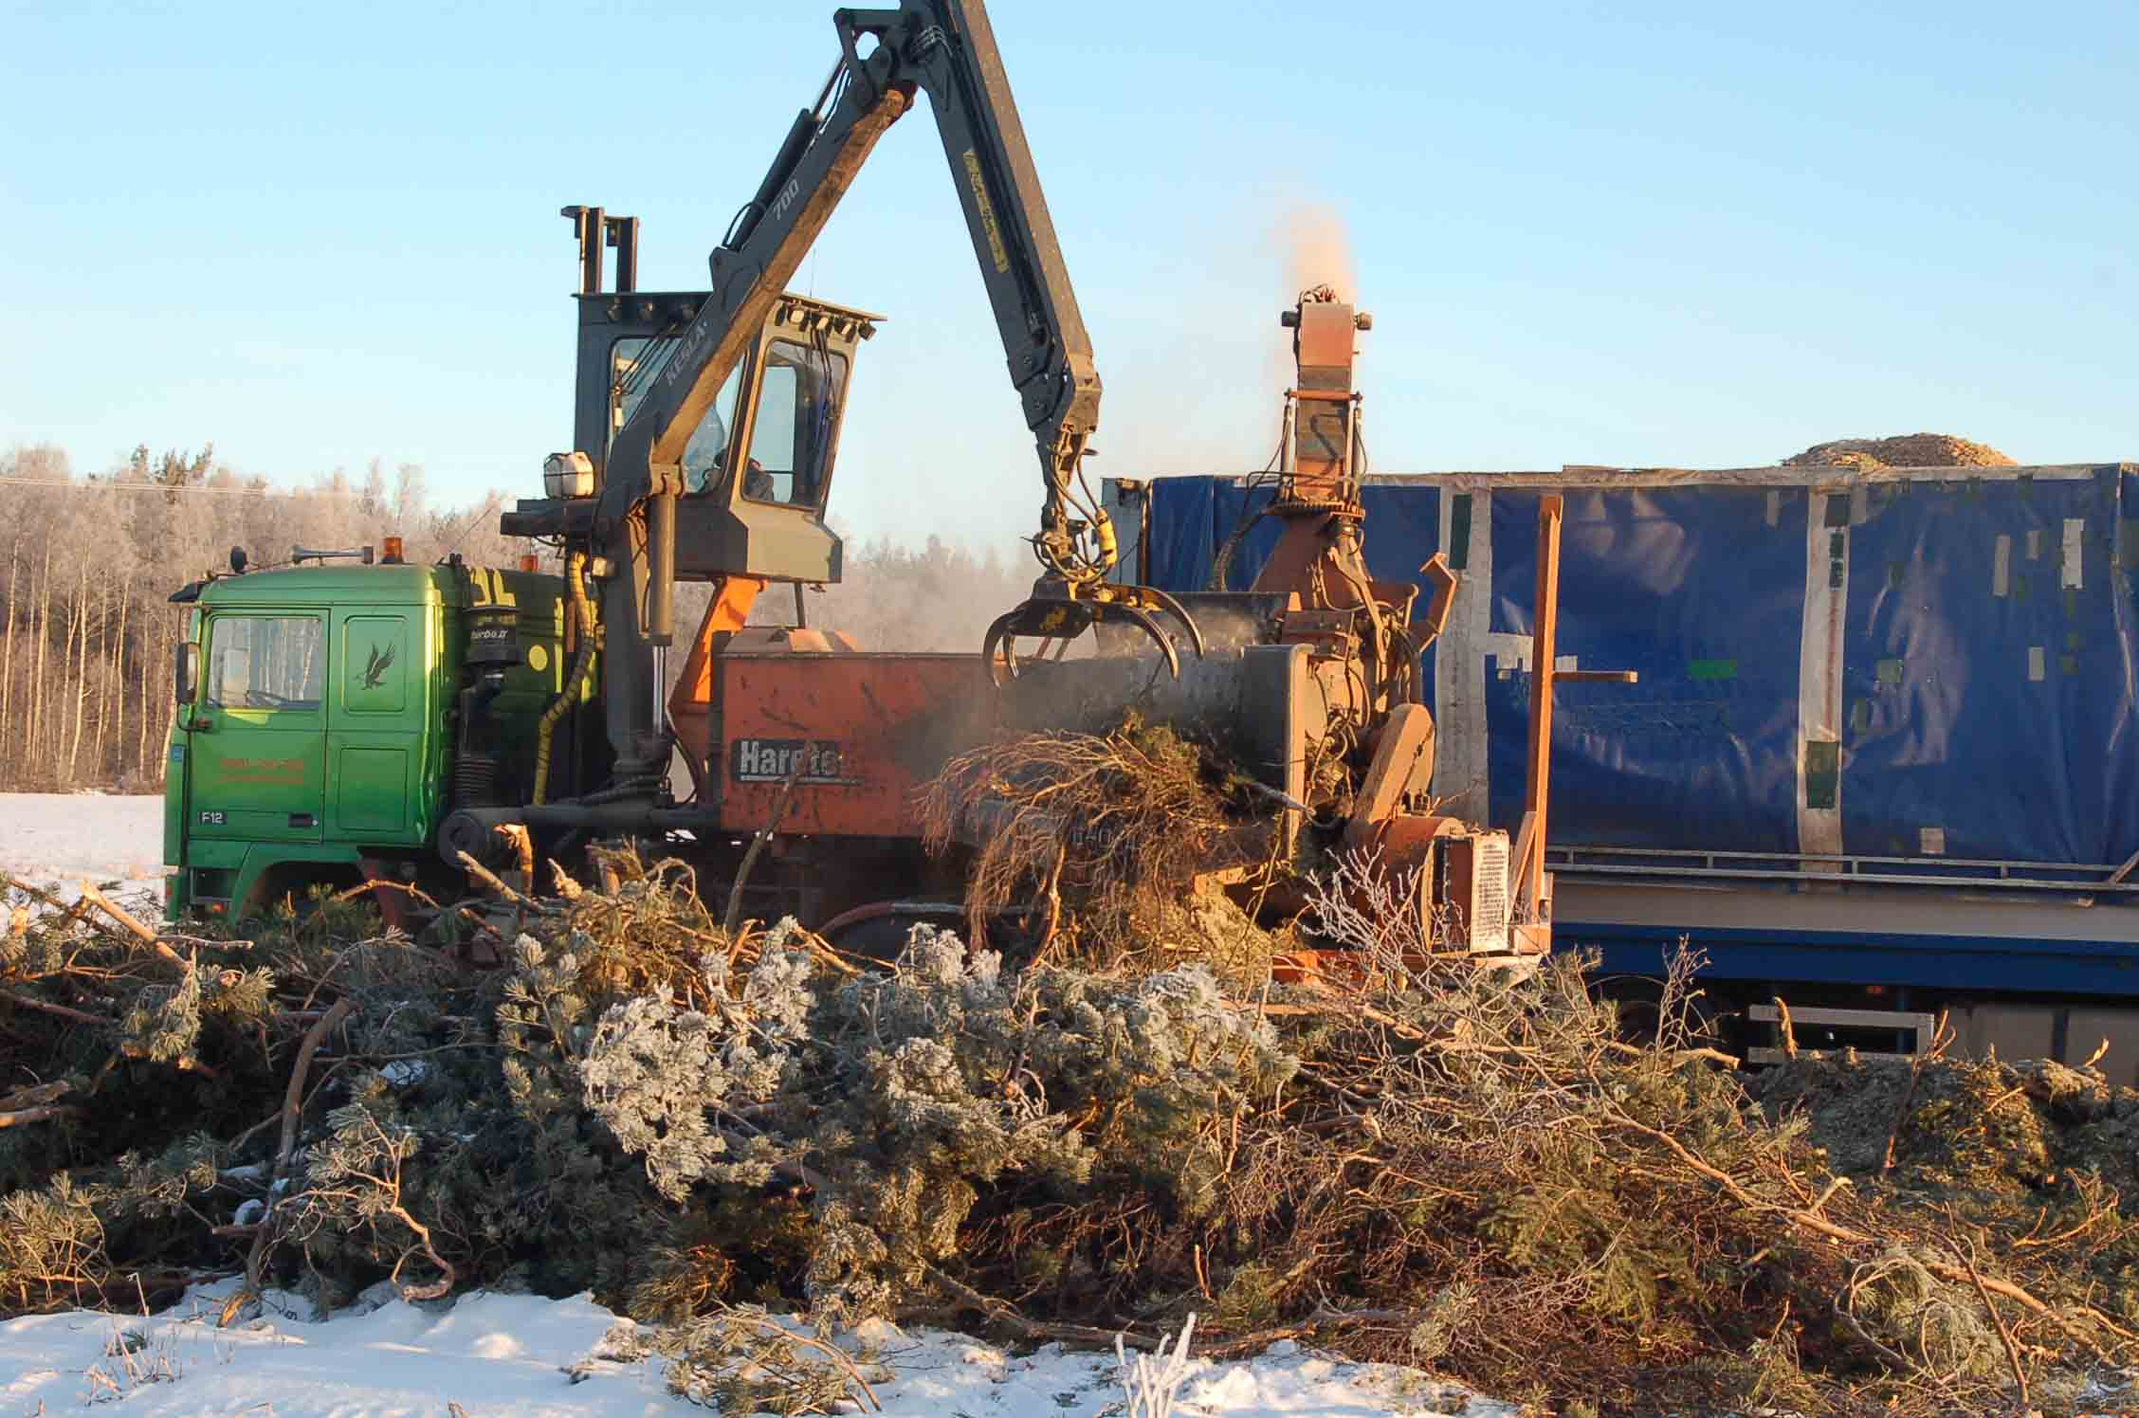
Figure 2. Chipper mounted as conventional configuration on Volvo chassis. Chips are blown into a high volume transport truck

Materials and methods
The study was conducted during commercial biomass production. The whole working day was studied, starting from the chipper truck garage up to the return at the same place. Work time was registered using the continuous-timing method with a three stopwatch system (Berti, 1989). Road distances were measured with the truck’s odometer, while maneuvering distances (for unloading, moving on the landing, etc…) were measured with an optic telemeter. The number of crane feedings to the chipper were registered using a manual counter. Biomass production was estimated by the number of containers of known volume. This data was facilitated by the operator’s use to fill the container at maximum capacity but not exceeding the container’s edge due to road severe transportation rules. When necessary the upper surface was manually leveled. Fuel consumption was estimated according to operator’s experience.
The two machines were driven by different operators, thus the comparison between the two systems can only be indicative. The driver of the truck mounted chipper was the very owner of the firm, hence highly motivated to meet the highest possible productivity because payment was agreed per cubic meter. On the other hand the chipper truck driver was an employee, with a hourly basis salary. Furthermore the driver was still on training, with three months experience maneuvering a chipper. Personal motivation and skill level draw a clear difference, expected to be reflected in terms of productivity output.
Wood chip samples were collected at each different chipping site. In order to have a sample representative of the whole container about 15 dm³ of biomass was randomly collected from different locations. Wood chips were closed in plastic bags and carefully stored in a shelter at external temperature (several degrees below zero). Cold weather prevented samples from losing humidity or start microbial activity before laboratory tests.
When field work was completed all samples were taken back to the Faculty of Forestry of the University of Seinäjoki that kindly provided the facilities for laboratory analysis. Samples were prepared by mixing the content of each bag, spreading it on a tray and dividing 5 small subsamples (about 100 g) for oven analysis and 5 bigger subsamples for bulk density estimation. Moisture content was determined as difference of fresh weight and dry weight after 48 hours in a ventilated oven at a temperature of 103 ± 2°C.
During field work was not possible to measure containers mass. In order to have a better estimate of chipper production for each site the bulk density of samples was determined. A 2,5 dm³ bucket was filled up to the top with the subsamples. Wood chips were pressed in order to simulate the compaction action of the chipper’s spout and the upper layers of biomass in the container. Result is a rough estimate, but provides the relative differences in bulk density among the samples and therefore the different raw material chipped at each site.

Results
The work time share for the two machines is presented in figure 3 and 4. Work was divided in different operations, namely chipping (chip), changing position for chipping along the pile (move), planning the work with other operators (plan), preparing the machine for work or transfer (prep), machine delays (tmm), organizational delays (tmo), subjective delays (tms), transferring to other site (transf) and in the case of the chipper truck also loading of the empty container (load) and unloading the full one (unload), both including the translocation from the pile to the container deposit site and vice versa.
Both machines show a similar performance in terms of net time on chipping, with respectively 65,3% for the Sisu mounted chipper truck and 68,8% for the Volvo mounted chipper. The extra operation of loading and unloading the containers in the chipper truck only counts for 2,5% of total work time, explaining the difference in chipping share.
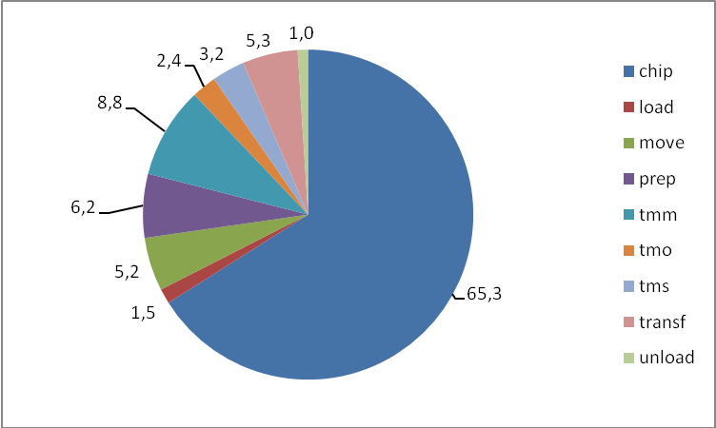
Figure 3. Distribution of gross effective time as percentage of total. Chipper truck (Sisu)

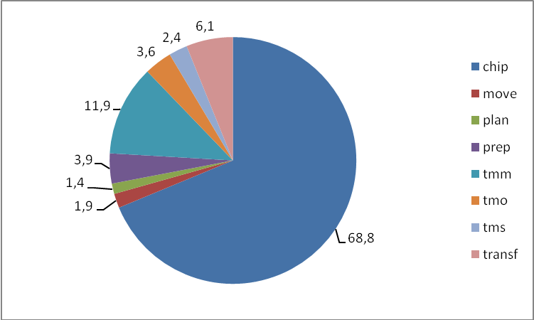
Figure 4. Distribution of gross effective time as percentage of total, truck mounted chipper (Volvo)

Regarding productivity the differences are much the sharper. The chipper truck performed a net average productivity of 0,46 m³/minute against the 0,69 m³/minute. The difference is statistically significative under analysis of variance with Fisher's least significant difference procedure (LSD=95%).
As for the produced biomass table 2 shows the results of sample analysis. Moisture content ranges from a maximim of almost 54% in fresh pine slash and one year old pile snow covered. Minimum moisture is found in paper covered residuals left on the field two years.

Slash origin | Age | Cover | Chipper | Moisture content |  | Bulk density |  | Estimated 43 m³ container load
(clearcuts) |  |  |  | % on fresh weight | SD | kg/dm³ | SD | t
spruce | two years | paper | Sisu | 34,5 | 1,932 | 0,34 a | 0,0073 | 14,68
spruce | one year | paper | Sisu | 43,8 | 0,689 | 0,49 b | 0,0176 | 21,03
spruce and birch | one year | paper | Sisu | 53,9 | 2,529 | 0,42 b | 0,0064 | 18,06
spruce | one year | paper | Sisu | 45,6 | 2,980 | 0,41 d | 0,0161 | 17,84
pine | fresh | none | Volvo | 53,6 | 1,824 | 0,31 b | 0,0057 | 13,53
spruce and birch | two years | paper | Volvo | 33,8 | 2,040 | 0,34 b | 0,0097 | 14,53
Table 2. Characteristics of piles, values on the same row marked with different letter show a significant difference with a 95% LSD
Bulk density of loaded biomass varied from a minimum of 0,31 kg/dm³ of fresh pine (with green needles) to a maximum of 0,49 kg/dm³ with a clear influence on payload optimization.

Discussion
In spite of all the problems occurred during the study, results of the research are encouraging. The chipper truck can perform as much as 30 m³ of loosen material per hour working in very difficult conditions: slash piles force chipper to work in suboptimal conditions, with very poor feeding and non continuous actual chipping (Spinelli and Hartsough, 2001). Furthermore the Chipper truck operator was a trainee with a limited experience on chipping, while the truck mounted chipper operator was a senior professional, thus a comparison of the two machines is not possible. Knife change can be used to weight the operator’s influence on the machine performance: working on exactly the same chipper the Sisu operator changed the two knives in 21 minutes against less than 10 minutes required by the other operator.
Overall logistics and organization resulted much easier handling roll-off containers. A single truck and trailer could assist the chipper truck, delivering the biomass in Turku (120 km far). The truck mounted chipper required the constant presence of a transport truck for loading, thus engaging two lorries and relative operators for the same period. This simplification in terms of work system result in consistent cost saving but further studies are required to assess the real impact of logistics on the overall work system and the potential performance of the chipper truck configuration.

Acknowledgement
The author wish to thank the firm Biowatti for the collaboration and Mr. Jouko Hakala, owner of the chipping and logistic firm Haretek Oy (www.haretek.org) object of the main study. A special thank to the team of Ähtäri (University of Seinäjoki, Faculty of Forest Sciences campus, Tuomarniemi) and particularly to Dr. Risto Lauhanen for his great help and support.

Bibliography
Berti S., Piegai F. e Verani S., 1989. Manuale d'istruzione per il rilievo dei tempi di lavoro e delle produttività nei cantieri forestali. Quaderni dell'istituto di assestamento e tecnologia forestale fascicolo 4:1-45.
European Commission, 1997. Energy for the Future: Renewable Sources of Energy. White Paper for a Community Strategy and Action Plan. COM(97)599 final (26/11/1997), Bruxelles, 54 p.
FAO, 2009. State of the world’s forests 2009. ISBN 978-92-5-106057-5 Rome, pp. 147
Hakkila Pentti, 2004. Developing Technology for Large-Scale Production of Forest Chips. Wood Energy Technology Programme 1999-2003. TEKES, Helsinki. 101 p.
IPCC, 1990. Climate change - The IPCC scientific assessment. Cambridge University Press, 1990, 406 p.
Spinelli R., Nati C., Magagnotti N., 2007. Recovery logging residue: experiences from the Italian Eastern Alps. Croatian Journal of Forest Engineering 1:1-9.
Spinelli R., Hartsough B. 2001 Indagine sulla cippatura in Italia. CNR-IRL Contributi Scientifico-Pratici n° XLI, Firenze, 112 p.
Tapani Tasanen, 2009. Personal communication. Seinäjoki, Finland.
Detailed daily program
(February)
DAY | MAIN ACTIVITY
1st | Travel from Florence to Ähtäri (Faculty of Forest Sciences campus, Tuomarniemi) via Helsinki-Seinäjoki.
2nd | Visit to the main structures of the University of Seinäjoki and The Seinäjoki Science Park.  Travel to Huittinen (about 250 km) with Dr. Lauhanen reaching the actual work area of the designed Biowatti Oy contractor, Mr. Jouko Hakala owner of the chipping and logistic firm Haretek Oy (www.haretek.org).
3rd | Accompanied by Dr. Lauhanen first study day. Sisu™ truck mounted chipper in normal working conditions in the area of Sastamala.
4th | Accompanied by Mr. Hannu Humalamäki field study on Sisu™ truck mounted chipper.
5th | Accompanied by Dr. Lauhanen field study on Sisu™ chipper-truck and travel back to Ähtäri.
6th | Attendance to the Parka agriculture and forestry fair. Accompanied by Dr. Tasanen interview to the main Finnish forestry and bioenergy players: UPM, Metsäliitto, StoraEnso and Biowatti. Further contacts where established with some forestry and bioenergy equipment producers and dealers (Farmi, Naarva, Nisula, etc.).
7th and 8th | Weekend in Tuomarniemi.
9th | Travel to Huittinen with a hired car. Direct contact with Mr. Jouko Hakala who informs me about the car accident suffered by the Sisu™ chipper-truck: made unavailable for the following days. Agreement with entrepreneur for studying as alternative the Volvo™ mounted chipper (different configuration).
10th | Field study of Volvo™ mounted chipper.
11th | Field study of Volvo™ mounted chipper. Machine suffers breakage by the end of working day, but contractor informs about the availability of Sisu™ chipper-truck for the next day.
12th | Field study of Sisu™ chipper-truck. Machine suffers breakage at noon. Accompanying of truck to workshop for repairing.
13th | Field study of Sisu™ chipper-truck.
14th | Travel back to Ähtäri.
15th | Weekend in Tuomarniemi
16th | Preparing of wood chip samples collected during the previous two weeks (preserved as naturally frozen) for oven drying (ventilated oven, 105°C, 48 hours). Data analysis.
17th | Travel to the Agronomy Faculty of the University of Seinäjoki settled in Ilmajoki. Visit to the Faculty’s structures and lecture presentation providing to students and teachers an overview of renewable energies in Italy - with specific attention to bioenergy and Finnish technology implementation -, CNR-IVALSA research activity on bioenergy, scope and first results of the chipper-truck study in Finland.
18th | Visit to the Metsäliitto’s office for the Province of Seinäjoki and the area of South Ostrobotnia: presentation of the cooperative’s activity on bioenergy and logistics for biomass procurement to SEVO oy, the local Combined Heat and Power (CHP) plant. Following visit to the plant’s facilities, namely stocking structures, truck management system, peat and biomass delivery and fuel quality laboratory.
19th | In Ähtäri, work office, interview with local newspaper and lecture presenting an overview of renewable energies in Italy - with specific attention to bioenergy and Finnish technology implementation -, CNR-IVALSA research activity on bioenergy and forest machinery, scope and first results of the chipper-truck study in Finland. Trip back to Helsinki.
20th | Planned visit to the Metla’s Vantaa Research Unit, in Jokiniemi, hosted by the researcher Liisa Ukonmanaho Ph.D.. Visit was finally not possible due to Dr. Ukonmanaho’s unexpected problems.
21st | Flight back from Helsinki to Florence.

