Spin Dynamics in InAs quantum dots
Report on the measurements at the Vanderbilt University (Nashville, USA) during the Short Term Mobility period from May 23 to June 13

Introduction

It is well known that semiconductor nanostructures provide a means to create artificial potentials for carriers, electrons and holes in semiconductors, opening the way to new device concepts. In particular, when the confinement potential is limited to zero-dimensions we obtain quantum dots (QD). Moreover, recent achievements in the field of spin based electronic have made possible innovative devices exploiting both the spin and charge degree of freedom of the material. Combining the nanostructured semiconductors and the new development of materials with magnetic and semiconducting properties it is possible to tailor new materials with controlled optical and magnetic properties. The increasing interest in the application of nanostructured materials in the development of spintronic devices and the implementation of quantum computation logic units has stimulated a lot of spin dynamics studies in semiconductor quantum well and quantum dots. Knowledge of the processes governing spin dynamics is essential for designing novel multifunctional and optoelectronic devices, including base components for quantum computing.
For efficient spintronics devices, one must learn how to manipulate the spin and its interactions during very short time scales. Ultrafast pump-probe magneto-optical spectroscopy is an ideal technique for characterizing the magnetization dynamics of these innovative materials, providing unique information about spin relaxation in semiconductor heterostructures as well as spin-polarized electron transport across interfaces.
The objective of the measurements performed during the short term mobility was to investigate, using fast pump-probe magneto-optic techniques, the dynamic of the spin carriers produced by optical injection in self assembled InAs QDs grown on GaAs. Time Resolved Faraday Rotation was used to probe the magnetization dynamics as a function of the sample temperature, pump intensity and radiation wavelength. The optical measurements were performed at the Department of Physics of the Vanderbilt University (Nashville, USA) using InAs quantum dots samples produced at the department of Physics at the University of Rome “Tor Vergata”.

Experimental

The InAs quantum dots samples were prepared by Molecular Beam Epitaxy (MBE) technique. The GaAs(001) substrate was deoxidized at about 640 °C until a weak 2×4 RHEED pattern was observed. Afterwards, the substrate temperature lowered to 590 °C and an epitaxial GaAs buffer layer was grown in As₄ overflow. After 10 min annealing, the temperature was further lowered to 500 °C for the InAs growth. The 2D–3D transition was monitored by RHEED. A sudden change of the diffraction pattern from streaky to spotty and a rapid increase of the RHEED intensity signals the morphology transition. It starts after deposition of 1.5 ML of InAs and is centred at about 1.7 ML. Two samples were grown: one obtained depositing 1.9 ML InAs and a second one with 1.4 ML InAs, both samples were capped by 200 nm GaAs. Because the critical thickness for the 2D – 3D transition of the InAs growth on GaAs is 1.6 ML the first sample contains InAs quantum dots embedded in the GaAs layer whereas the second one presents only the InAs wetting layer (WL). The GaAs capping layer prevents oxidation of the sample and, due to the different band gap width of the two materials (1.52eV and 0.42eV for GaAs and InAs respectively), gives rise to a confining potential in the QD.
The experimental apparatus used for the optical pump probe measurements is schematically reported in Fig. 1. The output of a Ti:sapphire pulsed laser (76 MHz repetition rate, ~150 fs pulse width) is split in a circularly polarized pump beam and a linearly polarized probe beam; both the pump and the probe beams are focused on the sample surface but the probe pulse is retarded by a variable delay using a delay line. The use of a circularly polarized pump beam allows controlling the spin state of the injected electrons. An Acoustic Optic Modulator (AOM) or a Photo-Elastic Modulator (PEM) are used to modulate the intensity or the photon helicity (σ⁺, σ⁻) of the pump beam at a frequency of about 50 kHz. Time resolved Kerr rotation or reflectivity were measured as a function of the probe delay time by measuring the signal from the photodiode detecting the reflected probe beam. The lock-in technique was used to measure the signal from the photodiode. Using the PEM reference signal to trigger the lock-in and measuring the differential signal from the two channel of the detector the time evolution of the pump induced Kerr rotation is measured. On the other hand, measuring the signal from a single channel of the photodiode with the pump beam intensity modulated by the AOM the pump induced reflectivity is obtained giving the time evolution of the optically injected electrons.

Results
The magnetic dynamics and the time evolution of the charge carriers in the QD and WL samples were investigated as a function of the sample temperature, pump power and radiation wavelength. The complete data set is under analysis and will be the subject of a forthcoming publication, below are reported some representative results.
The measurements were performed using a radiation wavelength ranging from 830nm to 820 nm, thus close to the bulk GaAs energy gap at about 80 K. In this way the electron spin carriers are injected in the sample capping layer. Schematically the electron energy levels involved in the excitation are reported in Fig. 2. Because the dynamic measurements were performed in a single color setup (the pump and probe beam have the same photon energy), the life-time of the injected electrons and spin in the capping layer is measured which is affected by the presence of the electron energy level due to the wetting layer and/or the quantum dots.
In Fig. 3 the Kerr rotation of the probe beam due to the optically induced magnetization as a function of the time is reported for the two samples, measured at different pump powers with a probe power fixed at 5mW. As can be seen in Fig. 3 the spin dynamics in these samples is characterized by a fast process (within the first 20 – 30 ps) and a longer decay time. The fast initial dynamics depends on the pump power whereas the long decay tail is not affected by the pump beam power. Comparing the 10 mW measurements for the two samples it is possible to note that the decay time is influenced by the presence of the quantum dots in the sample. Clearly, as shown in the first panel of Fig. 4, the decay time in the sample with the quantum dots is shorter than in the sample with only the wetting layer. In particular, a fitting procedure using a single exponential curve for the two spectra shows a τ time which is about double for the wetting layer sample. In Fig. 4 right panel the pump induced reflectivity for the two samples is reported measured with a pump power of 10 mW. Clearly the injected carrier dynamics is faster in the case of the quantum dots sample than in the case of the wetting layer one, in agreement with the spin dynamics measurements.
In Fig. 5 the Kerr rotation as a function of the delay time is reported for the two samples measured at different pump and probe beam wavelength. The wavelength range is scanned around the GaAs band gap. Clearly the shape of the reported time spectra strongly depends on the sample and wavelength demonstrating that the dynamics of the injected spin depends on the details of the excited electron states. A very fast dynamics is observed within the first few ps from the injection followed by a long decay tail that is almost absent for the long wavelength measurement. The strong dependence on the pump-probe wavelength is also observed in the reflectivity measurements reported in Fig. 6 for the two samples.

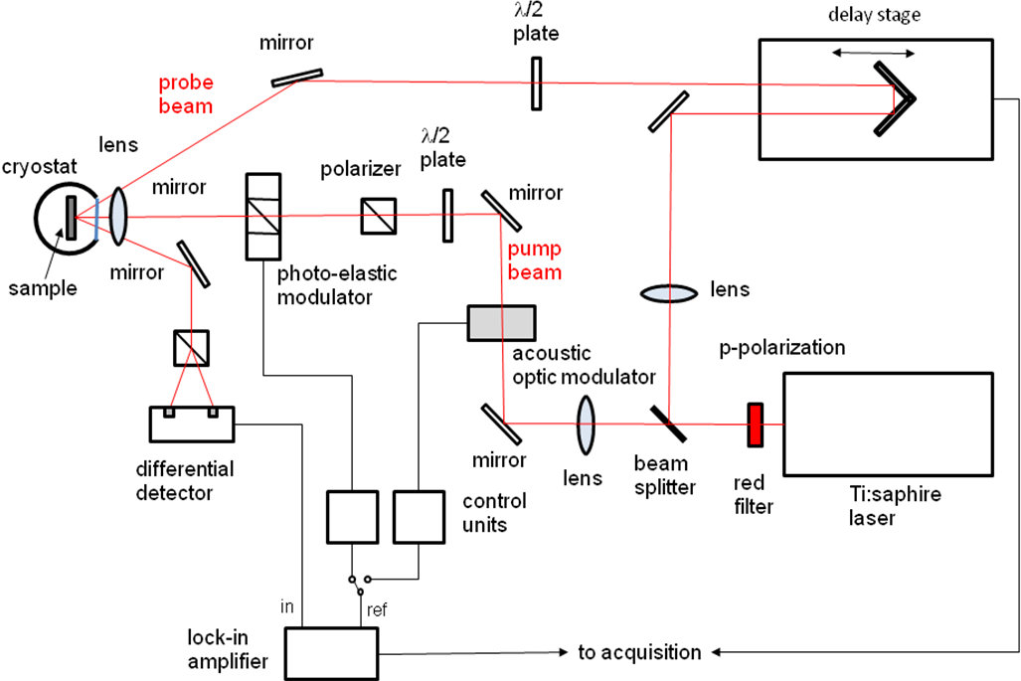

Fig. 1 Experimental set up.

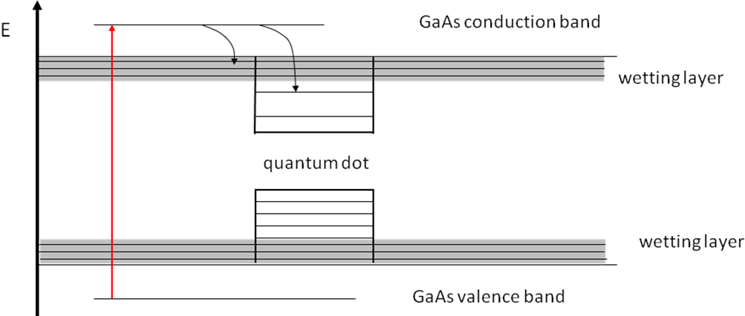

Fig. 2 Schematic model of the electronic levels involved in the sample excitation.
Fig. 3 Pump induced Kerr rotation as a function of the delay time measured for different pump power at 820 nm wavelength.

Fig. 4 Left: comparison of the spin dynamics in the wetting layer and sample dots samples measured at 80 K and a wavelength of 820 nm, the black lines are a single exponential fit for the two samples.
Right: comparison of the pump induced reflectivity dynamics in the wetting layer and quantum dots samples measured at 80 K and a wavelength of 820 nm.

Fig. 5 Pump induced Kerr rotation as a function of the delay time measured for different pump-probe wave length.

Fig. 6 Pump induced reflectivity as a function of the delay time measured for different pumb-probe wave length.

