PROGRAMMA SHORT-TERM MOBILITY – ANNO 2008
TITOLO DEL PROGRAMMA: Metabolic characterization of Prunus cerasus L. and Prunus mahaleb L. fruits.

PROPONENTE: Dott. ssa Giuseppina Mulè
FRUITORE: Dott. ssa Gerardi Carmela
DURATA: giorni 28
ISTITUZIONI COINVOLTE: ISPA-CNR, Unità di Lecce; Leiden University – Institute of Biology – Plant Metabolomics Research Group.
Relazione scientifica sull’attività svolta
Introduction
It is widely accepted that a diet rich in fruits and vegetable reduce the risk of several oxidative stress diseases, including coronary heart disease, cancer and stroke. These health benefits are ascribed to phytochemicals such as carotenoids and polyphenolics (1, 2, 3). The Institute of Sciences of Food Production (Territorial Unit in Lecce) has recently investigated the polyphenolic compounds, and particularly anthocyanins, content of Prunus cerasus fruits along with the total antioxidant activity of extract from flesh fruits (4). Moreover the metabolism of anthocyanins induced in cell cultures of P. cerasus have been investigated and the antioxidant activity of metabolites obtained in vitro have been assayed (4, 5). Succesively Prunus mahaleb L. fruits have been involved in this study; P. mahaleb is a tree species commonly used as rootstock in cherry crop. The P. mahaleb fruits have a bitter and sour taste and have a high content of organic acids, fructose and vitamin C. These fruits are thin-fleshed and are not fresh consumed from human because of their bitter taste; but the fruit kernels are used as a spice, which is fragrant and has a taste of bitter almonds. It is used in small quantities to sharpen sweet foods in Eastern Mediterranean countries. We have found few references on Prunus mahaleb fruits and the previous researches were focalised on kernel content in dihydrocoumarin and coumarin (6, 7).
The Short Term Mobility Program has allowed us to start a collaboration with the Plant Metabolomics Research Group in the Leiden Institute of Biology (section leader Dr. Pof. Rob Verpoorte) and to utilize their great scientific and technical knowledge of metabolomics to obtain a metabolomic profile of P. cerasus and P. mahaleb fruits. In recent years, metabolomics has become prominent as a part of systems biology with the expectation that functional genomics will uncover unknown gene functions. Moreover metabolomics is of interest in chemical classification of plants for chemotaxonomy (8).
The metabolomic characterization by NMR spectroscopy carried out during my short term mobility has the aim to add scientific data to the study of P. cerasus fruits as source of phytochemicals and to revalue, on scientific basis, a wild fruits like Prunus mahaleb, already known in traditional medicine, containing anthocyanins and coumarins. Moreover in this study, NMR spectroscopy coupled with multivariate data analysis was applied to Prunus metabolomics in order to investigate the botanical origins of Prunus cerasus and to identify the group of compounds responsible for differentiation of two species of Prunus (cerasus and mahaleb) and of two cultivars of Prunus cerasus (Montmorency and Marasca di Zara).

Materials and methods
Plant material and sample preparation
Ripe fruits of Prunus mahaleb L. and of two Prunus cerasus L. cultivars (Montmorency and Marasca di Zara) were harvested from trees in the experimental fields of Bari University (Apulia, Italy) and transported under chilled conditions to the ISPA-CNR laboratory. Then, fruits (without stone) were homogenized in liquid nitrogen and lyophilized using a freeze-dryer (Freezone 2.5, Labconco). The freeze-dried powder was sent to the Plant Metabolomics Research Group Laboratory in the Leiden Institute of Biology and there stored at -20° C until analysis.
Extraction
Freeze-dried fruit material (100 mg, in triplicate) was transferred to a 10 ml vials. A volume of 1.7 ml of a mixture of methanol and water (80:20) was added to the sample. The mixture was ultrasonicated at room temperature for 30 min and the extracted was vacuum filtered. The extraction procedure was repeated twice and the supernatants were collected together and evaporated. Dried extract was resuspended in 1 ml of deionized water (pH 7) and then shaken by liquid-liquid extraction using EtOAc (equal volume, three times) as extracting solvent, obtaining an organic fraction (fraction A) and an aqueous fraction (fraction B). Fraction A was dried with Na₂SO₄ and evaporated; dried fraction A was resuspendend in 1 ml of deionized water for further analysis.
Solid phase extraction (SPE)
SPE-C18 cartridges (Waters, Milford, MA, USA) were used in this study to partially purified both fraction A and fraction B. The general extraction was performed following these steps: cartridges were initially conditioned by elution with 2 ml of methanol and 2 ml of water, 1 ml extract was applied to the cartridge and eluted successively with 2 ml of water and 2 ml of methanol containing 0.01% (v/v) acetic acid. All two collected eluates were evaporated by a rotary evaporator.
¹H-NMR spectroscopy
The acidified methanol eluates from SPE-C18 cartridges were resuspendend in CD₃OD + KH₂PO₄ buffer in D₂O pH 6. Successively, in order to highlight the anthocyanins, both water and acidified methanol eluates from SPE-C18 cartridges were resuspended in CD₃OD/trifluoroacetacid (TFA) (95:5). In all cases 800 μl solvent were added to a 5 mm NMR tube.
NMR parameters
¹H NMR spectra were recorded at 25 ºC on a 500 MHz Bruker Avance 500 spectrometer (Bruker BioSpin, Karlsruhe, Germany) operating at a proton NMR frequency of 500.13 MHz. Each ¹H NMR spectrum consisted of 128 scans with the following parameter: 0.16 Hz/point, pulse width (PW) = 30º and relaxation delay (RD) = 1.5 sec. A presaturation sequence was used to suppress the residual H₂O signal with low powder selective irradiation at the H₂O frequency during the recycle delay. FIDs were Fourier-transformed with LB = 0.3 HZ. The resulting spectra were manually phased and baseline-corrected and calibrated to the residual solvent signal, using XWIN NMR (version 3.5, Bruker).
Data Analysis
The ¹H-NMR spectra were automatically reduced to ASCII file. Spectral intensities were scaled to total intensity and reduced to integrated regions of equal width (0.04) corresponding to the region of δ 0.0-δ 10.0. For the water fraction, the region of δ 4.75− δ 4.9 was excluded from the analysis because of the residual signal of the D₂O. For the methanol-water fraction, also the region of δ 3.28− δ 3.34 was excluded, because of the residual signal of the MeOH-d₄.
Bucketing was performed by AMIX software (ver.3.7, Bruker) with scaling to total intensity. Principal component analysis (PCA) was performed with SIMCA-P software (v. 11.0, Umetrics, Umeå, Sweden) with scaling based on Pareto method.

Results
A previous study (9) on flavonoid profile of Prunus mahaleb fruits demonstrated that the aqueous-methanol extraction method had allowed more anthocyanins recover in respect to not aqueous methanol and that during SPE-C18 purification the anthocyanin fraction was eluted in acidified methanol eluent. Moreover in another study (10) it was determined that methanolic extract of Prunus cerasus fruit is the more effective antiradical agent source in comparison to hexane and ethyl acetate extracts. As the first aim of this study was to revalue P. mahaleb as a source of phytochemicals, we selected an extraction method of the fruits in aqueous methanol and started to analyze the NMR spectra of the compounds eluted from SPE-C18 cartridges in acidified methanol both for organic fraction (fraction A) and aqueous fraction (fraction B). As shown in Fig. 1 a clear difference was observed between P. mahaleb and P. cerasus spectra both for fraction A and fraction B. The different peaks were observed both in the sugar and organic acid regions (~3-5 ppm) and in the phenolic region (~ 5.5-8.5 ppm). Clearly the aqueous fractions showed more and higher peaks in the sugar and organic acid regions compared to organic fraction. In fact at pH 7, organic acids are present in their ionic form and therefore stay in the aqueous phase. Phenolic secondary metabolites can be extracted in the ethyl acetate phase. In this way, a separation of primary and secondary metabolites is
obtained, with primary (sugar, organic acids) in the aqueous, and secondary metabolites in the ethyl acetate phase. As showed in Fig. 1 this separation between primary and secondary metabolites worked better in P. cerasus than in P. mahaleb fruit, as confirmed by the presence of high peaks in aqueous spectra of P. mahaleb between 5.5 and 8.5 ppm. This result can be explained by an higher content of phenolic compounds, like flavonoids, in P. mahaleb fruits in comparison to P. cerasus fruits. Moreover in the spectra of aqueous fraction (B) of all samples are clearly visible the peaks of anomeric H of α (5.2 ppm) and β (4.6 ppm) glucose, these peaks are absent in the organic fraction (A). An in depth qualitative analysis of the spectra is in progress with the aim of identify

B
A
anomeric H of α- and β-glucose

Fig. 1 ¹H NMR spectra of acidified methanol fraction from SPE column of organic fractions (A) and aqueous fraction (B) extracted from fruits of P. cerasus cv Montmorency (black spectra), P. cerasus cv Marasca di Zara (blue spectra) and P. mahaleb (green spectra).

more compounds extracted from the fruits. This results will be reached comparing our spectra with a database of NMR-spectra of common plants metabolites built in the Plant Metabolomics Research Group of the Leiden Institute of Biology (11).
Principal component analysis (PCA) was chosen for multivariate data analysis. PCA was applied to the bucketed NMR data of NMR spectra in Fig. 1 that were performed in triplicate. The analysis was performed separately for organic fraction and aqueous fraction. In the PCA score plot of the acidified methanol fraction eluted from SPE column starting from organic fraction (fraction A), the two species, P. cerasus and P. mahaleb, were clearly separated on the basis of principal component (PC) 1 (75,7% of variance, Fig.2). Moreover the two cultivars of P. cerasus were separated on the basis of PC 3. For the identification of the metabolites responsible for the separation between the two species of Prunus the loading plot of PC1 was analized (Fig.3). High concentration of aminoacids, organic acids and phenolics were characteristic for P. mahaleb fruits, while P. cerasus fruits showed higher level of anomeric H of sugars. The loading plot of PC3 (not showed) indicated that the fruits of cv Montmorency have higher concentration of sugars and phenolic compounds in comparison to cv Marasca di Zara and a different pattern of organic acid.
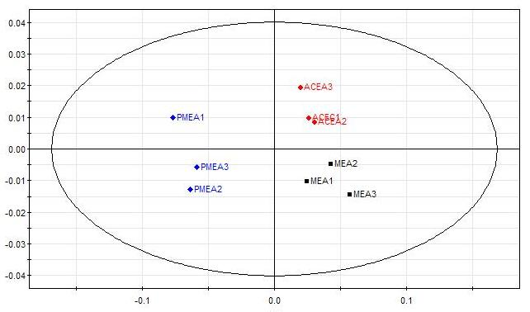
PC3 (5,4%)
PC1 (75.7%)

Fig. 2 Score plot of PCA of acidified methanol eluates from SPE column of organic fraction of P. cerasus cv Montmorency (MEA), P. cerasus cv Marasca di Zara (ACEA), and P. mahaleb (PMEA) fruits. P. mahaleb and P. cerasus samples, were clearly separated on the basis of PC1, while the two cultivars of P. cerasus were separated on the basis of PC3.

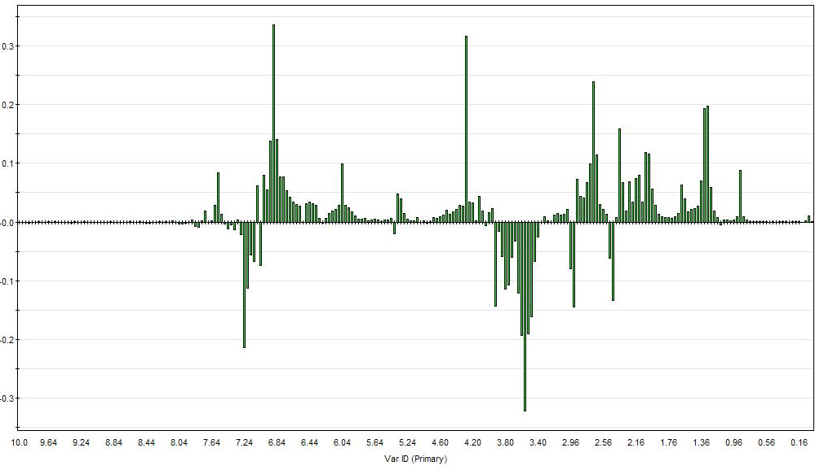
PC1
Fig. 3 Loading plots for PC1 related to score plot in Fig. 2.

The PCA score plot performed on the NMR data obtained from the acidified methanol fraction eluted from SPE column starting from aqueous fraction (fraction B) is shown in Fig. 4. The two species are clearly separated by the PC1 (48,7 % of variance), on the contrary this analysis was not able to separate the two cultivars of P. cerasus.

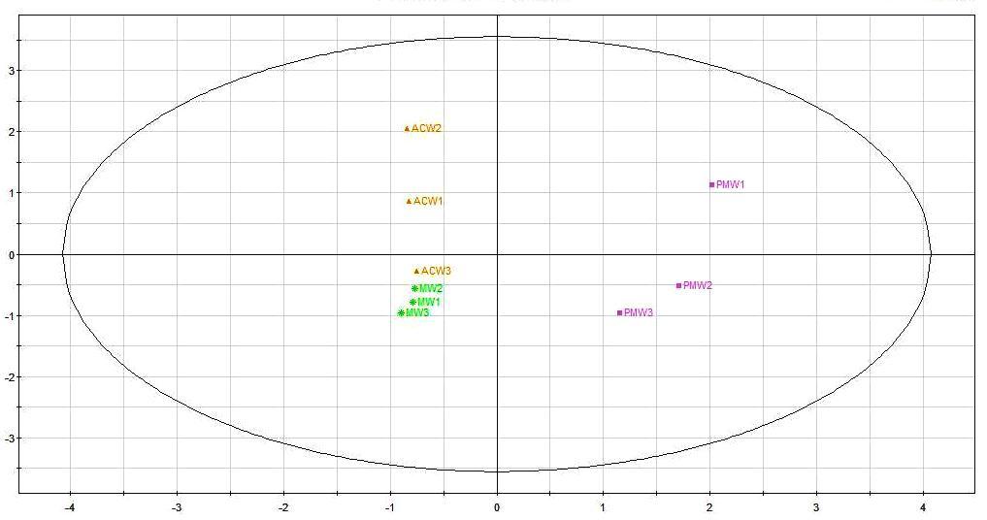
PC2 (36,9%)
PC1 (48,7%)

Fig. 4 Score plot of PCA of acidified methanol eluates from SPE column of aqueous fraction of P. cerasus cv Montmorency (MW), P. cerasus cv Marasca di Zara (ACW), and P. mahaleb (PMW) fruits. P. mahaleb and P. cerasus samples, were clearly separated on the basis of PC1.

From the analysis of loading plot of PC1 related to plot in Fig. 4 (Fig. 5) and original ¹H NMR spectra, we can conclude that P. mahaleb fruits, in the aqueous fraction, contain more phenolics, organic acid and aminoacids; peaks related to sugar regions of NMR spectrum, are high in both species, even if slightly higher in P. mahaleb (Fig. 5).
As reported in previous works (12, 13, 14), the red natural pigment anthocyanins, that are responsible of cherry fruits red colour, have ¹H NMR spectra with characteristic peak of a singlet at high value of magnetic field (~9 ppm) if the spectra are acquired using an acidified solvent. At acidic pH, anthocyanins exist predominantly in the form of the red flavylium cation (Fig 6). Because of these peaks related to proton H-4 were absent from our spectra, we decided to reacquired the ¹H spectra of some samples using as solvent CD₃OD/trifluoroacetacid (TFA) (95:5).
The samples reanalyzed were: acidified methanol and water fraction eluted from SPE column of organic fraction (fraction A) and aqueous fraction (fraction B) for P. mahaleb and P. cerasus (cv Montmorency). As showed in Fig. 7, in the new spectra we could identify the peaks related to proton H-4 of antocyanins compounds; they are present in ¹H
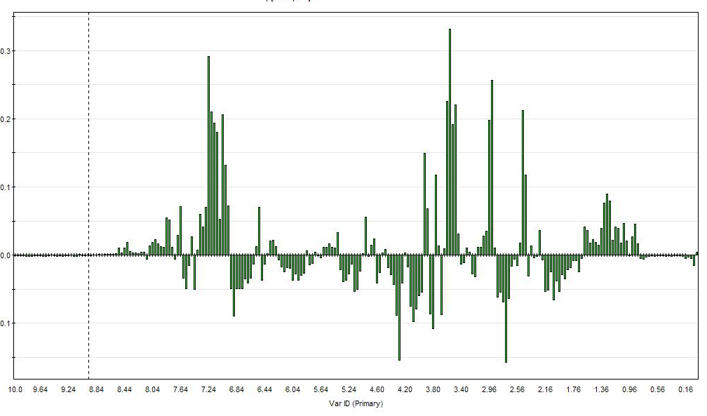
PC1
PC1
Fig. 5 Loading plots for PC1 related to score plot in Fig. 4.

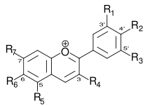

Fig. 6 Flavilium cation planar structure.

NMR spectra of acidified methanol fraction from SPE column of aqueous fraction (B) extracted from fruits of P. mahaleb and P. cerasus cv Montmorency, but the height and the number of the peaks were totally different. In fact we could identify four singlet peaks that looked higher in P. mahaleb in comparison with the two singlet peaks observed in P. cerasus spectrum. The same peaks, even if at lower level, were observed in the spectra of water fraction from SPE column of aqueous fraction (B) extracted from both cultivars (data not showed). On the contrary no signals were observed at ~ 9 ppm in any of the ¹H NMR spectra obtained from organic fraction (fraction B, data not showed). The presence of anthocyanidins in the aqueous fraction of our samples was confirmed by the

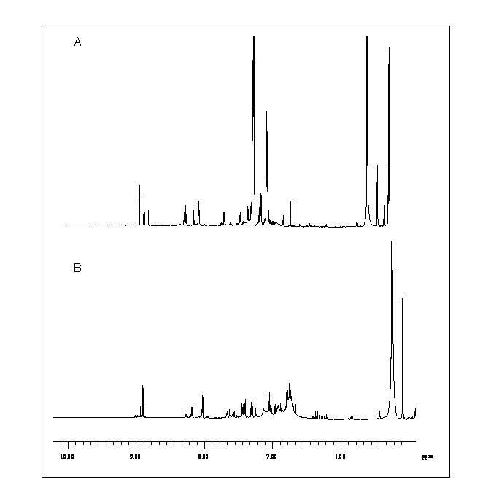

Fig. 7 Aromatic region of ¹H NMR spectra of acidified methanol fraction from SPE column of aqueous fraction (B) extracted from fruits of P. mahaleb (A) and P. cerasus cv Montmorency (B). Circles contain the singlet peaks related to H-4 of anthocyanidin compounds.

comparison of our ¹H chemical shifts with published data (12, 14). At the moment we are completing ¹H NMR analysis in CD₃OD/trifluoroacetacid (TFA) (95:5) for all samples. The next steps will be the identification of the anthocyanins structure (both aglycone and sugars moieties) by ¹H-¹H COSY and 2D J-resolved NMR spectra. This study is in progress in collaboration with the Plant Metabolomics Research Group at the Leiden Institute of Biology.

Conclusion
During the of Short Term Mobility Program the method for metabolomic analysis of Prunus species fruits has been developed. We couldn’t find previous references related to a so unbiased metabolite fingerprinting of Prunus. The collaboration with the Plant Metabolomics Research Group in the Leiden Institute of Biology has allowed us to learn more about the strength of NMR spectroscopy in metabolomic studies allowing identification, structure elucidation and relative quantification in mixtures of compounds. Moreover we became familiar with principal component analysis that we used to highlighted differences between Prunus cerasus and Prunus mahaleb and between two cultivars of Prunus cerasus (Montmorency and Marasca di Zara), with loading plots giving clues as to the nature of these differences. In this work we obtained the ¹H NMR spectra of the two species and the two cultivars and from the comparison of these spectra, we found that P. mahaleb fruits have an higher concentration of phenolic compounds, like flavonoids, and organic acids, in comparison to P. cerasus fruits. The same results were obtained when we focalized our attention on anthocyanins. It is known that these natural colorants, with high antioxidant activity, occur at high concentration in P. cerasus fruits. In this study we identify the signals of anthocyanin protons in ¹H NMR spectra of a mixture of compounds in aqueous extracts of both P. cerasus and P. mahaleb fruits but the latter species showed an higher concentration and structure variety of these compounds. This metabolomic analysis gave us the data to scientifically revalue a traditionally-used plants like P. mahaleb and to identify its potential as source of biofunctional compounds to be used from food and/or pharmaceutical industry. Moreover this collaboration will continue with a comparison of the spectra obtained during this study with a database of NMR spectra of common plant metabolites built by the host Institute, with the aim to identify as much compounds as possible responsible of differences between the two species of Prunus and the two cultivars of P. cerasus. After all the use of two-dimensional NMR methods in the fractions containing anthocyanin compounds, will enable structure elucidation and identification of these antioxidant molecules avoiding time consuming and complex methods of purification.

References
- Hollman, P.C.H. Evidence for health benefits of plant phenols: local or systemic effects? J. Sci. Food Agric. 2001, 81, 842-852.
- Kaur, C.; Kapoor, H.C. Antioxidant in fruit and vegetables- the millenium’s health. Int. J. Food Sci. Technol. 2001, 36, 703-725.
- Manach, C.; Scalbert, A.; Morand, C.; Rémésy, C.; Jimenez, L. Polyphenols: food sources and bioavailability. Am. J. Clin. Nutr. 2004, 79: 727-747.
- Blando, F.; Gerardi, C.; Nicoletti, I. Sour cherry (Prunus cerasus L.) anthocyanins as ingredients for functional foods. J. Biom. Biotech. 2004, 5, 253-258.
- Blando, F.; Scardino, A.P.; De Bellis, L.; Nicoletti, I.; Giovinazzo, G. Characterization of in vitro anthocyanin-producing sour cherry (Prunus cerasus L.) callus cultures. Food Res. Intern. 2005, 38, 937-942.
- Mavlyanov, S.M.; Abdulladrhanova, N.G.; Dalimov, D.N. Polyphenols from certain fruiting plants growing in Uzbekistan. Chem. Nat. Compd. 2003, 39 (5), 450-452.
- Al-Said, M.S.; Hifnawy, M.S. Dihydrocoumarin and certain other coumarins from Prunus mahaleb seeds. J. Nat. Prod. 1986, 49 (4), 721.
- Abdel-Farid, I.B.; Kim, H.K., Choi, Y.H.; Verpoorte, R. Metabolomic characterization of Brassica rapa leaves by NMR spectroscopy. J. Agric. Food Chem. 2007, 55, 7936-7943.
- Blando, F.; Negro, C.; Miceli, A.; Longo, L.; Vasapollo, G.; De Bellis, L. Proceedings of 5th International Congress on Pigments in Food. Helsinki 14-16 August, 2008, 91-94.
- Wang, H.; Nair, M.G.; Strasburg, G.M.; Booren, A.M.; Gray, J.I. Antioxidant polyphenols from Tart cherries (Prunus cerasus). J. Agric. Food Chem. 1999, 47, 840-844.
- Verpoorte, R.; Choi, Y.H.; Kim, H.K. NMR-based metabolomics at work in phytochemistry. Phytochem Rev. 2007, 6, 3-14.
- Košir, I.J.; Kidrič J. Use of modern nuclear magnetic resonance spectroscopy in wine analysis: determination of minor compounds. Anal. Chim. Acta 2002, 458, 77-84.
- Fossen, T.; Slimestad, R.; Andersen, Ø. M. Anthocyanins with 4’-glucosidation from red onion Allium cepa. Phytochemistry, 2003, 64. 1367-1374.
- Wang, H.; Nair, M.G.; Iezzoni, A.F.; Strasburg, G.M.; Booren, A.M.; Gray, J.I. Quantification and characterization of anthocyanins in Balaton tart cherries. J. Agric. Food Chem. 1997, 45, 2556-2560.

Lecce, 07/10/2008

Firma del Proponente Firma del Fruitore
Dott.ssa Giuseppina Mulè Dott.ssa Carmela Gerardi

