SEIRA Effects in Cyclopentabithiophenethiol-capped Gold Nanoparticles

CPDTH2-Au nanoparticles before and after the chemical coupling with iodine vapor to oligomers (scheme 1) were analyzed with the FTIR technique.

Scheme 1

The signals in the FTIR spectrum of the CPDTH2-Au nanoparticles (fig.1b) correspond substantially to those of free CPDTH2SH (fig.1a) but for the significant disappearance of the weak SH stretching band at 2570 cm⁻¹, in agreement with surface immobilization via sulfide bonding. Moreover the bands at 2950, 2850 and 1460 cm⁻¹, due to CH2 stretching and scissoring in the C6 chains, are weaker compared with the CH oop bands at 795 and 675 cm⁻¹, which points to selection rules of SEIRA according to which the plane of the CPDT moiety is essentially parallel to the gold surface.

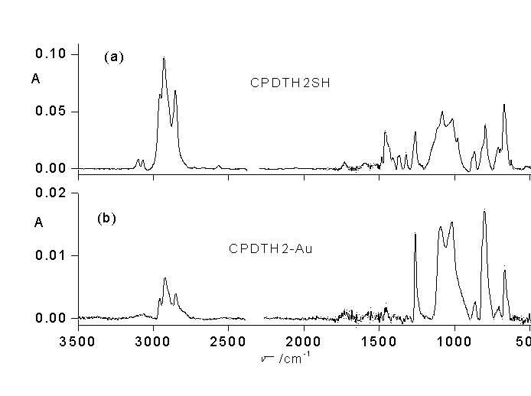

Fig. 1

CPDTH2-Au films were chemically coupled with iodine vapor to oligomers (sexithiophenes mainly). The FTIR spectra (fig.2 a to b) indicate the appearance of a signal (shoulder) at 830 cm⁻¹, due to the aromatic C-H out-of-plain vibrations characteristic of 2,5-disubstituted-3-alkylthiophene and a decrease of the band at 670 cm-1 due to the terminal C-H oop modes of CPDT. Moreover the CH2 stretching and scissoring bands in the C6 chains are even weaker, which points to a better parallel disposition to the gold surface of the CPDT plane promoted by coupling.
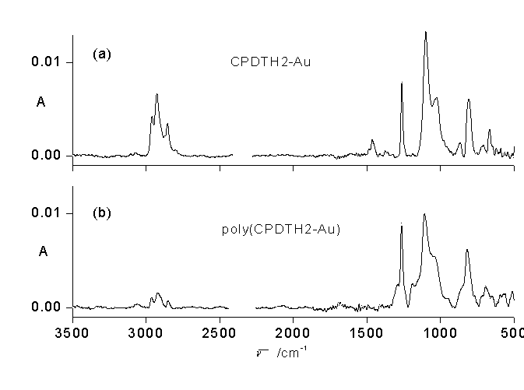

Fig. 2

