# Prize-winning research Discovered a previously unknown Neolithic society in Morocco

**The research, published in the journal *Antiquity* in 2024, uncovered the earliest and largest agricultural complex yet found in Africa beyond the Nile, indicating North Africa played a key role in Mediterranean prehistory.**

* **The annual *Antiquity* prize was founded in 1994 to recognise the best article published each year in *Antiquity*.**
* **This year’s winning article documents the site of Oued Beht, Morocco, revealing a previously unknown 3400–2900 BC farming society.**
* **This is the earliest and largest agricultural complex yet found in Africa beyond the Nile.**
* **It shares similar features with contemporaneous sites in Iberia.**
* 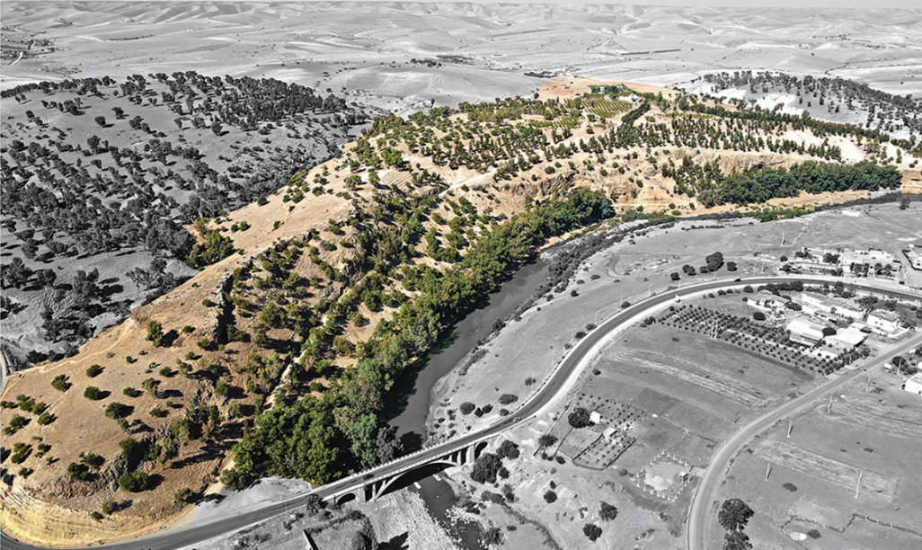**This suggests the Maghreb was instrumental to the shaping of the western Mediterranean during the fourth and third millennia BC.**

### [Aerial photograph of the Oued Beht ridge and river, highlighted in colour (credit: Toby Wilkinson)]

### Images can be found here: <https://drive.google.com/drive/folders/1Ril_vtdYSWD4sC6F8Z_Kty4bInVTsfO5?usp=sharing>

Archaeological fieldwork in Morocco uncovered a hitherto unknown early farming society from a poorly understood period of north-west African prehistory, revealing for the first time the importance of the Maghreb (north-west Africa) in the emergence of complex societies in the wider Mediterranean.

With a Mediterranean environment, a border with the Sahara desert and the shortest maritime crossing between Africa and Europe, the Maghreb is perfectly located for major cultural developments and intercontinental connections in the past.

Whilst the region’s importance during the Palaeolithic, Iron Age and Islamic periods is well known, there is a significant gap in knowledge of the archaeology of the Maghreb between c. 4000 and 1000 BC, a period of dynamic change across much of the Mediterranean.

To tackle this, Youssef Bokbot (INSAP), Cyprian Broodbank (Cambridge University), and Giulio Lucarini (CNR-ISPC and ISMEO) carried out multidisciplinary archaeological fieldwork at Oued Beht, Morocco. Their results were published in the journal *Antiquity* in 2024 and have been awarded the 2025 *Antiquity* Prize.

“For more than a century, the last great unknown of later Mediterranean prehistory has been the role played by the societies of the Mediterranean’s southern African shores west of Egypt,” state the authors. “Our discoveries prove that this gap has been due not to any lack of major prehistoric activity, but to the relative lack of investigation, and publishing. Oued Beht now affirms the central role of the Maghreb in the emergence of both Mediterranean and wider African societies”.

These results revealed that the site was the largest agricultural complex from this period in Africa outside of the Nile region. All of the evidence points to the presence of a large-scale farming settlement—similar in size to Early Bronze Age Troy. The team recovered unprecedented domesticated plant and animal remains, pottery and lithics, all dating to the Final Neolithic period. Excavation also revealed extensive evidence for deep storage pits.

Importantly, contemporaneous sites with similar pits have been found on the other side of the Strait of Gibraltar in Iberia, where finds of ivory and ostrich egg have long pointed to African connections. This suggests that the Maghreb was instrumental in wider western Mediterranean developments during the fourth millennium BC.

Oued Beht and the north-west Maghreb were clearly integral parts of the wider Mediterranean region. As such, these discoveries significantly change our understanding of the later prehistory of the Mediterranean and Africa.

As the authors of the *Antiquity* article state: “it is crucial to consider Oued Beht within a wider co-evolving and connective framework embracing peoples both sides of the Mediterranean-Atlantic gateway during the later fourth and third millennia BC—and, for all the likelihood of movement in both directions, to recognise it as a distinctively African-based community that contributed substantially to the shaping of that social world.”

Read the prize-winning research FREE: <https://doi.org/10.15184/aqy.2024.101>

### [Distribution of polished axes/adzes and chipped stone tools (credit: Toby Wilkinson)]

### [Stone tools from Oued Beht (credit: Lorena Lombardi & Moad Radi)]

---Ends---

# Notes for editors

# **Oued Beht, Morocco: a complex early farming society in north-west Africa and its implications for western Mediterranean interaction during later prehistory** - Cyprian Broodbank, Giulio Lucarini, Youssef Bokbot, Hamza Benattia, Aïcha Bigoulimen, Lucy Farr, Arnau Garcia-Molsosa, Hassan Hachami, Rafael Laoutari, Lorena Lombardi, Adelaide Marsilio, Louise Martin, Jacob Morales, Moad Radi, Francesco Michele Rega, Toby Wilkinson

<https://doi.org/10.15184/aqy.2024.101>

## Contacts

ANTIQUITY:

Max Storey,

Public Engagement and Press Coordinator

Tel: +44(0)7771 842 557

Email: [media@antiquity.ac.uk](mailto:media@antiquity.ac.uk)

#### research:

Professor Cyprian Broodbank

University of Cambridge, UK

Email: [cb122@cam.ac.uk](mailto:cb122@cam.ac.uk)

Dr Giulio Lucarini

National Research Council of Italy

Email: [giulio.lucarini@cnr.it](mailto:giulio.lucarini@cnr.it)

## About

#### ABOUT ANTIQUITY

*Antiquity* is an international peer-reviewed journal of world archaeology, published six times a year and edited by Professor Robin Skeates. The journal was founded by O.G.S. Crawford in 1927 and is currently edited in the Department of Archaeology at Durham University. The journal is published in partnership with Cambridge University Press (CUP).

Antiquity website: <http://www.antiquity.ac.uk>

CUP Cambridge Core page: <https://www.cambridge.org/core/journals/antiquity>

Twitter: <https://twitter.com/AntiquityJ>

Facebook: <https://www.facebook.com/AntiquityJournal/>

Instagram: <https://www.instagram.com/antiquityjournal/>

Threads: <https://www.threads.net/@antiquityjournal>

Bluesky: <https://bsky.app/profile/antiquity.ac.uk>

#### ABOUT CAMBRIDGE JOURNALS

Cambridge University Press publishes over 350 peer-reviewed academic journals across a wide spread of subject areas, in print and online. Many of these journals are leading academic publications in their fields and together form one of the most valuable and comprehensive bodies of research available today.

For further information about Cambridge Journals, visit: <http://journals.cambridge.org>

#### ABOUT CAMBRIDGE UNIVERSITY PRESS

Cambridge University Press is part of the University of Cambridge. It furthers the University’s mission by disseminating knowledge in the pursuit of education, learning and research at the highest international levels of excellence.

Its extensive peer-reviewed publishing lists comprise 45,000 titles covering academic research, professional development, over 350 research journals, school-level education, English language teaching and bible publishing.

Playing a leading role in today’s international market place, Cambridge University Press has more than 50 offices around the globe, and it distributes its products to nearly every country in the world.

For further information about Cambridge University Press, visit: <http://cambridge.org>