The workshop “Innovative Materials for The Release of Bioactive Principles and the Protection of Natural Matrices”, organized within the BIONANOF project was held on October 6th at the CNR–Itm institute (Figure 1).

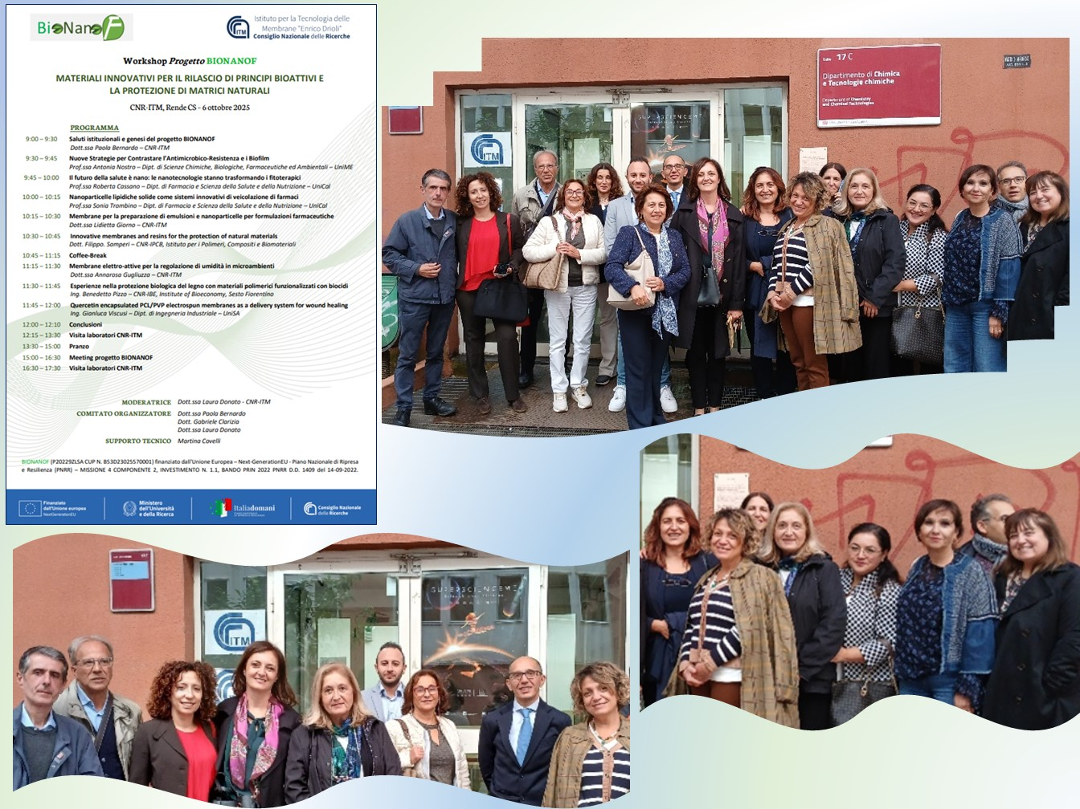
Figure 1. Bionanof workshop program and participants

The project BIONANOF is funded by the European Union – NextGenerationEU within the action PRIN 2022 PNRR in the PE5 ERC field (Physical Sciences and Engineering). The consortium includes the Cnr-Itm (as coordinator) the Cnr-Ipcb (Institute of Polymers, Composites and Biomaterials, Section of Catania), the Cnr-Icb (Institute of Biomolecular Chemistry, Section of Catania), the University of Catania (Department of Drug and Health Sciences), and the University of Messina (Department of Chemical, Biological, Pharmaceutical and Environmental Sciences).
The BIONANOF innovation deals with the development of novel “smart Drug Delivery Systems” based on antimicrobial/anti-inflammatory/antioxidant nanoconstructs embedded into polymeric films for a local multidrug treatment of wound infections.
The program involved speakers from the BIONANOF consortium (Cnr–Itm, University of Messina) as well as from the University of Calabria (UniCal) where the Cnr–Itm is located, from the CnrR–Ibe, the Cnr–Ipcb and University of Salerno (Figure 2).
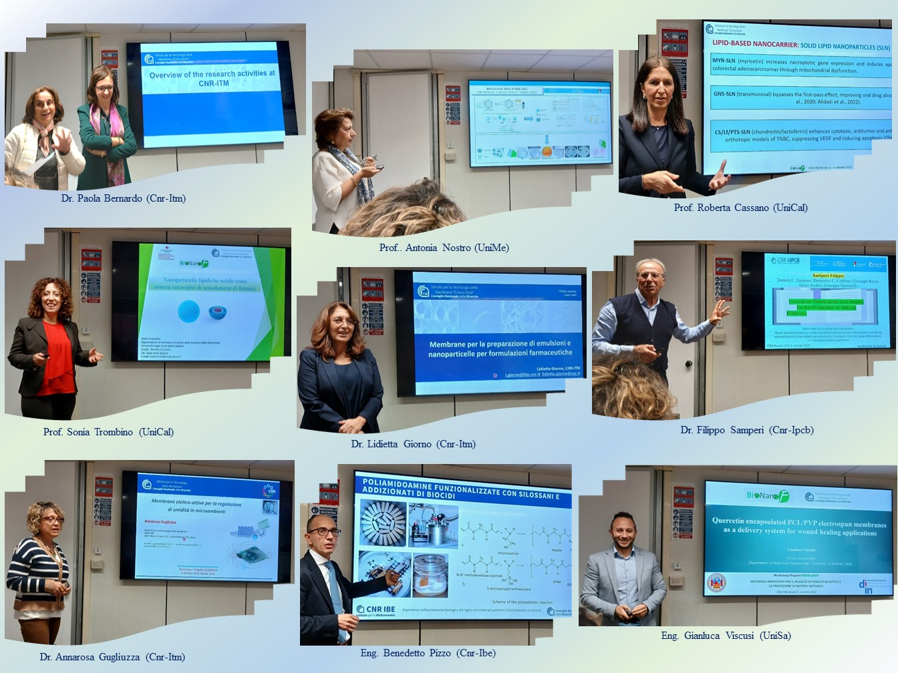
Figure 2. Speakers of the Bionanof workshop

The workshop was combined with a meeting for the BIONANOF participants to discuss the latest results and with visits of the CNR–Itm laboratories (Figure 3).
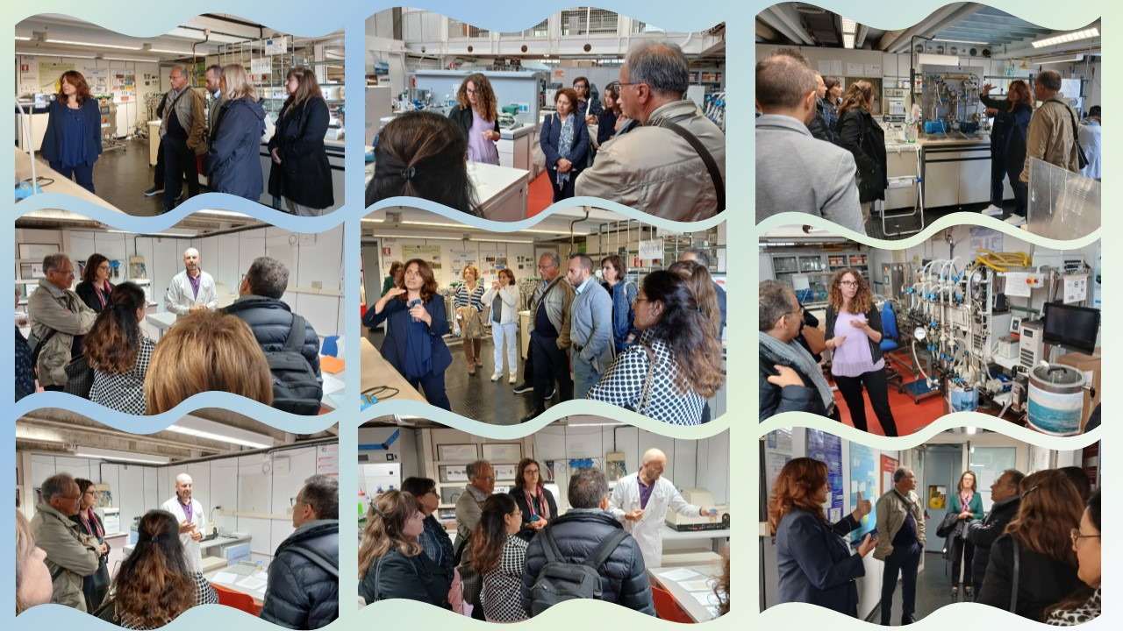
Figure 3. Visit to the Cnr-Itm laboratories
The event, provided an up-to-date overview of multidisciplinary research activities addressing some urgent needs related to the development of advanced materials at different scales for health and environmental protection as well as for the conservation of artifacts. The participants particularly appreciated the interesting talks and the opportunities of networking, also through convivial and social moments (Figures 4-5).

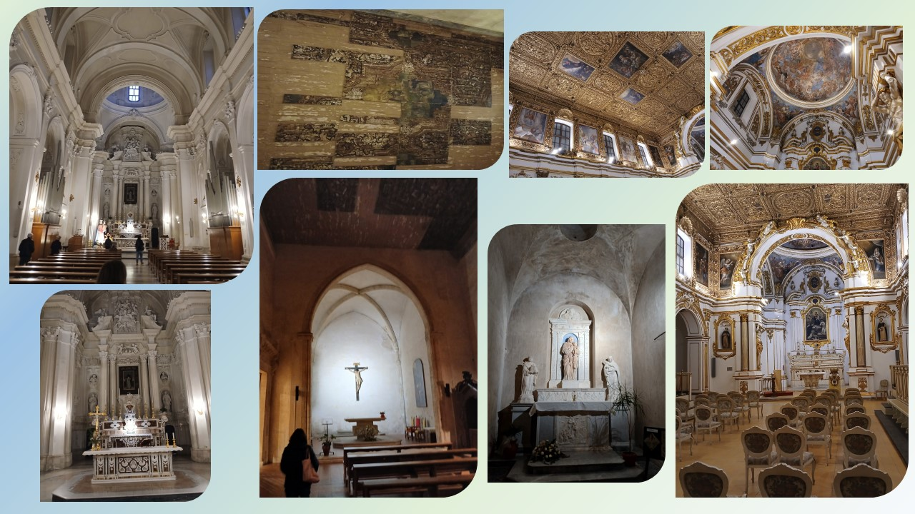
Figure 4. Visit to the Monumental Complex of San Domenico (CS)

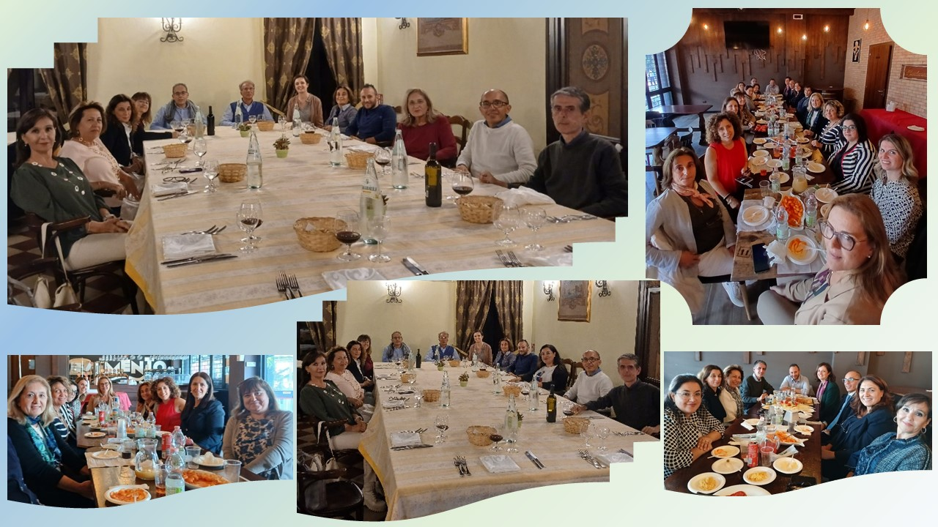
Figure 5. Convivial and socializing moments for participants at the Bionanof workshop

