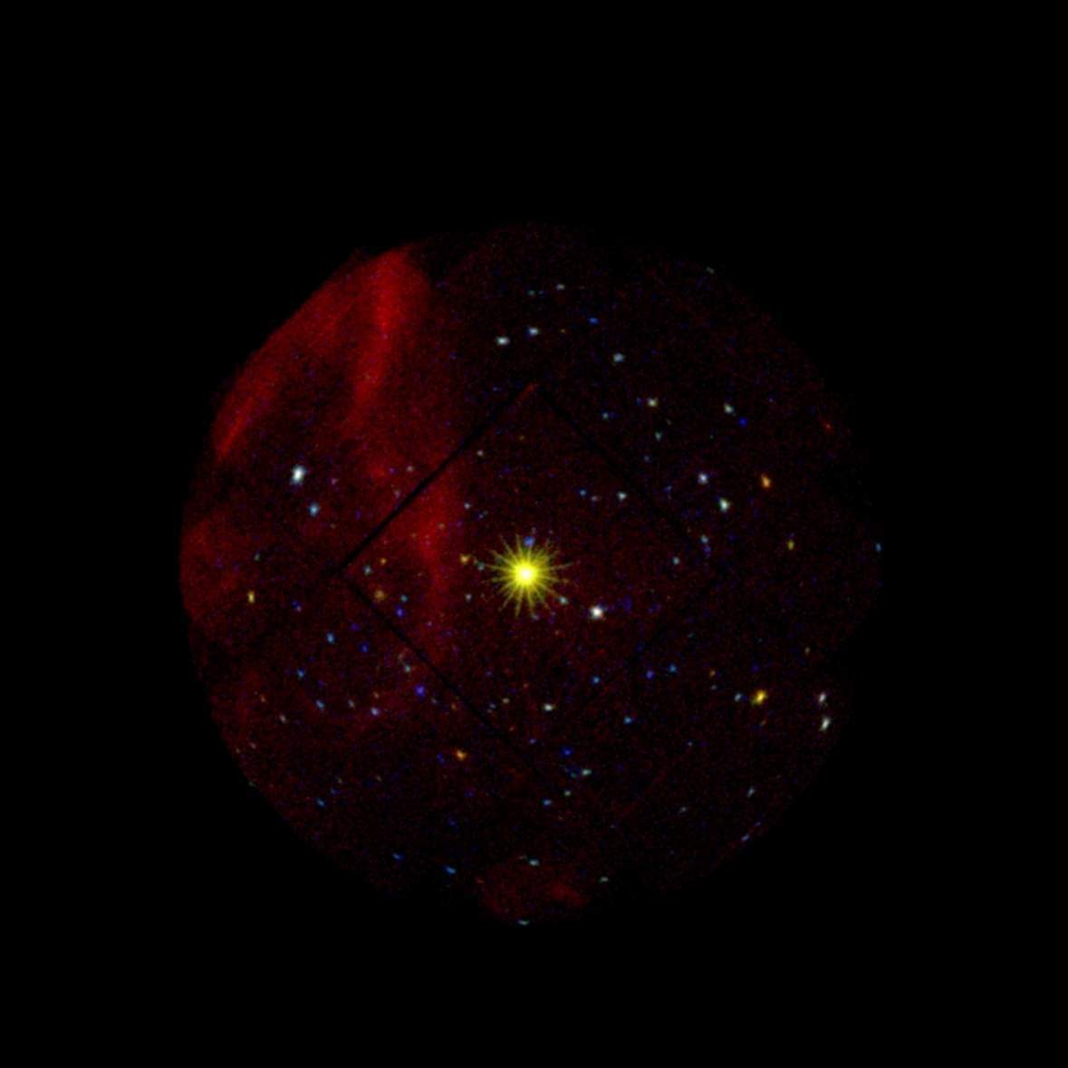
EPIC MOS image of the field of 1E1207.4-5209. The source appears in the center of the image together with ~200 serendipitous sources. This image is the deepest galactic exposure performed so far by the XMM-Newton observatory

