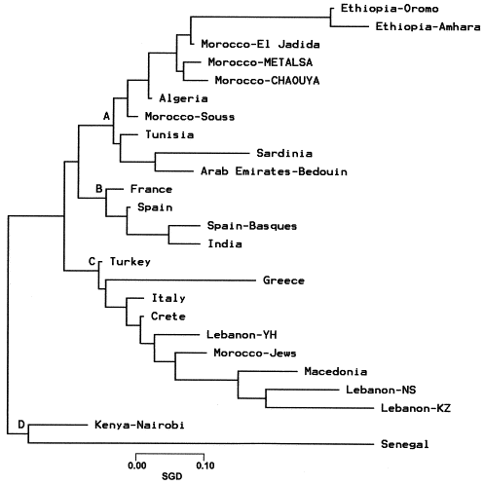

Neighbor-joining dendrogram illustrating the relatedness of the Metalsa and Chaouya Moroccans, and other populations. Standard genetic distances (SGD) were calculated using only data from high-resolution DRB1 typing. Bootstrap values from 1000 replicates are illustrated.

