INTEGRAL: The Italian way to High Energy Space Astrophysics
INTEGRAL (International Gamma Ray Astrophysical Laboratory) has been successfully launched with a Proton rocket October the 17th, 2002 and injected into the predicted highly excentric orbit (10.000km perigee and 153.000km apogee). This ESA satellite is a Space Observatory, opened to the scientific community at large, and is an devoted to high resolution imaging and spectroscopy in the hard X–ray / soft γ–ray range. The mission is currently approved for a duration of 2 years with expected extension to 5. The INTEGRAL science payload consists of two main instruments, the spectrometer SPI and the imager IBIS, both covering the 15 keV−10 MeV range, complemented by two subsidiary instruments for X–ray (JEM-X) and optical (OMC) monitoring. All these instruments are co-aligned and will be operated simultaneously to provide a broad spectral coverage of the targets. The two subsidiary instruments are of great importance as they will allow INTEGRAL to observe for the first time astronomical sources simultaneously in the optical, X–rays and γ–rays. Thanks to the technological improvements the INTEGRAL measurements will combine improved sensitivity with an angular and spectroscopic resolution never reached before in the soft γ–ray range (Δθ ∼12′, ΔE∼2 keV at 1 MeV). The CNR Institutes now forming the IASF have been involved in INTEGRAL since its early phases. This has led to a substantial participation of the four IASF Sections which play a fundamental role in the INTEGRAL mission with important management and realization responsibilities (PI of IBIS, Co-I's of JEM-X, SPI and ISDC).

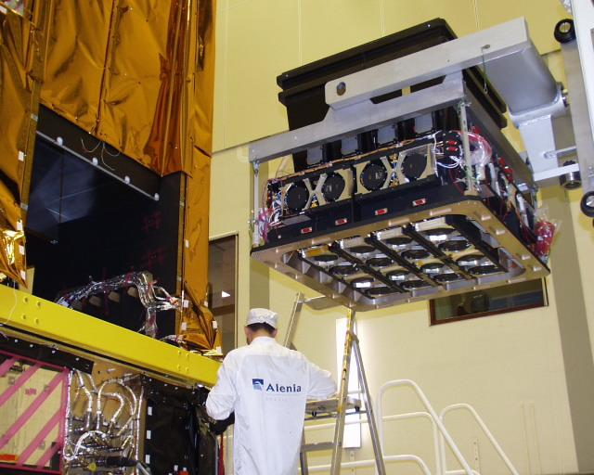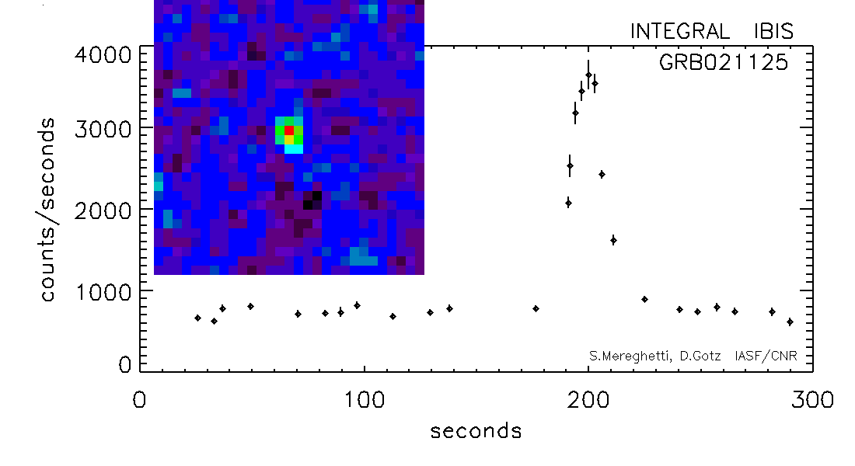
The IBIS instrument being integrated into the INTEGRAL Satellite. The first Integral Gamma Ray Burst
IBIS (Imager on Board the INTEGRAL Satellite) is a coded mask γ–ray telescope optimized for the imaging performances, based on innovative, high technology solid state detectors. IASF/RM has the programmatic responsibility of the whole IBIS instrument (PI and System Team) and was responsible for the Veto system, the internal Calibration Unit and the mechanical main frame. IASF/BO developed the PICsIT layer, which consists of 8 modules, each including 512 independent detectors and is the result of a strict cooperation between research institution and industry (Laben).

SPI (SPectrometer on INTEGRAL) is based on an array of 19 hexagonal high purity Ge detectors cooled by a Stirling cooler system to an operating temperature of 85 K. A hexagonal coded aperture mask is located 1.7 m above the detection plane in order to image large regions of the sky (fully coded FoV = 16°) with an angular resolution of 2°. The main IASF contribution to SPI consists of a plastic veto located below the mask, which is essential to reduce the 511 keV background to an acceptable level.JEM-X (Joint European X–ray Monitor) is made of two nearly identical units and the IASF contribution to JEM-X consists of the High Voltage suppliers, the calibration sources and the software for the simulations and background evaluation.The ISDC (INTEGRAL Science Data Center) is the scientific part of the INTEGRAL ground segment. This is the first time that the realization of such an important part of a space mission has been assigned by ESA to a consortium of institutes funded by national agencies. Like the other members of the international ISDC consortium, IASF/MI has participated to the ISDC development by providing scientific and software engineering staff at the ISDC premises (Geneva Observatory, CH). The main IASF responsibilities are the subsystem for the data preprocessing and the software for the automatic detection and localization of GRBs in real time (IBAS).

