
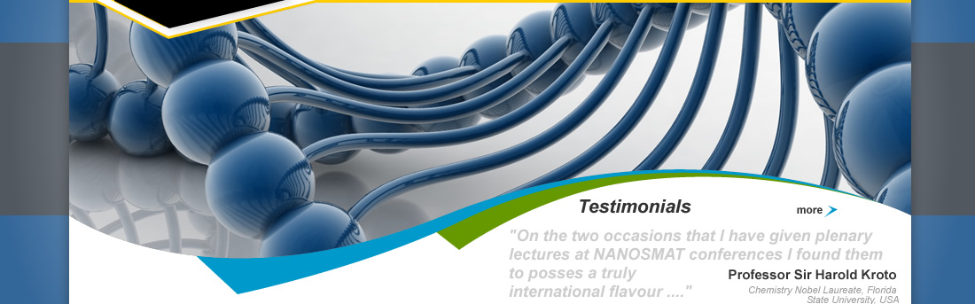
Welcome To NANOSMAT Conference

 |  | 
    
    Abstracts
    Accommodation
    Committees
    Deadlines
    Gallery
    Highlights
    Invited
    Latest News
    NANOSMAT Prize
    Poster Competition
    Publications
    Testimonials
    Special Sessions
    Workshops
    Young Lecture Competition
    
    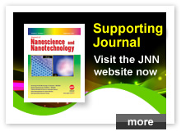
    NANOSMAT is a premier conference in the field of materials related Nanoscience, Engineering and Nanotechnology.
    Since 2005, it has been very successfully organised in several European countries, including Portugal, Spain, Italy, France, Poland and Czech Republic. The conference fosters the gathering of talented and truly international people to exchange novel ideas, share new knowledge and technical know-how in the broad fields of nanoscience and technology.
    SYMPOSIA:
    - Nanomaterials
    - Surface, Science, Engineering and Technology
    - Nanotechnology for Energy
    - Nano-Medicine and Nano-Biotechnology
    - Carbon Nanotechnology
    Key HIGHLIGHTS include: 2014 NANOSMAT Prize, NANOSMAT Lecture, Young Scientist Lecture Competition, Poster Competition, Workshops, Expert Panel discussion, Exhibition, Special Sessions, Poster Sessions & Tutorials.
    We hope to see you join us in Dublin, Ireland during 8-11 September 2014 for what promises to be a memorable conference.
    Dr Nasar Ali, UK (Chair)
    Inizio modulo
    
    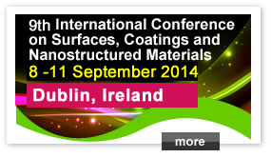
    Call for Papers NANOSMAT 20...
    Abstract Submission Deadline is 31 May 2013. Click on www.nan ...
    2013 NANOSMAT Prize...
    To make nominations for 2013 NANOSMAT PRIZE Click on http://w ...
    